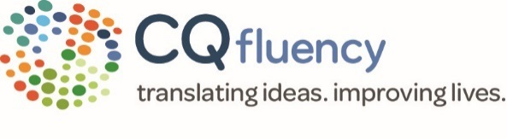

FOR IMMEDIATE RELEASE
CQ Fluency
2 University Plaza Drive, Suite 406
Hackensack, NJ 07601
Media contact:
Alysia Gemma
alysia.gemma@cqfluency.com
201.487.8007

CQ FLUENCY NAMED 2019 BEST PLACES TO WORK IN NEW JERSEY BY NJBIZ
Hackensack, New Jersey May 14, 2019 – CQ fluency, a Hackensack, NJ based language translation services company that specializes in cultural adaptation communication for healthcare insurance and life sciences, has been named one of the 2019 Best Places to Work in New Jersey by NJBiz. The Best Places to Work in New Jersey awards program recognizes and honors the state’s top employers who show a dedication to their employees’ professional growth and quality of life. The analysis for making the list is based on two surveys: The Employer Questionnaire and the Employee Survey. The program collects data confidentially, allowing employees to comfortably share feedback about the companies they work for – and for those companies to interpret and act on what they’ve learned.
The rapidly growing company was ranked at #11 in the ranking released for 2019, marking this as the second consecutive year that CQ fluency has earned a place on the list. “CQ fluency is extremely grateful to again be named to the Best Places to Work in New Jersey list and so proud that we increased our ranking for 2019,” said Elisabete Miranda, CQ fluency President and CEO. “We continue to cultivate our collaborative and family-oriented culture and reward our employees for their loyalty and dedication as well as celebrate their exceptional skill sets that translate to unmatched client service.”
“CQ is a family and everyone looks after each other, whether it be help being given to ensure an employee has extra hands to get a project done, or an encouraging pep talk to help through a difficult situation. Management is open and always available to any employee. I truly feel valued as an employee and person” said one of the employees of CQ fluency. CQ fluency offers a wellness program, profit sharing, flexible work schedules, remote employee opportunities, and extensive training and career path development. In addition, the Company actively participates in charitable events as well as sponsors 120 children through the Save the Children organization and increases that number each year. Employees look forward to coming to work and doing their best at CQ fluency, which increases overall retention and value in client service.

About CQ fluency:
CQ fluency is a language services company that specializes in culturally relevant translations for life science and healthcare in over 150 languages. We translate meaning and feeling of messages to facilitate real connections and true cultural understanding between people who don’t speak the same language. More about CQ fluency can be found on our website at: www.CQfluency.com

About NJBIZ "Best Places to Work in New Jersey"
The awards program, created in 2005, is produced by NJBIZ. The "Best Places to Work in New Jersey" program is made up of 100 companies split into two groups: 65 small/medium-sized companies (15-249 employees) and 35 large-sized companies (more than 250 employees). Companies from across the state entered the two-part process to determine the 100 Best Places to Work in New Jersey. The overall registration and survey process was managed by Best Companies Group (BCG). BCG also analyzed the data provided and used their expertise to determine the final rankings. For more information on the "Best Places to Work in New Jersey" program, visit njbiz.com/events.

####

