
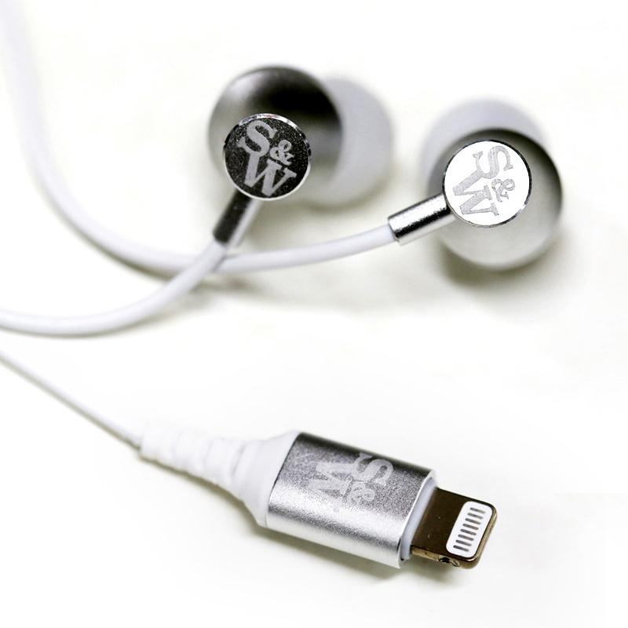

FOR IMMEDIATE RELEASE

CONTACT: Andy Curtis
EMAIL: press@straussandwagner.com

NEW HEADPHONE COMPANY, STRAUSS & WAGNER, DEBUTS WITH AUDIOPHILE-QUALITY SOUND ISOLATING EARPHONES WITH APPLE MFI CERTIFIED LIGHTNING CONNECTION

Apple Users Can Rejoice at Best-in-Class Sound At An Affordable Price

NEW YORK, May 16, 2019 — Strauss & Wagner, a newly launched American high-end audio brand, has officially released today its SI201 Sound Isolating Earphones with Apple MFI Certified Lightning Connection And Mic+Remote.

The SI201 offers an easy and stylish solution for audiophile iOS users tired of their adapters. Its in-ear design is optimized for noise isolation, with three sizes of silicone ear tips included in the package. The three-button remote allows for quick volume and playback adjustment, along with a microphone for taking calls and using Siri voice commands.

Early reviewers have praised the SI201’s performance. “With good isolation, a comfortable fit, great sound, and a wide soundstage, the SI201 does just about everything right,” said Carroll Moore from MajorHiFi, comparing it to some of the leading audiophile brands on the market.

Introduced at $49.95 USD, Strauss & Wagner’s SI201 is backed by a one-year warranty and available for purchase at Strauss & Wagner and any of its authorized dealers.
###

ABOUT STRAUSS & WAGNER
Strauss & Wagner products, with their exceptional build quality and characteristic audio fidelity, offer class-leading earphones and audio accessories that won’t break the bank. Based in New York, Strauss & Wagner has delivery channels across the U.S. and internationally. Their hardline attention to nuanced, immaculate sound lends itself to a unique listening experience meant to be shared with everyone. Visit at: https://straussandwagner.com

