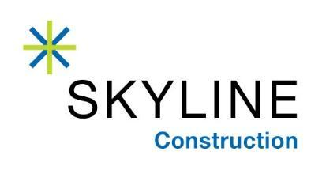
FOR IMMEDIATE RELEASE
5/20/2019

SKYLINE CONSTRUCTION WELCOMES TIM LALLY AS SAFETY, QUALITY, AND PRODUCTION DIRECTOR
Construction safety expert Tim Lally joins Skyline Construction

San Francisco, CA – 100% employee owned general contractor Skyline Construction is pleased to announce that Tim Lally is joining as National Safety, Quality, and Production Director. Lally brings more than 20 years’ experience in construction safety operations to Skyline Construction and its subsidiaries ACCEND Construction in Chicago and Skyline Capital Builders in the Bay Area.

In this role, Lally will oversee our risk and safety efforts to ensure the well-being of employees, subcontractors, projects and the public throughout Skyline’s family of companies. Lally will collaborate with teams to enhance the firm’s solid commitment to safety, quality, and production.

Over the course of his career, Lally has served as a regional and national Safety Director at many reputable construction companies. He is widely known for his “SQP philosophy” the idea that safety, quality, and production are all one common, interdependent goal. Under this model, Lally places an emphasis on early project planning and innovative, whole-brain thinking – which allows for potential risks and constraints to be identified and solved prior to construction mobilization.

“I am honored to have Tim Lally join our National Corporate Services Team,” said Jessica Carps, CFO of Skyline Construction. “Tim brings tremendous experience and knowledge to enrich our existing safety program, and will serve as a wonderful resource for new firms joining Skyline’s family of companies as we acquire and expand throughout the United States over the next ten years.”

About Skyline Construction
An award-winning, general contractor in the Bay Area, Skyline Construction is known for specializing in corporate interiors and delivering the highest level of client service. Skyline is one of the very few general contractors to be 100% employee owned through an Employee Stock Ownership Plan (ESOP). In 2019, Skyline expanded into both new markets and sectors of the industry with the opening of two subsidiaries: ACCEND Construction LLC in Chicago and Skyline Capital Builders LLC in the Bay Area. Skyline’s 2018 sales were over $500 million. The Skyline family of companies is just getting started and plans for future expansion into many major US cities over the next 10 years. For more information, visit http://www.skylineconstruction.build/

