INFORMATION FOR RELEASE
Contact:
Danielle Eldredge
904.477.9182
Danielle@maxwellhca.com

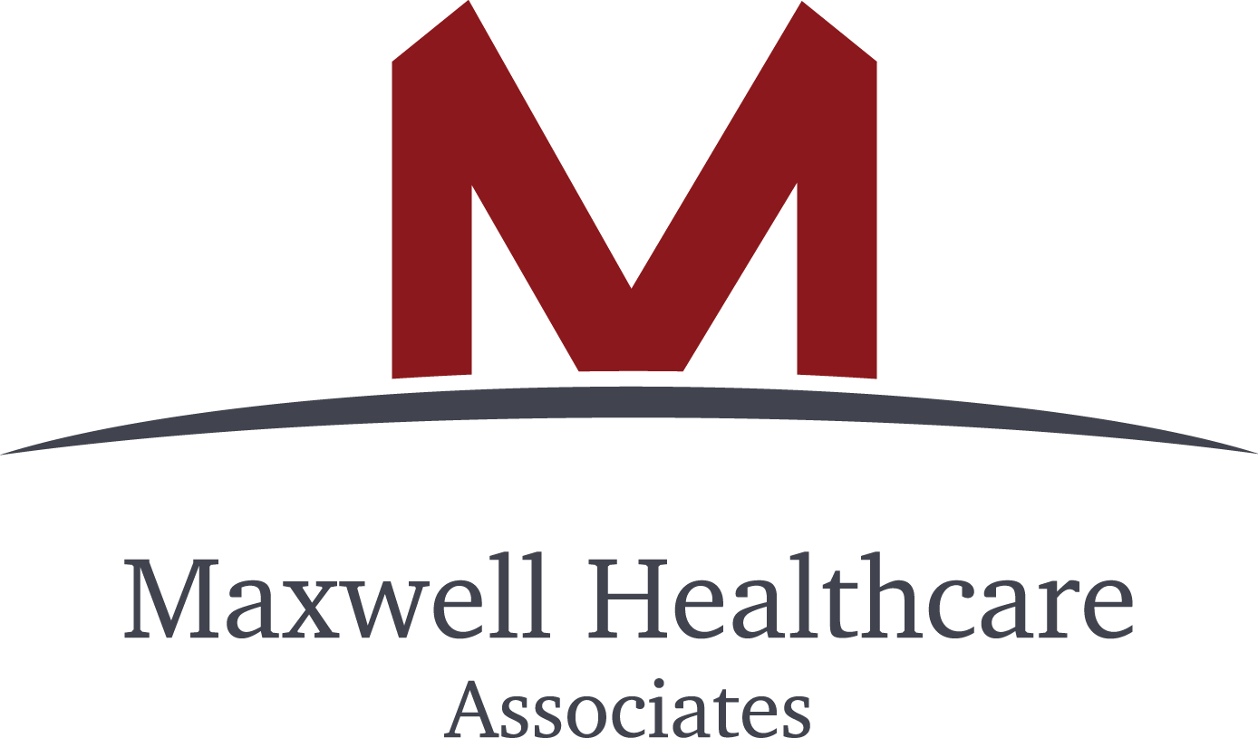

Maxwell Healthcare Associates Helps Take 700 Patients Live on a New EMR in Record Time

New case study details how Hospice Care of South Carolina enlisted Maxwell Healthcare Associates’ consulting services to quickly and effectively implement a new EMR post acquisition.

SHOREVIEW, Minn., June 18, 2019 – Today, home health and hospice consulting firm, Maxwell Healthcare Associates (MHA) released a new case study demonstrating how post-acute providers are leveraging EMR implementation services in conjunction with due diligence services to ensure a swift, seamless and customized EMR implementation that leads to long term reporting and compliance gains. The study details MHA’s work with Hospice Care of South Carolina (HCSC) where they took 700 patients live on a new EMR, post-acquisition, in three months.

“A successful EMR implementation is an agency’s biggest predictor of success. It’s an investment on the front end that will give you the greatest advantage in the long run--especially in the current regulatory landscape where efficiency and quality has never been more important,” said Troy Yarborough, co-CEO of HCSC. “You have one chance to get it right. You don’t get a do over. We decided to do it right and that’s why we hired Maxwell.”

In addition to a speedy and thorough implementation, HCSC had several key criteria in their search for EMR implantation project management consulting services:

- EMR implementation expertise combined with industry excellence. While the agency’s clinicians were already delivering quality care, new management wanted to create new processes that would drive compliance, ease clinical documentation requirements, improve margins and enable even higher quality gains. By working with experts who know the ins and outs of the technology and are also well-versed in industry compliance standards, the EMR could serve as an engine to support best practices, processes and efficiency.
- Reduced screen time and enhanced face time. Agency leaders are believers in technology that elevates without getting in the way. Their vision was for their clinicians to embrace new technology because it would support more time with patients rather than more time on point-of-care devices. To that point, leadership wanted to optimize their EMR to support usability with little-to-no duplicative data entry or redundancies.
- Enhanced reporting and dashboards. While the EMR purchase includes initial training and implementation support, agency leaders wanted more--especially when it came to customized dashboards and reporting. They wanted experts who could create reports that would measure the true health of their organization moving forward focused on clinical, financial and operational outcomes.
- Training. Agency leaders understand that technology can only be as good as those using it every day. They wanted to make sure their team was properly trained and confident in the new technology, so they could fully leverage its power long term.

“It’s our mission to help home health and hospice providers best leverage their technology to enhance care quality,” said MHA co-founder and co-CEO, Jennifer Maxwell. “It’s our pleasure to work with an innovative and patient-centric provider like HCSC who shares our vision and belief in the power of fully optimized tech to transform care.”

“While we’re often helping agencies best implement or optimize their EMR, it’s less frequent we’re able to help through both due diligence and implementation,” said MHA co-founder and co-CEO, Tom Maxwell. “It was a powerful combination that allows us to help the acquiring agency realize value on its investment quickly.”

The case study details MHA’s solution for HCSC and the results. Interested parties can download the case study at: http://bit.ly/HCSCcasestudy

###
About Maxwell Healthcare Associates
Tom and Jennifer Maxwell founded MHA to help their friends in the post-acute healthcare space succeed amid healthcare’s transition from volume to value. Providers have tighter budgets with less room for error and need to be more efficient than ever. That’s where outside and knowledgeable perspectives become invaluable and necessary. Tom and Jennifer have assembled the most elite group of experts with a combined knowledge base unlike any other consulting team in the industry to help home health and hospice providers best optimize their operational, technological, regulatory, clinical and financial processes. MHA’s core services include EMR implementation, EMR optimization, PDGM assessment and optimization and M&A assistance. For more information visit: maxwellhealthcareassociates.com

About Hospice Care of South Carolina
Hospice Care of South Carolina has been delivering comprehensive hospice services across the Palmetto State for more than 20 years. They pride themselves on their commitment to quality compassion and innovation. Their mission is to be the leader in end-of-life care, always. For more information visit: hospicecare.net

Hospice Care of South Carolina has been delivering comprehensive hospice services across the Palmetto State for more than 20 years. They pride themselves on their commitment to quality, compassion and innovation. Their mission is to be the leader in end-of-life care, always.

