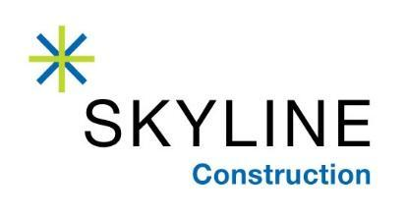
FOR IMMEDIATE RELEASE
7/10/2019

DEEPAK LATHKER JOINS SKYLINE’S CORPORATE SERVICES LEADERSHIP TEAM
AS HEAD OF IT & SECURITY

San Francisco, CA – Award winning general contractor Skyline Construction is pleased to announce that Deepak Lathker is joining as Head of IT & Security. Lathker will oversee the implementation of emerging construction technology and is responsible for the secure operation of all aspects of technology including network, server, data-protection, communication/collaboration tools and applications. He brings a deep and broad level of experience and expertise in the IT and cyber security space to Skyline’s family of companies including ACCEND Construction in Chicago and Skyline Capital Builders in the Bay Area.

Lathker holds 20+ years of hands-on technology leadership, strategy, visionary experience and expertise in IT infrastructure, cyber security, data-center virtualization, cloud, corp/biz applications engineering, DevOps, and governance risk management & compliance (GRC) practices/controls. He is recognized as a global IT strategist and a trusted IT advisor who builds and manages global teams while aligning business needs with technology solutions.

“Deepak is a wonderful and very timely addition to our NationaI Corporate Services Team,” said Jessica Carps, CFO of Skyline Construction. “We are all aware that the construction industry is ripe with new and emerging technology. At the same time, contractors have a responsibility to protect themselves, their customers and subcontractor partners from the increased security threats posed to the industry. I am thrilled to have an expert in global security, technology implementation and integration on our team to elevate the safety, service and experience offered to our clients, partners and employees alike.”

Over the course of his career, Lathker has worked for companies ranging from early stage startups all the way to global enterprise and Fortune 50/500 multi-billion dollar revenue/capital conglomerates. Most recently he worked for Alta Devices Inc. (part of a renewal-energy/solar MFG conglomerate “Hanergy”), and previously at Verizon Terremark, ACCESS, and Booz Allen Hamilton. In addition, he ran his own consulting practice in Security and IT. Deepak has actively participated in numerous mergers and acquisitions and has led teams to fully integrate technology platforms.

About Skyline Construction
An award-winning, general contractor in the Bay Area, Skyline Construction is known for specializing in corporate interiors and delivering the highest level of client service. Skyline is one of the very few general contractors to be 100% employee owned through an Employee Stock Ownership Plan (ESOP). With annual sales of over $500 million, Skyline recently expanded into both new markets and sectors of the industry with the opening of two subsidiaries: ACCEND Construction LLC in Chicago and Skyline Capital Builders LLC in the Bay Area. The Skyline family of companies is just getting started and plans for future expansion into many major US cities. For more information, visit http://www.skylineconstruction.build/.

###

