FOR IMMEDIATE RELEASE

One Lucky Reader Will Win a Trip to Africa with Leadership Author

ATLANTA, GA – July 11, 2019

To support the ever-increasing global need for effective leaders, author and leadership expert Duane Cummings is giving one reader the opportunity of a lifetime. They will learn leadership lessons by literally, “living out” the final chapter of his latest book.

Known for defining CEO as Constantly Elevating Others, Duane Cummings lives life with a single purpose, “To Serve Others.” He’s the former CEO of Leadercast and a trusted advisor to organizations and individuals around the world. With the release of THE SENSATIONAL LEADER - A Story of Growth: Providing a Simple Path to Becoming a Leader Worth Following, Duane hopes to help those lost on their leadership journey find the right path. And for the winning reader, that path will extend to Africa.

Four years ago, Duane selected Sheila McGlarry as the winner of a similar trip during his first book release. Her life was positively impacted after spending eight days with him and his wife in Italy. (https://sheilamcglarry.wordpress.com/2016/06/27/winning-a-trip-led-me-to-a-journey-to-purpose/)

Influencers are already applauding…“Leadership Legend Duane Cummings has done it again! Your life, your leadership, and the lives of those you lead will never be the same!”
Bob Burg, best selling coauthor of The Go-Giver and The Go-Giver Influencer

Duane honed his leadership skills early in life as a member of the U.S. Army and then by winning championships as a professional soccer player and coach. After retiring from athletics, he successfully transferred to the business world, where he has held many C-level positions for a variety of companies, and is now owner or partners in several others.
- MORE -
About the Book:

This is the story of Thomas Frickle, an accomplished salesman, whose life takes an abrupt turn, thrusting him into a leadership role. Thomas rises to the occasion thanks to the help of mentors who teach him priceless lessons. It is entertaining and easy to follow. With lessons on topics such as awareness, communication, fearlessness, and cultural mastery, this story provides a step-by-step blueprint for how to become an effective leader in any situation.
When asked about the book and the trip Duane humbly stated, “There are countless people on this planet that just need a spark in their life. If my book or giving someone an opportunity to go on a once in a lifetime trip gets their fire started, then it’s well worth it. I’m only in this position because other people provided a spark for me…and for that I’m eternally grateful.”

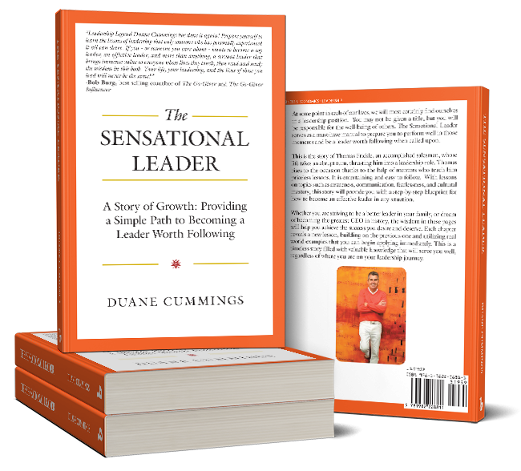
duane@duanecummings.com
404-245-2694
https://www.duanecummings.com
Publisher: Balboa Press https://www.balboapress.com/en/bookstore/bookdetails/793701-the-sensational-leader Review copies available upon request.

To be eligible for this once in a lifetime opportunity, simply buy a copy of the book and send Duane an email confirming the purchase. (Some restrictions apply) The winner will be selected during a live stream event at the end of the summer, using a random generator software program. The trip will be scheduled to accommodate the winner’s schedule.
- ### -

