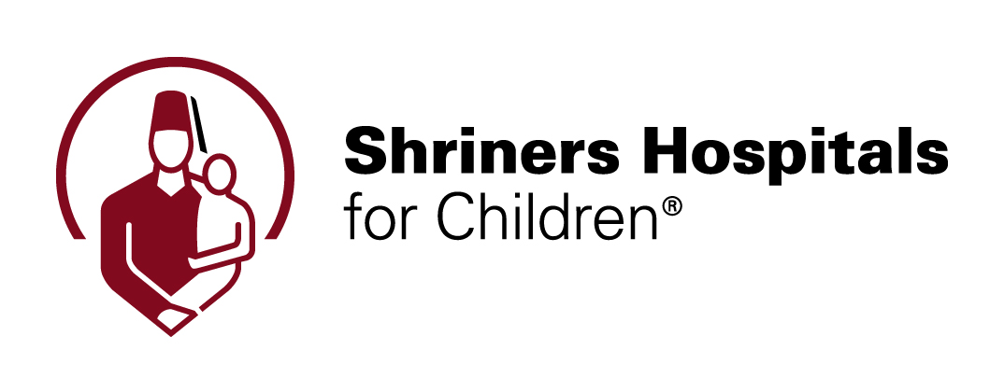

FOR IMMEDIATE RELEASE

Contact:
Mel Bower, Shriners Hospitals for Children
813-233-6836
mbower@shrinenet.org

New medical device for scoliosis treatment approved by FDA

Spinal fusion is not the only option; anterior vertebral body tethering (VBT) is an innovative surgical procedure for some young teens coping with scoliosis

PHILADELPHIA (August 16, 2019) – A new medical device for treating scoliosis, curvature of the spine, has received FDA approval, providing an alternative that both corrects the curve and maintains flexibility in the spine.

The FDA’s clearance is for The Tether™, which uses patented methods and techniques developed by medical staff of Shriners Hospitals for Children®— Philadelphia. It is the first commercially available product used specifically for VBT, anterior vertebral body tethering, a surgical procedure for patients with scoliosis who meet very specific criteria. VBT is an alternative to spinal fusion procedures.

Children worldwide are affected by scoliosis, and Shriners Hospitals for Children — Philadelphia has an extensive scoliosis program designed to treat all forms of the condition, using every non-surgical and surgical option available.

Since 2011, the Philadelphia Shriners Hospitals for Children has offered VBT as an option for patients who meet specific criteria. VBT is a promising alternative for certain patients with scoliosis who are still growing and for whom surgery is indicated.

How it works
Instead of using metal rods, VBT uses a strong, flexible cord to gently pull on the outside of a scoliosis curve to straighten the spine. A screw is placed in each vertebra of the curve and then attached to the flexible cord with the spine in a straighter position. Scoliosis progression is stopped, the spine is realigned and can continue to grow, and flexibility is maintained. As the child grows, it is anticipated that curve progression will be halted and the spine will remain straight.

The Tether straightens the spine using the patient’s growth process. The pressure from the cord slows the growth on the tall side of the vertebra, so that the short side can grow and catch up. This novel technology allows for both correction and continued motion at the levels of the spine treated, unlike fusion surgeries. As an emerging treatment for a small patient population, this system is being made available through the FDA’s humanitarian device exemption (HDE) pathway.

Innovative approach
The Philadelphia Shriners Hospitals for Children medical staff developed the methods and techniques underlying VBT and has worked closely with the FDA and industry partners to bring this product to approval, demonstrating our commitment to transforming the lives of children.

“The ability to utilize a child’s growth to correct the curve in their back is a leap in the way these children are treated – properly selected patients can achieve curve correction while maintaining mobility,” said Amer Samdani, chief of surgery, Shriners Hospitals for Children — Philadelphia.

Customized treatment
Whether a child has common idiopathic adolescent scoliosis or a highly complex spine deformity, they deserve an individualized treatment plan utilizing the most advanced and innovative techniques. The spine team at the Philadelphia Shriners Hospital takes a fully integrated team approach to the treatment of pediatric spine conditions, with a focus on early detection and fusionless treatments for the growing spine, as well as offering minimally invasive and advanced surgical techniques for those children who require spinal fusions.

Shriners Hospitals for Children is committed to offering our patients high quality, compassionate care and the most innovative treatment options in order for them to have the best chance for full recovery and the ability to pursue their dreams.

About Shriners Hospitals for Children
Shriners Hospitals for Children improves the lives of children by providing pediatric specialty care, conducting innovative research, and offering outstanding educational programs for medical professionals. Children with orthopaedic conditions, burns, spinal cord injuries, and cleft lip and palate are eligible for care, regardless of the families’ ability to pay, and receive all care and services in a compassionate, family-centered environment. For more information, please visit shrinershospitalsforchildren.org.

Fast facts: Scoliosis
The key in all care and treatments of scoliosis is prevention; the earlier detection happens in children and adolescents, the better possible outcomes.

There are many types of scoliosis:
- Neuromuscular scoliosis, related to underlying conditions affecting the nerves, including cerebral palsy and spina bifida.
- Scoliosis associated with a syndrome or other condition such as Marfan syndrome
- Congenital scoliosis, associated with malformed vertebra (bones in the spine) and/or ribs
- Idiopathic scoliosis, not related to another condition

About Anterior Vertebral Body Tethering
- 450 VBT procedures have been completed at the Philadelphia Shriners Hospital since 2011.
- As with all medical care and procedures, results differ based on individual patients.
- Patients who opt for the tethering procedure can return to their routine activities, including sports, after about one month. In comparison, after a spinal fusion, it can take six months to a year to reach that point.
- Tethering may be an option for adolescent patients with scoliosis for whom wearing a brace is difficult for physical and/or psychosocial reasons.

Media Assets:
- Interview with Dr. Samdani
https://shriners.vids.io/videos/489ddab91214e3cdc0/dr-samdani-vt-fda-mp4
- Two clips with patient reviewing x-ray and post-operative results https://shriners.vids.io/videos/a09ddab91215ebc628/vt-fda-broll-mp4

XXX

