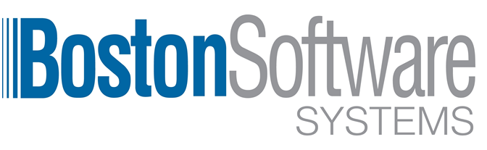
FOR IMMEDIATE RELEASE August 9, 2019

Boston Software Systems Bridges the Digital Divide Between Legacy EMR and Cerner Millennium

Complete Patient Appointment Data on Day One of Go-Live in Cerner

Boston, Massachusetts:
Boston Software Systems announces appointment migration success at Philadelphia’s largest independent academic medical center. With the addition of our technology and expertise, Einstein Medical Center was able to optimize their migration of appointment data within time and budgetary constraints, bridging any technology gaps and eliminating months of administrative data burden.

For a myriad of reasons, appointment data rarely makes the trip from legacy platforms to new EHR systems unscathed. Critical patient details are often missed, resulting in disruption of clinical and administrative processes.

EHR Migration Success with Intelligent Automation of Appointment Data

The Problem:
The facility had recently implemented a new Cerner Millennium EHR. They had tens of thousands of patient appointments that could not be migrated to the new system quickly and accurately. They requested a complete, repeatable solution that required minimal human intervention. This was a matter of not only moving the data to Cerner, but of reconciling the data to be sure the process included data validation. The inability to migrate over appointments and registrations in time for the scheduled Go Live, posed a problem to the entire healthcare organization, impeding workflow, administrative process and efficiency.

The Goals:
- Migrate accurate and complete appointment data from the legacy EMR to Cerner Millennium.
- Create a clean, consistent process, to improve efficiency and lower cost for future clinics and provider offices as they transition from multiple legacy EMRs.
- Lower technical complexity and reduce the administrative burden of manually entering hundreds of appointments, requiring months of manual data entry and impeding operational success.
- Complete the migration outside of normal business hours, without impacting clinical workflow. Crosswalk and match the old appointment types to the new appointments, adjusting times or dates when necessary.

The Results:
- Patient appointment and registration data was available on day one of Go Live.
- Thousands of hours in manual data entry and administrative time were eliminated.
- Accurate appointment data from day one reduced roadblocks, accelerated usability, and aligned to workflow in the hospital, health system, and across provider locations.
- This project of loading the appointments was complete in only hours, starting on Friday evening and completed by Sunday, with a highly repeatable process used across all locations of care.

About Boston Software Systems
Founded in 1985, Boston Software Systems is the worldwide leader in machine learning and healthcare automation. With an exclusive focus in healthcare, expert knowledge of HIPAA, PHI and security regulations, and entirely US-based support, Boston Software Systems accelerates the performance of data, eliminates technical complexity, cuts cost, and improves workflow for the entire healthcare ecosystem.

Press Inquiries:
Contact: Matt Hawkins
Phone: 866-653-5105
Email: marketing@bossoft.com
Website: https://www.bostonsoftwaresystems.com/

