FOR IMMEDIATE RELEASE
Contact:
Katie Jackson
Marketing Manager, Symmetry Software
katie@symmetry.com
480.596.1500

Symmetry Software Celebrates National Payroll Week by Offering Free Paycheck Calculators and Tips for Better Understanding Your Paycheck
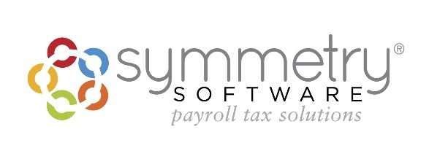
Scottsdale, AZ August 28, 2019 - Symmetry Software, specialists in payroll tax withholding software that determines the correct amount of tax to withhold from a paycheck, is celebrating the contributions of American workers and payroll professionals during National Payroll Week, which runs annually the week of Labor Day.

The American Payroll Association and its more than 20,000 members have launched a nationwide public awareness campaign that pays tribute to the nearly 150 million people who work in the United States and the payroll professionals who support the American system by paying wages, reporting worker earnings, and withholding federal employment taxes.

Labor Day is dedicated to the social and economic achievements of American workers. It’s a yearly national tribute to the contribution workers make to the strength, prosperity, and well-being of our country. This national day of recognition is often celebrated with an annual event like a party or a weekend get-away. Symmetry Software wants to help create a new ritual to add to this day of dedication - honoring your own personal prosperity and well-being by reviewing your paystub. The perfect opportunity to create a yearly ritual that will ensure you are getting the most out of your paycheck.

By going to PaycheckCity.com, you can use one of 17 calculators to help set the proper withholdings and deductions for your personal financial goals. These calculators are free and easy to use. Prepared with your most recent paystub, you can evaluate and model several different “what if” scenarios to better manage the money you work so hard to earn.

A study conducted by the Workforce Institute at Kronos reveals almost 64 million Americans say their paystub is hard to read. 42% of all employees say taxes and deductions on their paycheck are confusing to read and understand.

A general understanding of your pay stub will go far to help you when doing a paycheck check-up. Below are the most common terms you’ll find:
- Rate: If paid hourly, the hourly rate you are paid.
- Hours: If paid hourly, the number of hours you are being paid for work in this pay period.
- This Period: How much you were paid in this current pay period.
- Year-to-Date: How much you have earned this year.
- Gross Pay: The total amount you earned before any deductions/allowances (which, as you’ll learn below, are based on the W-4).
- Net Pay: The total amount you earned after deductions. This is the amount you go home with.
Other terms you’ll see on a pay stub (which are determined based on where you live) include federal, state, and local taxes, Social Security and Medicare taxes. However, if you live in one of these seven states, you can avoid paying state income tax — Alaska, Florida, Nevada, New Hampshire, South Dakota, Tennessee, Texas, Washington, and Wyoming. Here’s a breakdown of the payroll taxes:
- Federal income tax withholding, based on your W-4, and the withholding tables in Publication 15 from the IRS.
- The Federal Insurance Contributions Act Tax (FICA), which includes Social Security and Medicare.
  - Social Security – Employees and employers both pay 6.2%. If you’re self-employed, you must pay both, for a combined total of 12.4%.
  - Medicare – Employees and employers both pay 1.45%. Again, if you’re self-employed, you’ll have to pay both the employee and employer tax.
- State income tax withholding – This changes based on where you live and work
- Local tax withholding – Also changes based on where you live and work. States like Ohio, Pennsylvania, and Kentucky all have intricate local taxes. Pennsylvania taxes all the way down to your school district.
"Knowledge is power," said Dan Maddux, executive director of the American Payroll Association." Through far-reaching education initiatives, we can empower our current and future workforce to make smart decisions with their paychecks and how they're paid."
However you choose to enjoy Labor Day this year, consider incorporating this annual ritual into your routine. Finding the best way to manage your paycheck can maximize your take-home pay. Now that’s something to celebrate!
To learn more about maximizing paychecks, visit PaycheckCity.com.
To learn more about National Payroll Week, visit NationalPayrollWeek.com
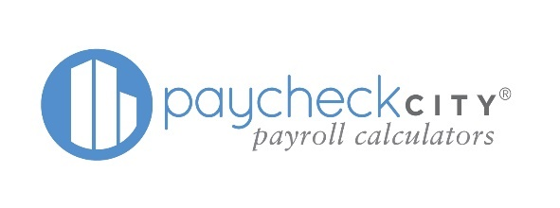
About Symmetry Software
Symmetry Software simplifies the payroll process with our dependable and accurate payroll withholding tax solutions. Our team of software engineers and taxation experts provide innovative, regulatory compliant payroll software products including the Symmetry Tax Engine2®, Symmetry Payroll FormsTM, Payroll Point®, and PaycheckCity® calculators. Since 1984, Symmetry Software has been helping clients get the right taxes, the first time.

###

