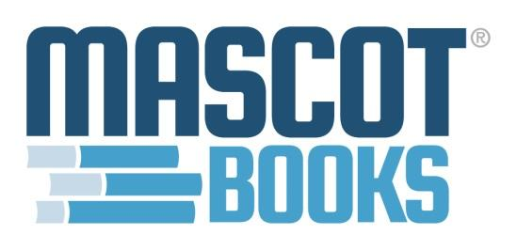

FOR IMMEDIATE RELEASE:

Mascot Books Publishes Honest Support Guide for Cancer Patients
Voices of Cancer by Lynda Wolters
Herndon, VA; October 1, 2019: Mascot Books announces the release of Voices of Cancer: What It’s Really Like, What We Really Need by Lynda Wolters.
"I don't know what to say" and "I don't know what to do" are common responses to a life-threatening diagnosis.
Voices of Cancer is here to help.

Every cancer story is different, but there is one commonality: both patients and the people supporting them often struggle to properly articulate their wants and needs through particularly challenging—and in many cases, uncharted—territory. Lynda Wolters knows firsthand: she was diagnosed with stage 4 terminal mantle cell lymphoma in August of 2016.

Voices of Cancer offers a candid look into the world of a cancer patient, informed by Lynda’s own story and conversations had with dozens of patients weighing in on their needs, wants, and dislikes as they navigate the complex world of diagnosis, treatment, and beyond. With comprehensive and accessible insight from people who have been there, Voices of Cancer helps educate, dispel fears, and start positive conversations about what a cancer diagnosis truly means, while shining a light on how best to support a loved one on their own terms.

A portion of the proceeds from this book will be donated to Epic Experience, a nonprofit, fully donation-run camp helping adult cancer survivors and thrivers learn to live beyond cancer. To learn more about Epic Experience and to donate directly, please visit epicexperience.org.

To learn more about Lynda Wolters and her personal cancer journey, visit: voicesbookseries.com

To set up an interview, reading, signing, or for information regarding Voices of Cancer: What It’s Really Like, What We Really Need, please contact Chris Baker at chris@mascotbooks.com.

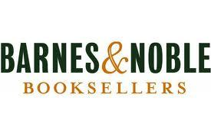
Voices of Cancer: What It’s Really Like, What We Really Need is registered with the American Wholesale Book Company, Baker & Taylor, Follett Library Resources, and Ingram, and available online with the following retailers:
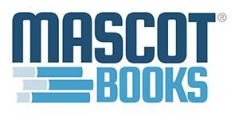

About Mascot Books
Mascot Books is a full-service, multi-genre, hybrid book publisher and distributor headquartered in Herndon, Virginia. Co-founded in 2003 by Naren Aryal, Mascot has published more than 2,500 books in a variety of genres, including fiction, nonfiction, children's, cookbooks, and coffee table books. Learn more at www.mascotbooks.com.

