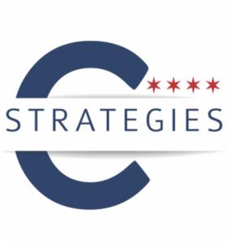
FOR IMMEDIATE RELEASE
Monday, September 16, 2019

CONTACT
Isabelle Stafford
isabelle@cstrategies.com
720-854-5929

C-Strategies Welcomes Marisa Kollias as Senior Director of Communications
Industry veteran Marisa Kollias joins Chicago-based C-Strategies

CHICAGO - C-Strategies, a strategic communications and public affairs firm whose leadership has served on the front lines of major public policy and political campaigns in Chicago and Illinois for nearly two decades, announced today that Marisa Kollias has joined the firm as its senior director of communications.

“We are thrilled to have Marisa join our team,” said Becky Carroll, President and CEO, C-Strategies. “Her considerable experience and track record of executing successful communications campaigns will be a valuable asset to each of our clients as we continue to grow our firm.”

Marisa is an 18-year veteran communications strategist and former Chicagoland television journalist. Prior to joining C-Strategies, she led high-profile public communications campaigns and strategies to develop and amplify new initiatives on transportation, higher education, trauma, medicaid expansion, the Affordable Care Act, and other public policy issues. Marisa has spent nearly 10 years in the public sector both at the State of Illinois and at the Cook County Health System. She served as Vice President of Corporate Communications at Tribune Publishing, and most recently consulted on Mayor Lori Lightfoot's transition team.

“I am so honored to join team C-Strategies,” said Marisa Kollias. “I am looking forward to being part of a firm known for elevating important public policy issues facing our city and state, while empowering and lifting up women in the business and civic spaces.”

Marisa is a born and raised Chicagoan who graduated with honors from Columbia College Chicago. She has served on boards that promote early childhood and elementary education and resides in Lakeview with her husband and two daughters who attend Chicago Public Schools.

About C-Strategies
C-Strategies is a strategic communications and public affairs firm whose leadership has served on the front lines of major public policy and political campaigns in Chicago and Illinois for nearly two decades. Employing results-driven tactics and utilizing its networks to build strategic plans, guide public opinion and manage through crisis, C-Strategies brings passion and veteran experience to help clients meet their business goals, turn big ideas into action and simply get things done. Learn more at http://cstrategies.com/

