FOR IMMEDIATE RELEASE
MEDIA CONTACT: Jodi Dart
Phone: (217) 306-5823
E-mail: jodi@prescriptionjustice.org

PRESCRIPTION JUSTICE ANNOUNCES NEW REPORT CARD
FOR SENATORS ON PRESCRIPTION DRUG PRICES
Non-Partisan Group Offers First of Its Kind Report Card
To Help Evaluate Congresspersons' Records
October 17, 2019 - Prescription Justice, a non-partisan nonprofit organization dedicated to lowering drug prices in America, has published a Congressional report card on drug prices. This first of its kind Congressional report card on drug prices can help voters and political organizations determine who they want to support in upcoming elections.
The report card evaluates the voting records and actions of 91 U.S. senators who were in office at the end of the last Congress. The grades are accessible on the organization's website at PrescriptionJustice.org. Grades on all senators from the current Congress and members of the House of Representatives are forthcoming next year.
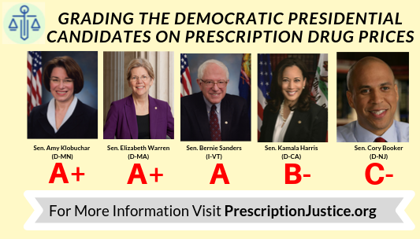
"High drug prices are a public health crisis in our country," said Prescription Justice founder Gabriel Levitt. "Tens of millions of Americans are suffering health consequences, and in too many cases, such as with insulin, are dying because they can't afford their prescribed medications. Citizens deserve to know whether their elected officials are working to solve the problem, and our new report card will help them find out."
Other report cards are often based on a series of votes taken in Congress. However, votes on drug prices have been virtually non-existent because the pharmaceutical industry lobby has been effective in stopping legislation from coming to the floor.
In the absence of extensive voting records, Prescription Justice's grading methodology employs a multidimensional assessment of actions on drug pricing issues and influence by pharmaceutical companies. The variables are: 1) Sponsorship of drug price bills, 2) The few relevant votes on the subject of drug prices, 3) Statements on Congressional websites in support of lowering drug prices, and 4) Campaign contributions from pharmaceutical companies.
Overall, about eighty percent of Americans believe drug prices are unreasonable. Unlike on other issues where voters split along ideological lines, Democrat and Republican voters agree on the scope of the prescription drug pricing problem and on significant policy initiatives to address it. Ninety percent of Democrats and 80% of Republican voters want to empower Medicare to negotiate drug prices.
Members of Congress can raise their grades or get a head start on new grades coming out in the Spring of 2020 by filling out the Prescription Justice questionnaire and go on the record on the organization's policy platform.
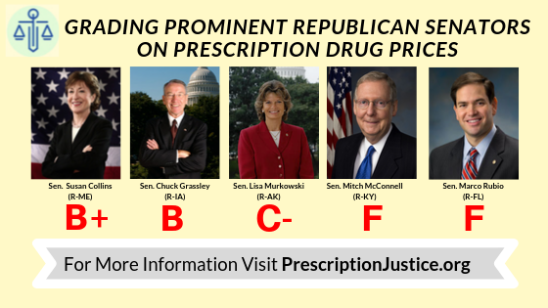
"Politicians who want to take a stand on drug prices can fill out the Prescription Justice questionnaire," said Jodi Dart, Executive Director of Prescription Justice. "For each yes answer they give, they are awarded 3 points toward a new or higher grade. As a long-time Republican voter, I would like to see members of my party begin to move on this issue and give their voters the relief on drug prices."
About Prescription Justice
Prescription Justice, a 501c4 nonprofit organization, is dedicated to ending the crisis of high drug prices in America. Bringing together doctors, lawyers, public health and consumer advocates, and concerned citizens from across party lines, Prescription Justice advocates for serious regulatory and legislative reforms that will substantially lower the cost of prescription drugs for all Americans and expand access to lower-cost medication from abroad. Learn more at: https://prescriptionjustice.org/
Link to Video: https://www.youtube.com/watch?v=Q2ZilgMfGZo

