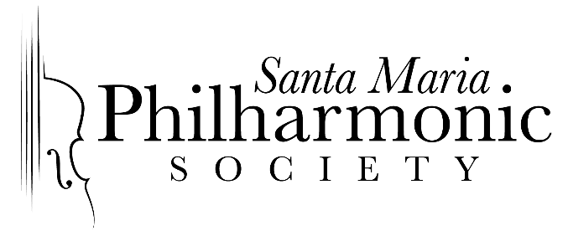

December 2019
FOR IMMEDIATE RELEASE
Contact: Megan DeCicco, Community Ambassador
megan@solutionson2nd.com
805-325.9747

Santa Maria Philharmonic Presents Free Family Concert Next Month

Don’t miss the Santa Maria Philharmonic’s presentation of their popular concert "Fly Me to the Moon: From JS Bach to Mr. Spock." Under the direction of Maestro Michael Nowak, this free concert for the whole family will be presented on Sunday, January 26, 2020 at 4PM at the Pacific Christian Center in Santa Maria.

This is the first ever presentation of this popular concert for a wider audience. The concert is presented as part of the Santa Maria Philharmonic Society’s educational programming for 4th grade students in the Santa Maria Valley each year, to introduce them to the wonderful world of live orchestral music. The widespread popularity of the program - which includes a multimedia presentation, light show and live music performed by the Santa Maria Philharmonic and guest artists - prompted this additional Family Concert for the season. “We’re grateful to some very generous donors who’ve made the additional performance possible,” said Fran Saveriano, Executive Director, Santa Maria Philharmonic. “We’re very happy to be able to present it free of charge to residents and visitors alike in the Northern Santa Barbara County community.”

Maestro Nowak, co-creator of this project with his wife, Suzette Harbour, says, “This program is designed to captivate the imagination and creative spirit in all of us as we journey from our world out into the far regions of the universe. By blending extraordinary visuals with the world's greatest music, we guarantee an experience that is truly "out of this world".

Bring your friends, family and kids to this wonderful afternoon of live music and out of this world visual delight! For more information visit: smphilharmonic.org.

###

For the past 10 years, the Santa Maria Philharmonic Society has been presenting children’s concerts to thousands of fourth graders throughout the Santa Maria Valley as part of our educational outreach to the community.

The Santa Maria Philharmonic Society provides fine live classical listening experiences for all audiences with the public concerts in its subscription season, and helps fill the void of arts education in our schools by providing unique musical opportunities for children in our valley.

To learn more about our programs and to contribute, visit our website https://smphilharmonic.org/.

