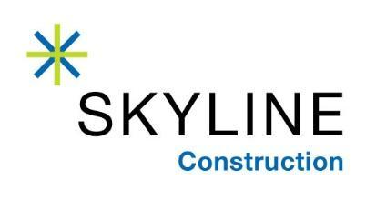

FOR IMMEDIATE RELEASE
December 18, 2019

SKYLINE CONSTRUCTION HIRES NICK ANDREOLAS
AS VICE PRESIDENT, CORPORATE CONTROLLER

Chicago, IL – 100% employee owned general contractor Skyline Construction is pleased to announce that Nick Andreolas is joining as Vice President, Corporate Controller. Andreolas brings 25 years of financial operations experience to his position. He will oversee the Finance and Accounting functions for Skyline’s Family of Companies nationally, including ACCEND Construction in Chicago, Skyline Construction and Skyline Capital Builders in the Bay Area.

Andreolas is a well-known corporate finance executive and CPA / MBA who has built, led, and advised corporations across Chicagoland. He brings more than two decades of progressive experience in finance and operations management within construction, manufacturing, environmental services, food and beverage and technology organizations ranging from $20m to $2b in revenues. Andreolas has proven expertise in connecting operational activities to financial implications and streamlining business operations that drive growth, increase efficiency and improve the bottom-line. He has strong qualifications in implementing financial controls and fostering change management strategies.

Andreolas possess solid leadership, communication and interpersonal skills. He is an analytical and detail-oriented team leader, who coordinates business planning, administrative functions, accounting and budgeting efforts. Andreolas has contributed directly to improved financial performance, heightened productivity, and enhanced internal controls for his former employers, including Coca-Cola, Pepsi, Severn Trent Services, Softer Lite Window Company, Nokia, Ecker Enterprises, Novak Construction, Hard Surface Solutions, Balanced Environments, and Loberg Construction.

“I am pleased to welcome Nick Andreolas to Skyline’s corporate leadership team,” said Jessica Carps, CFO of Skyline Construction. “Nick joins us during an exciting period of growth and brings tremendous construction accounting and finance experience to the organization. Based in Chicago, he will split his time between California and Chicago as he helps expand the Family of Companies into a national commercial construction platform. I look forward to the continued synergy between the Bay Area and Chicago teams through the strategic hiring of Nick.”

About Skyline Construction
An award-winning, general contractor in the Bay Area, Skyline Construction is known for specializing in corporate interiors and delivering the highest level of client service. Skyline is one of the very few general contractors to be 100% employee owned through an Employee Stock Ownership Plan (ESOP). In 2019, Skyline expanded into both new markets and sectors of the industry with the opening of two subsidiaries: ACCEND Construction LLC in Chicago and Skyline Capital Builders LLC in the Bay Area. The Skyline family of companies is just getting started and plans for future expansion into many major US cities over the next 10 years. For more information, visit http://www.skylineconstruction.build/.

