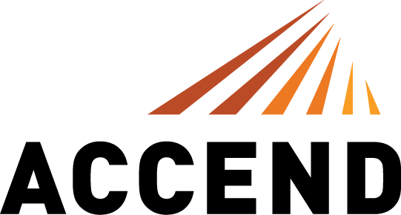

FOR IMMEDIATE RELEASE
Thursday, January 9, 2020

CONTACT
Caroline Wellford
caroline@cstrategies.com
901-216-7657

ACCEND CONSTRUCTION WELCOMES JIM SMILEY AS SENIOR PROJECT MANAGER
Chicago construction veteran joins ACCEND’s rapidly-growing team

Chicago, IL – 100% employee owned general contractor ACCEND Construction is pleased to announce that Jim Smiley is joining the firm as Senior Project Manager. An industry veteran with over 25 years in the field, Smiley will lead ACCEND’s construction projects, ensuring the on-time and quality completion of all projects for clients.

“I am pumped that Jim Smiley is joining our team,” said Andy MacGregor, President and CEO of ACCEND. “Jim’s relationships, reputation for true excellence and 25 years of Chicago construction experience will make a huge impact on our projects, clients and team as we scale. I’m happy and flattered that Jim chose to join us so he can thrive, grow and be an employee-owner.”

Smiley will build upon his previous experience as a Senior Project Manager to build teams, problem solve, and ensure that project delivery is consistently flawless. Smiley is an accomplished and revered leader in the Chicago construction market, having led projects for Google, Vital Proteins, Google Cloud, and Brookfield Properties (Formally GGP).

ACCEND Construction LLC opened its doors for business in February 2019. By utilizing an Employee Stock Ownership Plan (ESOP), ACCEND is one of the very few general contractors in the nation to offer every single employee the opportunity to be an owner. For more information, visit http://www.accendconstruction.com.

About ACCEND Construction
ACCEND Construction LLC is a general contractor with a fresh philosophy and approach to commercial construction. Led by industry veteran Andy MacGregor, ACCEND is catapulting the industry forward. It brings energy and vigor for full project optimization, streamlined processes, thoughtful ideas and a sincere desire to make the construction experience fun. ACCEND is one of the very few general contractors in Chicago that is 100% employee owned through an Employee Stock Ownership Plan (ESOP). For more information, visit http://www.accendconstruction.com.

