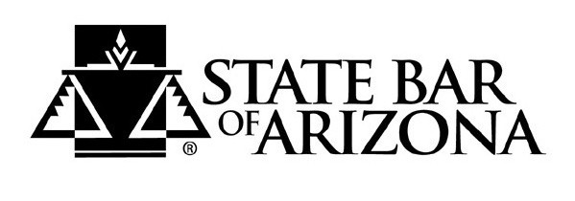

FOR IMMEDIATE RELEASE: Jan. 8, 2020
Contact: Lisa Bormaster Fontes, Advertising Manager
Phone: 602-340-7230
Email: lisa.bormaster@staff.azbar.org

Exhibitor Space Now Available - 2020 State Bar of Arizona Convention
More than 1,200 attorneys expected at Arizona’s largest annual legal event

Tucson– Exhibit spaces are now available for the State Bar of Arizona annual convention June 10-12 2020 at the Westin La Paloma Resort Resort & Spa, Tucson, Arizona. The convention is expected to draw more than 1,200 attorneys.
With an average income of $201,000, Arizona attorneys are an excellent target market for businesses that support the legal profession.
The convention offers opportunities for both sponsorships and exhibit space. Exhibitors who reserve their space prior to Feb.14, receive a complimentary, full-color display ad in the glossy convention magazine mailed to Arizona’s 23,500 attorneys. The 2020 convention features luncheons and evening networking events where vendors can mingle with attorneys. Every exhibitor receives complimentary tickets to these events.
Booth spaces are assigned on a first-sold, first-served basis. For more information on exhibit space and sponsorships for the 2020 convention, please contact Advertising Manager Lisa Bormaster Fontes at 602-340-7230 or lisa.bormaster@staff.azbar.org.
Learn more about advertising opportunities with the State Bar of Arizona by clicking here.
About the State Bar of Arizona
The State Bar of Arizona is a non-profit organization that operates under the supervision of the Arizona Supreme Court. The Bar includes approximately 24,000 attorneys and provides education and development programs for the legal profession and the public. Since 1933 the Bar and its members have been committed to serving the public by making sure the voices of all people in Arizona are heard in our justice system.

# # #

