P R E S S R E L E A S E

FOR IMMEDIATE RELEASE
Contact:

The LaunchPort
Robert Storey, Managing Partner, 443-994-2241 bstorey@mvrco.com

Engineered Medical Systems and The LaunchPort™ Partner with Longeviti Neuro Solutions

Partnership Brings New Sterilization Development Capability to

Baltimore Area Medical Device Developers

Baltimore, MD – January 13, 2020 – Engineered Medical Systems, Longeviti Neuro Solutions and The LaunchPort™ announced today that they have entered into an agreement to place new, low temperature, low toxicity hydrogen peroxide sterilization capacity at The LaunchPort™/EMS facility in Port Covington. The systems are being procured by Longeviti to support the Maryland production of their Low-profile Intracranial Devices (L.I.D.) platform. The Longeviti L.I.D. Platform has led to several innovative FDA cleared products thus far, the ClearFit and InvisiShunt, and more are in development. The systems will be operated by Engineered Medical Systems within EMS’s regulated medical manufacturing facility at LaunchPort™. These new systems are expected to have completed initial validations by the end of Q1 2020.

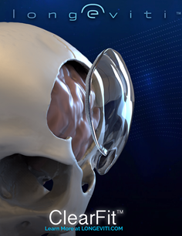
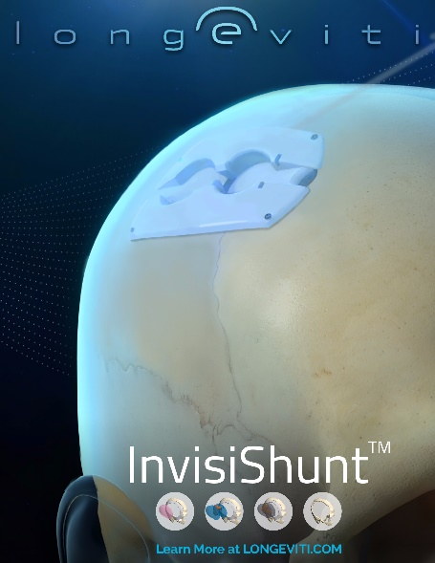

At the same time, Longeviti will become an addition to the LaunchPort™ Resident family and will open a development office within LaunchPort’s expanded medical device engineering area. That move-in is also slated to be completed in the 1Q of 2020.

Beyond Longeviti’s requirements, the excess sterilization capacity will be used to support the needs of LaunchPort’s current and future medical device residents, as well as other regional corporate and institutional developers along the I-95 corridor. Parties interested in exploring the use of this new capacity should contact Robert Storey, LaunchPort Managing Partner, at bstorey@mvrco.com.

About Longeviti Neuro Solutions (Hunt Valley, MD)
Longeviti is a neurotechnology company with a focus on surgical solutions for complex brain surgeries. The company manufactures and distributes neurosurgical implants globally with headquarters located in Hunt Valley, MD. Longeviti was founded in 2016 by a team of leading medical device industry executives, neurosurgeons, and biomedical engineers. Longeviti’s areas of expertise and continued focus include functional neurosurgery, neuro reconstruction, neuromodulation, and neuroplastic surgery.

About Engineered Medical Systems (Indianapolis, IN; Baltimore, MD; Penang, Malaysia)
Established in 1986, Engineered Medical Systems, does contract manufacturing and private label medical devices for a variety of private and multi-national medical devices manufacturers and distributors. Engineered Medical Systems - Malaysia in Penang, Malaysia was established in 2014 to support international products and markets. All EMS facilities are ISO-13485 certified facilities.
A sister company of EMS, Pulmodyne, Inc., develops, markets and sells a proprietary line of products in the Critical Care, Airway Management and Emergency markets, with a worldwide sales network of over 70 global distributors and 15 domestic distributors.

About The LaunchPort™ (Port Covington, Baltimore, MD)
The LaunchPort™ is a manufacturing accelerator that allows Medtech start-ups and emerging technology developers the ability to co-locate at an experienced, regulated manufacturing center. Located at the “City Garage” in Baltimore’s Port Covington, it is in close proximity to two of the Country’s premier medical schools (Johns Hopkins and University of Maryland) and at the center of the Nation’s largest urban investment project.
###

