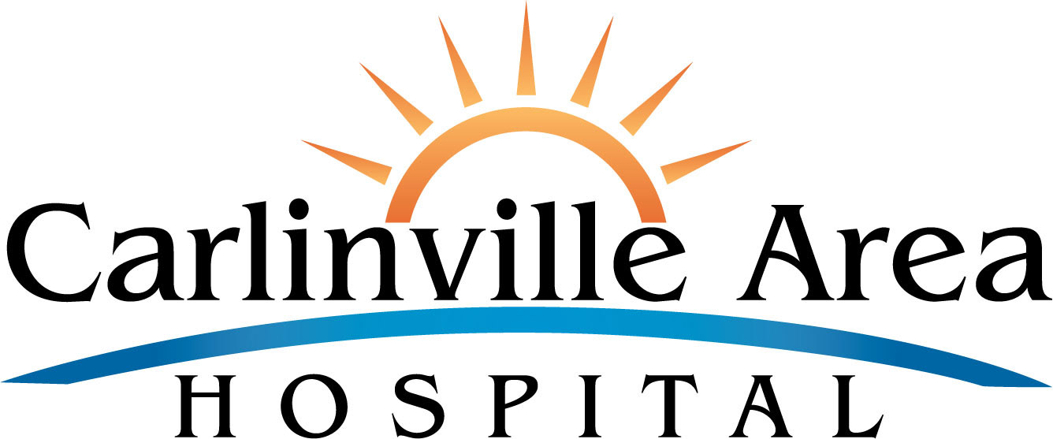
NEWS RELEASE
Marketing and Community Outreach | 20733 North Broad | Carlinville, IL 62626 | 217-854-3141 X264

CONTACT: Melissa Fernandez

Carlinville Area Hospital President/CEO Retirement Announced

HealthTechS3 and the Board of Directors of Carlinville Area Hospital announce the retirement of Ken Reid as CEO on January 31, 2020. Ken has served this community admirably for the past 14 years as the CEO at Carlinville. During his tenure, Ken oversaw the expansion and development of the Carlinville campus, the growth of the rural health clinics in Carlinville and Girard, the recruitment of excellent physicians and advanced practice nurses and financial stability for the hospital.
J. Richard Schien, Board Chair at Carlinville, said “Carlinville Area Hospital had the good fortune to find a highly qualified healthcare professional as our Chief Executive Officer for the past several years who also happened to grow up in Carlinville. Ken was already well respected as a healthcare executive with Springfield Clinic before he accepted the role of CEO at Carlinville Area Hospital. Ken’s leadership skills were front and center as the decision was made to build a new hospital and then only a few years later to add a medical office building attached to the hospital. His leadership allowed us to secure favorable financing for the facility projects while also adding new services such as the recently added MRI suite.”
Neil Todhunter, President of HealthTechS3, commented that “working with Ken over recent years has been a privilege and an honor. Ken never fails to treat people with dignity, thoughtfulness, and respect. His work at Carlinville, in the community and with the Illinois Critical Access Hospital Network, was terrific. We will miss him. Ken, and his wife Connie, are looking forward to completing a variety of projects, spending time with family, and enjoying some well-deserved time off. Please join us in thanking him for many years of great service!”
HealthTechS3 is searching for a permanent replacement CEO. Michael Layfield will arrive on January 27, 2020 to serve as the interim CEO until the search is completed. Michael is a seasoned Hospital CEO with over 35 years in the Health Care Industry. He has worked in both for-profit and not-for-profit hospitals as Regional Vice-President, CEO, and CFO with a major focus on quality care, patient experience, employee and provider engagement, and financial results. He has spent his last 15 years working in small-town, 25-bed critical access hospitals. The Board and HealthTechS3 welcome him to Carlinville.

