Media Contact:
Rob Kelly, Marketing Communications Manager
+1 (952) 995-8173

FOR IMMEDIATE RELEASE

Nidec Showcases Wide Range of High Efficiency Motor Controls at 2020 AHR Expo

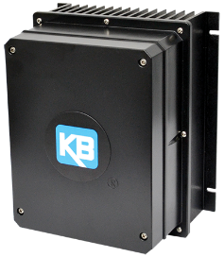
Minneapolis, MN (January 13, 2020) – Nidec Motor Corporation (NMC) continues to expand its motors and controls offerings with a full range of variable speed/high efficiency products to meet HVAC industry demands. Among the exciting new variable speed products to be showcased at the 2020 AHR Expo are:

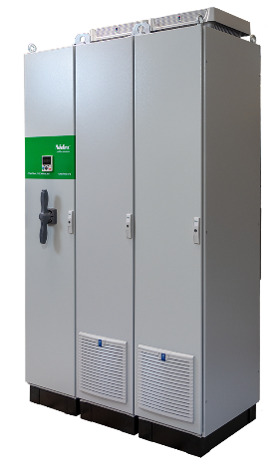
KBVF 4G AC drives –The 4th generation KBVF drives from KB Electronics, a Nidec brand, are the ideal matched control for Nidec’s high efficiency BPM and HVLS motors, providing excellent starting torque, high stability fan control and low noise solutions. Available in IP20 and IP65 standard enclosures, their design versatility provides multiple options to meet performance requirements and cost targets.

DFS Drive Free Standing - For more than 20 years, Control Techniques, a Nidec company, has been providing dedicated VFDs for the HVACR Industry. The new DFS offering incorporates the HVAC H300 building automation drive control in ultra-compact, pre-engineered NEMA enclosures. The DFS packages are available to ship in as little as one day with ratings up to 1,250 HP.

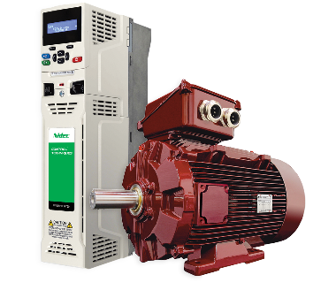
Dyneo Permanent Magnet motors – These Nidec PM motors are available in power ratings up to 500 HP and, when paired with Control Techniques drives, provide highly efficient, compact fan, pump and compressor motor drive solutions. Our Dyneo motors are more efficient than standard AC motors, especially when operated over a wide speed range, and are also smaller and lighter, which makes them easier to transport and install.

ENDS
###

About Nidec Motor Corporation
NMC is a leading manufacturer of commercial, industrial, and appliance motors and controls. The NMC product line features a full line of high efficiency motors, large and small, which serve industrial, residential, and commercial markets in applications ranging from agriculture, water treatment, mining, oil and gas, and power generation to pool and spa motors, air conditioning condensers, rooftop cooling towers, and commercial refrigeration. It also makes motors, controls, and switches for automotive and commercial markets. For more information, visit http://www.nidec-motor.com

Control Techniques, a Nidec Motor Corporation business, is a world leader in the design and production of electronic variable speed drives for the control of electric motors. Founded in 1973, the company has its America headquarters in Minneapolis, MN, USA and global headquarters in Newtown, Wales, UK. It has dedicated production and R&D sites globally, along with Automation Centers in 45 locations around the world. For more information, visit http://www.controltechniques.us/

Parent company Nidec Corporation, headquartered in Kyoto, Japan, is closely associated with approximately 300 group companies all over the world. Nidec is the world's No.1 comprehensive motor manufacturer handling "everything that spins and moves,” miniature to gigantic.

