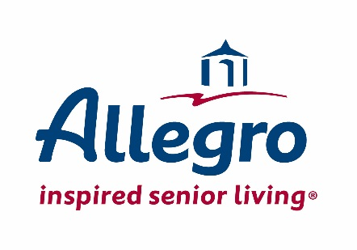
For Immediate Release
For more information, contact:
Mariella Canady
Phone: 314-512-8715
Email: mcanady@allegroliving.com

Allegro Celebrates Topping Out in Harrington Park, New Jersey

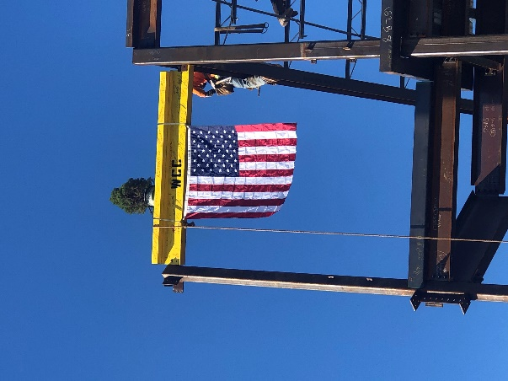
Harrington Park, NJ (January 29, 2020) – Allegro teamed up with Wohlsen Construction and celebrated the topping-out of Allegro in Harrington Park on Friday, January 24, 2020. The Allegro team gathered to watch the final steel beam installation on the forthcoming senior living community. The project picturesque nine-acre site borders the Oradell Reservoir, which will provide residents with
all-inclusive opulent amenities, services and an inspired lifestyle of vibrancy.

Upon its completion, Allegro in Harrington Park will offer 177-units for senior living, including independent living, assisted living and memory care. The community offers resort-style living with luxurious features, attentive personal service, a rich and varied dining culture, and a daily life filled with possibilities and purpose. The community will feature a grand central atrium, bistro, roof pub, indoor pool & hot tub, greenhouse, theater, fitness, spa, salon and penthouse units.

A full-time lifestyle director orchestrates a wide range of lifestyle programming catered to individual and shared experiences that keeps residents actively engaged in their own emotional and physical well-being.

Allegro's development team on this landmark project includes the best-in-class organizations, Wohlsen Construction, and Meyer Design. This community will be Allegro's first senior living community in New Jersey.

More information on the community can be found at www.allegroiscoming.com.

Wohlsen Construction Company, founded in 1890, provides construction management, general contracting and design/build services to clients throughout the Mid-Atlantic and Northeast Regions. As a leading merit-shop firm, Wohlsen provides construction services in the senior living, education, healthcare, and commercial markets, and maintains offices in Parsippany, NJ; Hamden, CT; Lancaster, Harrisburg and Berwyn, PA; Wilmington, DE; Baltimore, MD; and Vienna, VA.

Meyer Design is a national architecture and interior design firm built by relationships across the corporate real estate and senior living industries. With over 40 years in business, Meyer uniquely leads by a long-tenured group of 3 Business Executives and 5 Design Principals whose leadership philosophy is built around the power of people, relationships, and design. As co-founder of ONE Global Design, an alliance of 20 partner firms, together we rank as a Top 10 Design Firm in the country.

About Allegro:
Allegro Senior Living, a St. Louis based company, is a well-respected leader and expert in the senior living industry with a long-standing reputation of efficiently managing senior communities. Allegro inspires with distinctive, people-centered senior living communities that stand out from the rest. Allegro provides seniors with services and amenities to live an inspired life. To learn more about Allegro, visit www.allegroliving.com.

###

