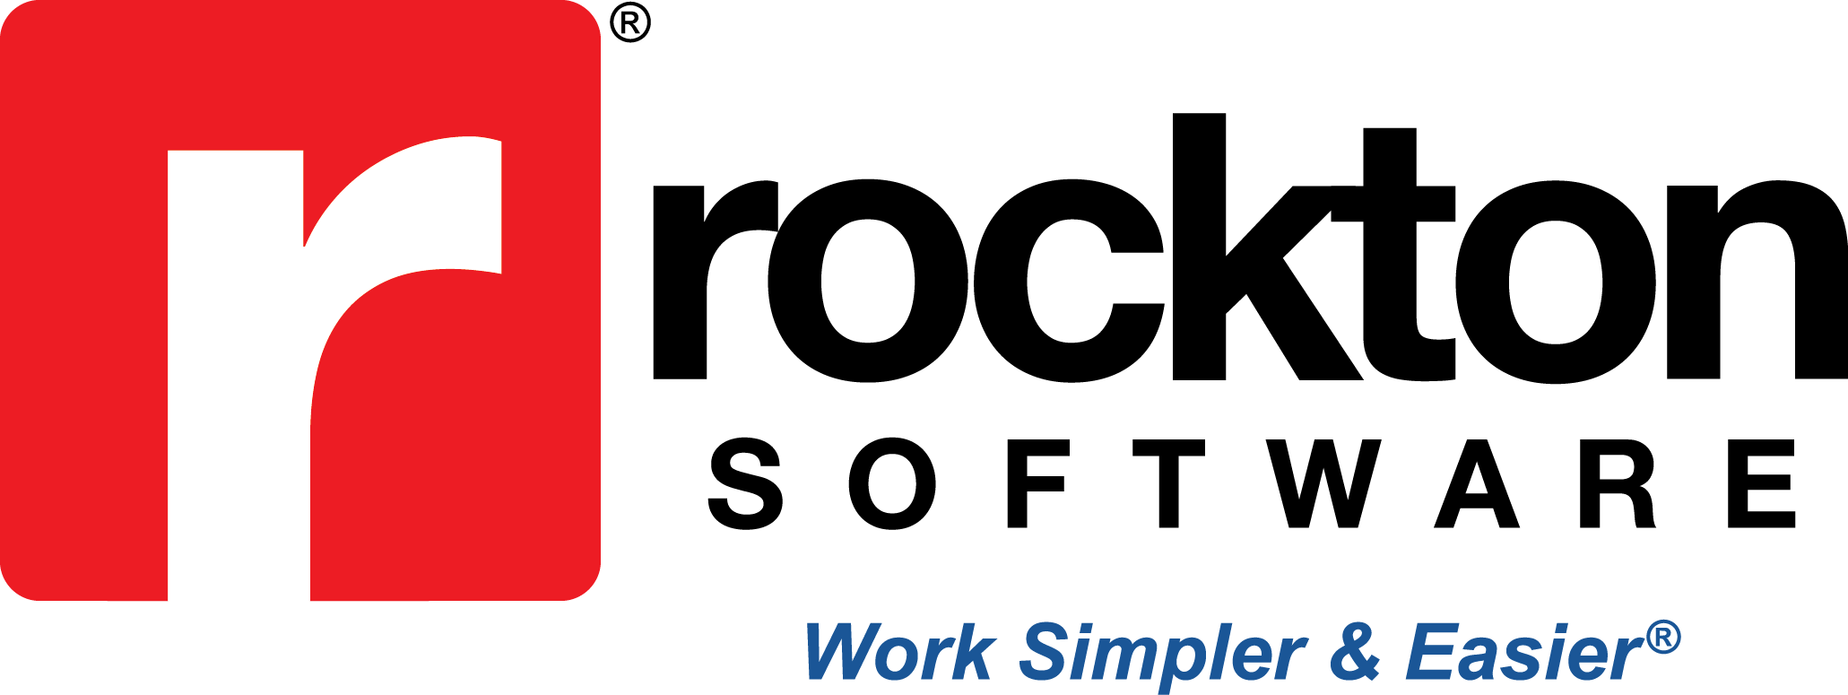
Media contact:
Amiee Keenan, Rockton Software
amieek@rocktonsoftware.com

Rockton Pricing Management Application Certified By Acumatica

The Rockton Pricing Management application is recognized as an “Acumatica-Certified Application” by the Cloud ERP company

Erie, CO — Feb. 10 — Rockton Software today announced that its software has been recognized as an Acumatica-Certified Application (ACA). Acumatica, the world’s fastest-growing cloud ERP company, has been recognized as a Visionary in Gartner’s Magic Quadrant for Cloud Core Financial Management Suites for Midsize, Large and Global Enterprises 2019, as well as in The Gartner Magic Quadrant for Cloud ERP for Product-Centric Midsize Enterprises.

Acumatica is a comprehensive, browser-based Cloud ERP solution optimized for ease of use, adaptability, mobility, speed, and security. The ACA title highlights outstanding development partners whose applications have met the highest standards set for Acumatica integration and functionality.

“Customers who want to stay competitive need flexible, responsive technology to execute their long-term business strategies,” said Christian Lindberg, Vice President of Partner Solutions at Acumatica. “Our ACA label is built to help customers find applications capable of delivering that. We’re proud to recognize Rockton Pricing Management as an Acumatica-Certified Application. It masterfully utilizes the Acumatica platform to meet customers’ growing business demands.”

To become an Acumatica-Certified Application, Rockton Software has demonstrated commitment to quality by passing the Acumatica software test and aligning to future Acumatica roadmap releases.

“We’re honored to receive this kind of recognition from the Acumatica developers themselves,” said Mark Rockwell, Rockton Software. “This is a testament to the strength of our application and the depth of our integration with the Acumatica platform. With our suite of enhancements and Acumatica’s solid foundation, I believe the sky’s the limit for us.”

About Rockton Software
Rockton Software is a virtual company with employees in seven states and its headquarters in Erie, Colorado. Serving over 100,000 users worldwide, Rockton Software supports innovation by offering Microsoft Dynamics and Acumatica add-ons for all industries. Whether you’re in need of auditing, pricing, searching, reporting, or general user enhancements, we’ve got the solution for you! Learn more by visiting, www.rocktonsoftware.com.

About Acumatica
Acumatica provides cloud-based business management software that enables small and mid-size companies to accelerate their businesses. Built on cloud and mobile technology and a unique customer-centric licensing model, Acumatica delivers a suite of fully integrated business management applications, such as Financials, Distribution, CRM, and Project Accounting, on a robust and flexible platform. For more information, visit www.acumatica.com.

###

