FOR IMMEDIATE RELEASE Contact: Albert Garvett, CEO
Company Name: Croxel
Phone: 321-312-1690
Email: contact@croxel.com

CROXEL ANNOUNCES KIOTE/11 FOR RAPID IoT PRODUCT DEVELOPMENT

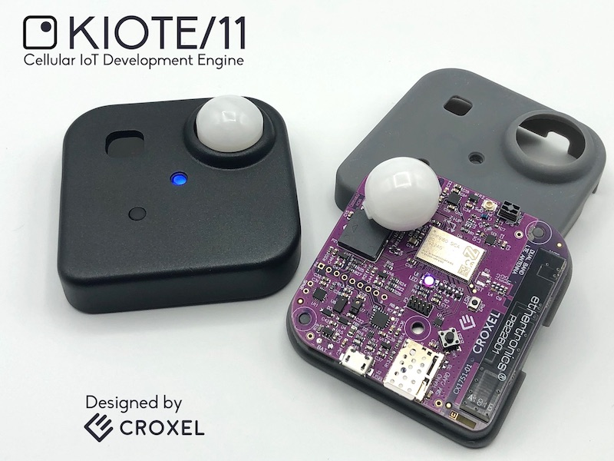

KIOTE/11 is a feature rich, IoT development platform for rapid prototyping

Melbourne, Florida, March 03, 2020 - Croxel announces the KIOTE/11, a low power, cellular IoT development platform containing all key elements for rapid prototyping of IoT products. While KIOTE/11 is feature rich to support a wide variety of applications, Croxel can customize KIOTE/11 to support unique demands.

Albert Garvett, CEO of Croxel says, “We know from experience it can be a real challenge to build applications on many of the platforms available today. We really wanted to develop a multi-tool development engine that allows us with our customers to quickly deploy cellular IoT applications with a full set of on-board sensors; a cloud-based platform for data storage and analytics; mobile and web dashboards; and readily available for monitoring and controlling.”

Croxel designed KIOTE/11 from the ground up leveraging the Nordic Semiconductor highly integrated System-in-Package (SiP) nRF9160 to take advantage of the rapid expansion of LTE Cat M1/NB IoT cellular networks.

KIOTE/11 is a flexible and customizable Cellular IoT platform with integrated GPS tracking capabilities plus extensive sensing features including temperature, humidity and barometric pressure; ambient light intensity and colors; sound level, long range PIR motion; shock and vibration detection; orientation recognition, proximity measurements and magnet detection.

-more-
The Croxel KIOTE/11 hardware features include onboard GPS and LTE-Cat M1/NB IoT antennas; rechargeable battery, USB charging, audio DAC with speaker output; digital microphone, RGB LED, beeper, user button, and a range of expansion interfaces.

KIOTE/11’s cloud based data analytics allows for custom applications of web and mobile dashboards, reporting, and alert notifications.

The KIOTE/11 platform from Croxel comprises all necessary hardware, firmware and software to fast track the most challenging of cellular IoT designs. The versatile platform allows Croxel to customize KIOTE/11 for unique customer applications. Croxel can add or remove sensors; change the board size or shape; support any power source or change its form factor.

Croxel Chief Technology Officer, Chet Neeley adds, “Croxel can help from requirements definition and analysis, through rapid proof of concept development and finally into production. Our in-house firmware, application software, design capture, PCB layout, mechanical design, SMT PCB assembly, 3D printing and 3 axis machining capabilities allow us to quickly execute on a wide range of solutions. We welcome challenges.”

Croxel says it invites enquiries from customers where the KIOTE/11 platform may benefit.

Learn more about KIOTE/11 and view a live dashboard by visiting https://iot.croxel.com/ .

###

Links:

More information on Croxel: www.croxel.com

More information on KIOTE/11: https://iot.croxel.com/

KIOTE/11 images and files for media use:
https://drive.google.com/drive/folders/1LP5I3V2okcuC7dMJWoeCI8G8U3CCIBZ-?usp=sharing

Short Demo Video (1 Min): https://youtu.be/bJxyfPTtYPo

About Croxel: Croxel was founded in 2016. Croxel helps businesses and individuals develop technology products from proof of concept into production stage with fast and agile execution.

