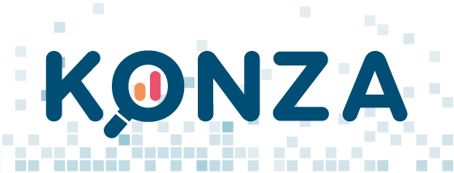

For immediate release. For more information contact: Josh Mosier at jmosier@konza.org

Free access to the KONZA nationwide health information exchange platform to combat COVID-19
4/7/2020
KONZA and The SSI Group announced today that during this unprecedented national emergency, the KONZA health information exchange platform is available at no cost for new members/participants to assist health care providers across the nation in combating COVID-19. KONZA is a nationwide health information network that electronically connects over 10,000 health care organizations to share critical patient medical records.
The KONZA health information exchange provides real-time patient data across facilities and is helpful for accessing patient health histories, including important COVID-19 diagnoses codes and lab data. SSI, which specializes in the aggregation and exchange of clinical data, and KONZA believe this access will assist providers with monitoring patient encounters and allow them to track COVID-19 details for their patients.
Laura McCrary Ed.D, President of KONZA noted that sharing patients’ medical records with their healthcare providers will save lives. “In this time of crisis, traditional physician and patient relationships may not exist. In many cases physicians are caring for patients they do not know, and patients may not be able to provide their full medical histories. KONZA’s longitudinal medical record helps to solve this problem. We are pleased to provide KONZA’s interoperability platform at no cost to healthcare workers fighting the battle to save lives each day.”
The KONZA network includes large health care systems, critical access hospitals, specialty clinics, public health departments, long-term care facilities, behavioral health providers and small rural practices. Many of these facilities are in the hardest hit areas of our country that are providing essential care to patients with COVID-19, including Yale New Haven Health in CT, Ochsner Health in LA, AdventHealth in FL, Ardent Health in NJ and TX, Grady Health in GA and many others through the nationwide eHealth Exchange.
“We are honored to partner with KONZA to provide valuable COVID-19 information to providers in the fight against the virus,” says Diana Allen, SSI CEO. “Healthcare providers are doing everything they can to save lives. Quick access to medical records is critical when time is of the essence, and we are pleased that we can provide our HIE platform to doctors at no cost during this crisis,” she said.
To view all of KONZA’s connections, visit www.konza.org. For more information on how to join the KONZA health information exchange network go to www.konza.org/contact and request an Emergency Participation Agreement and COVID 19 educational videos.

About KONZA: KONZA is a nationwide health information network created to allow connected physicians, health information exchanges, healthcare facilities, and other healthcare providers to share patient healthcare information. KONZA works directly with state medical societies to support their health information exchange efforts. These include, NJ, CT, GA, SC, LA, MO and KS. In additional to health information exchange KONZA participants have access to powerful analytics reports designed to help improve patient encounters and clinical outcomes while also empowering physicians as they transition to the new alternative payment models involving quality reporting, advancing care information, clinical practice improvements and resource use.
About The SSI Group: The SSI Group, a leader in financial performance solutions for providers and payers, is nationally recognized for excellence in healthcare revenue cycle management. SSI partners with health systems and health plans to optimize revenue, reduce costs and increase visibility into enterprise operations

