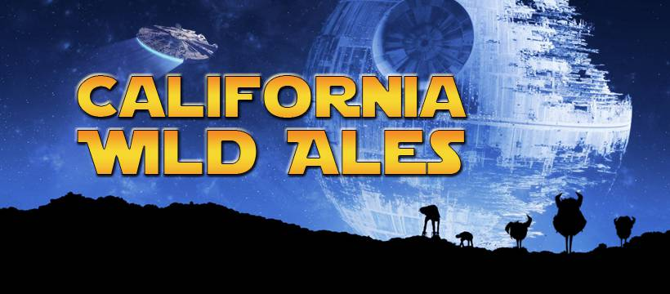

CALIFORNIA WILD ALES ANNOUNCES “MAY THE 4TH BE WITH YOU” BOTTLE RELEASE & COLLABORATION WITH TAPSHACK CRAFT LIQUID COMPANY

--Second annual beer release includes 12 new sour ales and sour ale kombucha blends to celebrate Star Wars Day

--California Wild Ales partners with TapShack Craft Liquid Company to create sour ale kombucha hybrid

SAN DIEGO (May 2, 2020) – California Wild Ales, San Diego’s Sour House and the city’s only all-barrel-aged sour brewery, today announced its second annual “May the Fourth be With You,” bottle release celebrating George Lucas’ “Star Wars.” The brewery is introducing 12 new sour ales and sour ale kombucha blends to commemorate Star Wars Day.

“Since we're living in crazy times and can’t celebrate Star Wars Day in our tasting room like we did last year, we decided to hold a huge online beer release,” said Bill DeWitt, co-owner and founder of California Wild Ales. “Last year's event was hugely popular so we hope these new series of wild ales give the sour beer community something to be excited about.”

The sour beer maker partnered with TapShack Craft Liquid Company to create a special blend of sour ale and kombucha. “As a craft beverage company, we’re committed to being innovative and providing more exciting options to our customers,” said Chris Bourgeois, co-owner of TapShack. “Working with California Wild Ales to create a sour kombucha is a logical step for us and we hope both sour beer and kombucha lovers alike give our blends a try!”

One bottle and 11 draft selections will be packaged in 16 ounce crowlers and available for online sales or curbside pickup on Monday, May the 4th. Customers can visit: www.californiawildales.com or call (855) WILD-ALE (855) 945-3253 to place orders. Each order will be accompanied by stickers and artwork of the special Star War’s-inspired designed for the event.

Only (40) 16 oz. cans of each flavor are available in addition to a special bottle release of 100 500ml bottles for the event called the “ImPEARial Stromtrooper.”
The Rebel Alliance Series
May the Force Be With Yuzu (Yuzu Citrus, Sea Salt)
Han SoLoQuat (Local Loquats)
Padme Almondala (Almond, Sea Salt)
Chewboocha (TapShack Kombucha Collab: Carrot, Ginger, Turmeric, Cayenne)
The Mangolorian (Mango, Ginger, Honey)
The Dark Side Series
BanAnakin Skywalker (Caramelized Banana, Toffee)
Tuskin Radler (Oro blanco and Ruby Red Grapefruit, Honey)
Mango Fett (Mango, Jalapeño)
The Dark Side TapShack Kombucha Collab: Beets, Pomegranate, Hibiscus)
Darth Citrus (Persian Lime, Meyer Lemon, Mandarin)
Emperor Pulpatine (Blueberry, Blackberry, Raspberry)

A single bottle release a 500ml Bottle The ImPEARial Stormtrooper (Julian Pear, Saigon Cinnamon)
All beer is available on May 4th for curbside pickup at the California Wild Ales brewery and tasting room located at 4202 Sorrento Valley Bld., Ste. L or free local delivery.

About California Wild Ales
California Wild Ales, San Diego’s Sour House, is San Diego’s only all-barrel-aged sour brewery. It began creating fresh and funky wild ale in 2015 and opened its tasting room in 2018. The brewery’s sour beer is aged in American, French, and Hungarian oak barrels for a minimum of nine months and uses fresh, local produce from local San Diego farmers. California Wild Ales is known for its branding, which includes characters representing the yeast and bacteria that’s used to ferment the sour beer named Lacto (short for Lactobacillus), Brett (short for Brettanomyces) and Pety (short for Pediococcus). www.californiawildales.com

About TapShack
Based in Ocean Beach, Calfornai, TapShack’s mission is to create the best-tasting, highest-quality kombucha and cold-brew coffee possible that combines modern brewing tebuquines with an ancient craft. We strive to push the boundaries on kombucha and cold-brew coffee innovation and fuel the daily lives of individuals through irresistible flavor and quality that improves the feeling of well-being and health. Driven by the passion for craft beverages, owners Chris and Amanda Bourgeois created TapShack to share with the local community and beyond. www.tapshackob.com

For additional information or imagery visit:
https://www.californiawildales.com/product-category/beer/star-wars/

Online Star Wars Beer Shop
https://www.californiawildales.com/product-category/beer/star-wars/

FB Event Page
https://www.facebook.com/events/232043618069192

Facebook: California Wild Ales
Instagram:@californiawildales
Twitter: @CaliWildAles
Hashtags: #californiawildales, #fermented, #sourbeer, #starwarsday, #maythe4thbewithyou, #beer, #beerrelease, #sdbeer, #maythefouthbewithyou, #bottlerelease, #supportlocalbusiness, #indiebeer, #barrelaged, #wildale, #wildales, #sdbeerlife, #craftbeerlife, #beeradvocate, #brewery, #sandiegocraftbeer, #instabeer, #beerporn, #beerstagram, #brewtography

Or contact:

Bill DeWitt
Co-Founder | Owner | California Wild Ales
4202 Sorrento Valley Blvd
Suite L/M
855-WILD-ALE (945-3253)
www.californiawildales.com

