**Bamboo Learning’s Alexa Skills *Bamboo Luminaries* and *Highlights Storybooks from Bamboo* Honored in Two Voice Application Categories in the 24th Annual Webby Awards**

*Bamboo Luminaries* only Honoree in *Apps, Mobile, and Voice: Education & Reference* Category*; Highlights Storybooks from Bamboo* Honored in *Apps, Mobile, and Voice: Best Writing* Category

**SEATTLE – May 6, 2020 –**Bamboo Learning, the leader in voice-powered education, earned the distinction of Webby Honoree in two categories in the 24th Annual Webby Awards earlier this week. Bamboo Luminaries Alexa skill was the only honoree in the Apps, Mobile, and Voice: Education & Reference category, and Highlights Storybooks from Bamboo was honored in the Apps, Mobile, and Voice: Best Writing category. The Webby Awards, which are judged by the [International Academy of Digital Arts & Sciences](http://www.iadas.net/), are hailed as the “Internet’s highest honor” by The New York Times, and have served as validation for some of the Internet’s best experiences for over two decades.

“The judges were clearly impressed with the creativity and innovation of Bamboo Learning's two voice applications – Bamboo Luminaries and Highlights Storybooks from Bamboo,” said Claire Graves, Executive Director of The Webby Awards. “It is a remarkable accomplishment to be selected among the best from nearly 13,000 entries for the 2020 Webby Awards.”

“We are elated to have both our Bamboo Luminaries and Highlights Storybooks from Bamboo Alexa skills honored as part of the 24th Annual Webby Awards,” said Ian Freed, Co-Founder and CEO of Bamboo Learning. “Our team works hard every day to create engaging, fun voice applications to help children and families learn using Alexa, and it is terrific to be recognized for our work.”

*Bamboo Luminaries* is a free voice application for Alexa for ages 7 to adult that teaches history through interactive exercises and trivia games about notable historical figures. *Bamboo Luminaries* now includes over 165 luminaries with diverse geographic, ethnic, and socioeconomic backgrounds from various fields including art, film, literature, music, science, social justice, and sports. Alexa owners can just say “Alexa, open Bamboo Luminaries” to try it.

**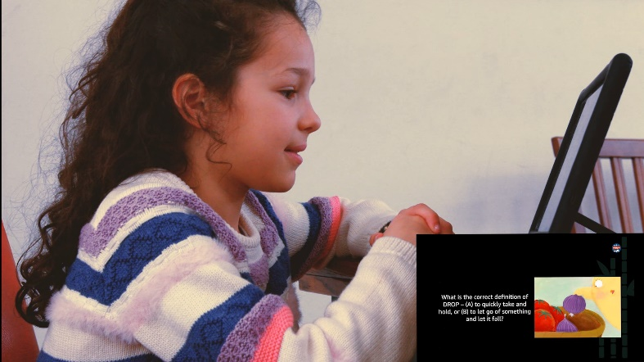***Highlights Storybooks from Bamboo* is a free voice application for Alexa designed by literacy experts at Highlights for Children and Bamboo Learning. *Highlights Storybooks from Bamboo* helps children aged 5 to 9 develop and practice skills in vocabulary building, language acquisition, and reading comprehension. Because the majority of interaction occurs through listening to exercises on Alexa, children can build the listening comprehension skills needed to become strong readers and learners. Alexa owners can just say “Alexa, open Highlights Storybooks” to get started.

“We are grateful to receive this honor from the Webby Awards for our work with Bamboo Learning to bring Highlights Storybooks to families in over 80 countries using Alexa,” said Kent Johnson, CEO of Highlights for Children. “Families have trusted Highlights for Children to foster Fun with a Purpose for over 70 years, and our work with Bamboo Learning is even more important today with so many children home from school for the foreseeable future.”

"We are thrilled to have Bamboo Luminaries and Highlights Storybooks from Bamboo’s educational content and listening comprehension exercises honored by the Webby Awards this year,” said Irina Fine, Co-Founder and Head of Content for Bamboo Learning. “We know how important it is to keep children engaged in learning, particularly while they are home from school and throughout the summer to address summer knowledge loss. Our Alexa skills are both fun and easy for children to use independently, relieving parents of some of the direct burden of ensuring their children are learning.”

Parents can review how their children are progressing in *Bamboo Luminaries*, *Highlights Storybooks from Bamboo*, and most of Bamboo Learning’s other Alexa skills – *Bamboo Math*, *Bamboo Books*, and *Bamboo Music*, by signing up for a free Bamboo Grove account at <https://grove.bamboolearning.com>. Using Bamboo Grove, parents can track their children’s progress and help them identify areas to work on in each Bamboo Learning Alexa skill. To learn more about Bamboo Learning’s Alexa skills, families can go to [https://www.bamboolearning.com](https://www.bamboolearning.com/).

**About Bamboo Learning**

Based in Seattle, Bamboo Learning is the award-winning leader in voice-powered education with a mission to bring engaging, high-quality educational experiences to customers around the world. Bamboo Learning develops skills for Alexa that enable families, teens, and adults to have fun learning and practicing diverse subjects while listening, viewing images, and using their voice. Bamboo Learning Alexa skills, including Bamboo Luminaries, Bamboo Books, Bamboo Math, Bamboo Music, and Highlights Storybooks from Bamboo, offer a range of challenging and engaging exercises to help customers master different levels of subjects. Customers can sign up for a Bamboo Grove account to follow their progress in Bamboo Learning Alexa skills.

Bamboo’s co-founders are Ian Freed, CEO, and Irina Fine, COO and Head of Content. Ian Freed is a 30-year veteran of the technology industry, including 12 years at Amazon, having served as vice president of Amazon devices, where he led both the Amazon Echo and the Amazon Kindle businesses, and served as technical advisor to Amazon founder and CEO, Jeff Bezos. Irina Fine is a 30-year veteran of curriculum development and teaching, having worked in public and private sectors of education in New York, Washington DC, London, and Moscow, after receiving her M.Ed. in Curriculum Development and an undergraduate degree in Piano Performance and Music Education.

Connect with Bamboo Learning, and learn more at: [www.bamboolearning.com](http://www.bamboolearning.com/), Facebook: [Facebook.com/BambooLearning](http://www.facebook.com/BambooLearning), Twitter: [@learnwithbamboo](https://www.twitter.com/learnwithbamboo), YouTube: bamboolearning.com/youtube, and LinkedIn: [linkedin.com/company/bamboolearning](https://www.linkedin.com/company/bamboolearning)

**About Highlights**

*Highlights* is a beloved global media brand dedicated to helping children become curious, creative, caring, and confident through engaging content and experiences that are focused on nurturing and developing the whole child. Highlights reaches children 0–12 with its most popular magazines and books, on multi-platform digital experiences, digital apps, toys/games, video platforms, and more. To learn more and connect with Highlights, visit [Highlights.com](https://www.highlights.com/), [HighlightsKids.com](https://www.highlightskids.com/), [Facebook](https://www.facebook.com/HighlightsforChildren/), [Instagram](https://www.instagram.com/HighlightsForChildren/), [Twitter](https://twitter.com/Highlights), [Pinterest](https://www.pinterest.com/funwithapurpose/), [LinkedIn](https://www.linkedin.com/company/highlights-for-children), and [YouTube](https://www.youtube.com/user/HighlightsMagazine).

**About The Webby Awards**Hailed as the “Internet’s highest honor” by The New York Times, The Webby Awards is the leading international awards organization honoring excellence on the Internet, including Websites, Video, Advertising, Media & PR, Apps, Mobile, and Voice, Social, Podcasts, and Games. Established in 1996, this year’s Webby Awards received nearly 13,000 entries from all 50 states and 70 countries worldwide. The Webby Awards are presented by the International Academy of Digital Arts and Sciences (IADAS). Sponsors and Partners of The Webby Awards include: WP Engine, Monday.com, Slack, YouGov, BASIC, KPMG, Adweek, Fast Company, The New Museum, and Social Media Week.

# # #

**Press Inquiries:**

Ian Freed for Bamboo Learning

info@bamboolearning.com