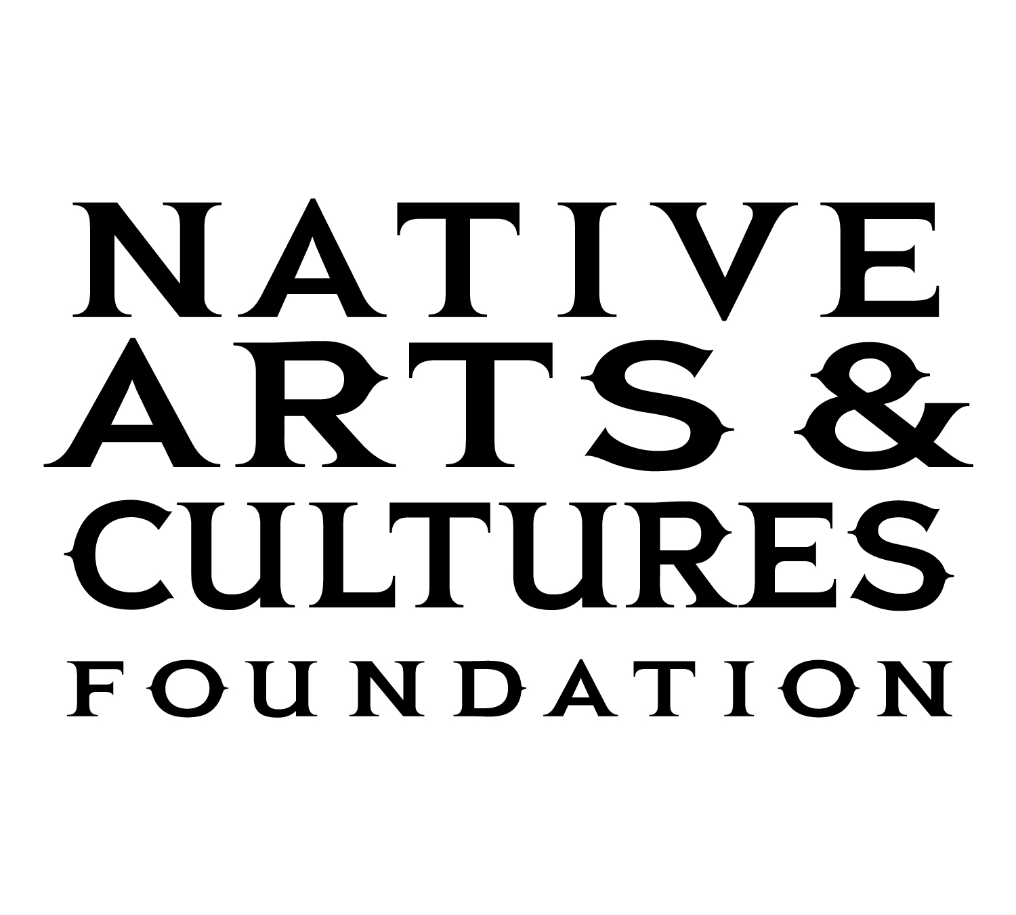

Media Contact:
Barbara Soulé
(360) 334-7263

NATIVE ARTS AND CULTURES FOUNDATION ANNOUNCES
2020 MENTOR ARTIST FELLOWSHIP AWARDS
VANCOUVER, Washington, May 6, 2020 – The Native Arts and Cultures Foundation (NACF) is pleased to announce the 2020 Mentor Artist Fellowship awards. The Mentor Artist Fellowship is a regional award open to accomplished American Indian and Alaska Native artists and culture bearers located in Alaska, Arizona, Idaho, Minnesota, Montana, New Mexico, North Dakota, Oregon, Southern California, South Dakota, Washington, and Wisconsin. Following an open call for applications, sixty Native artists were reviewed by a panel of arts professionals who specialize in Contemporary Visual Arts and Traditional Arts. This year, eleven artists were selected to receive a $30,000 fellowship award designed to support an established Native artist to mentor an emerging Native artist in the Contemporary Visual Arts and Traditional Arts.
“NACF is proud of the success of our Mentor Artist Fellowship. This intensive one-to-one mentoring program has proven to propel emerging artists and their careers, revitalize cultural and artistic practices within communities, and strengthen the mentoring skills of established Native artists and culture bearers,” says NACF Director of Programs Francene Blythe (Diné/Sisseton-Wahpeton/Eastern Band Cherokee). “With great pleasure and enthusiasm, we look forward to working with the eleven 2020 Mentor Artist Fellows and their apprentices in another promising mentorship experience.”
The Mentor Artist Fellowship is a structured fifteen-month program designed to empower artists and build capacity in Native communities for future generations. As part of the program, mentors and their apprentices will complete art projects by the end of the fellowship period to broaden Indigenous worldviews in both Native and non-Native communities. In addition to the monetary award, the fellows and their apprentices participated in a two-day virtual mentorship and professional development training on March 26-27, 2020.
Selected artists for the NACF 2020 Mentor Artist Fellowship and their chosen apprentices are as follows:
Contemporary Visual Arts:
- Nani Chacon, Diné, Murals, New Mexico. Chacon will mentor Lynnette Haozous, Chiricahua Apache (San Carlos Apache Tribe), Diné, Taos Pueblo.
- Gerald Clarke Jr., Cahuilla Band of Indians, Multi Media, Southern California. Clarke will mentor Deric Thornsberry, Member of the Cahuilla Band of Indians.
- Joe Feddersen, Member of Colville Confederated Tribes, Mixed Media, Washington. Feddersen will mentor Julie Edwards, Member of Colville Confederated Tribes.
- Cliff Fragua, Jemez Pueblo, Sculpture/Carving, New Mexico. Fragua will mentor Anthony C Wright-Romero, Ohkay Owingeh/Cochiti/Jemez Pueblo.
- Brenda Mallory, Cherokee Nation, Mixed Media/Installation, Oregon. Mallory will mentor Lehuauakea Fernandez, Kanaka Maoli (Native Hawaiian).

Traditional Arts:
- Earl Atchak, Cup’ik Eskimo, Carving, Alaska. Atchak will mentor Leo Unin Jr., Yup’ik.
- Jackie Larson Bread, Blackfeet (Amskapi Pikuni), Beading, Montana. Bread will mentor Dugan A. Coburn, Enrolled member of the Blackfeet Tribe (Piikuni), also a descendant of Klamath, Pit River.
- Ral Takook Christman, Kumeyaay Nation, Bird Singing and Gourd Making, Southern California. Christman will mentor Jeffrey French, Lipay Nation of Santa Ysabel.
- Nathan P Jackson, Tlingit, Woodcarving/Metalwork/Sculpture, Alaska. Jackson will mentor X̱’unei Lance Twitchell; Tlingit, Haida, Yup’ik, Sami.
- TahNibaa Naataanii, Navajo (Diné), Weaving, New Mexico. Naataanii will mentor Gloria C Begay, Diné (Navajo).
- April Stone, Bad River Band of Lake Superior Ojibwe, Black-Ash Weaving, Wisconsin. Stone will mentor Liandra Skenandore, Citizen of the Oneida Nation of Wisconsin; also Prairie Band Potawatomi, Seminole Nation of Oklahoma, and Mvskoke Creek Nation.
NACF is grateful to Margaret A. Cargill Philanthropies, The Ford Family Foundation, and to the James F. and Marion L. Miller Foundation for their support of the mentor program.
The Mentor Artist Fellowship is just one of the ways that NACF invests in artists and communities. Established in 2009, NACF has supported over 350 Native artists and organizations in 34 states and the District of Columbia. The Native Arts and Cultures Foundation’s mission is to promote the revitalization, appreciation, and perpetuation of American Indian, Alaska Native, and Native Hawaiian arts and cultures through grantmaking, convening, and advocacy. To learn more about the Mentor Artist Fellows and NACF’s work, visit www.nativeartsandcultures.org.
# # # #

