FOR IMMEDIATE RELEASE

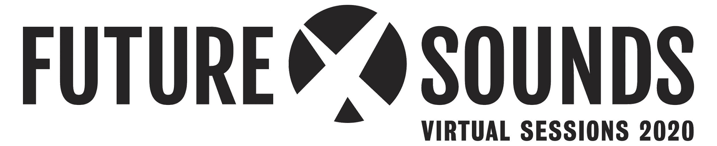
Presents
“Collaboration Sessions Vol. I” Virtual Release Festival featuring Tank & The Bangas, Chris Dave, Georgia Anne Muldrow, Black Milk and more.

LOS ANGELES (June 5, 2020) – Future x Sounds™, a music and arts series that invites artists, fans, and society to question the world around them, announces its 2020 Virtual Festival Guide to create new opportunities for artists and raise funds to support their communities.

Recognizing the situation we are all facing, we have worked to put together a program that fosters introspection and creativity so that we as a community may survive this pandemic and the upheavals of social injustice and not to return to "business as usual" but to a place of realized change.

Through the voices of artists, community-makers, and activists, we hope to provide a platform to unite, share, inspire, and take action together in a time of distress and limitations. The 2020 Virtual Sessions will take place until June 14th and will be kicking off with a strong Music and Community program.

Featuring Grammy-awarded and acclaimed artists including Tank & The Bangas, Chris Dave, Black Milk, Georgia Anne Muldrow and acclaimed activists such as Dr. Shamell Bell, Gina Belafonte, Jay Jordan, Joshua Kissi, Jamilah Lemieux, Joel Leon, Linda Sarsour and elite gymnast Katelyn Ohashi.

“Collaboration Sessions Vol. I” EP Virtual Release

Following the launch of Future x Sounds 2019 festival editions in Los Angeles, New York and Philadelphia, curated by Lalah Hathaway, Talib Kweli and James Poyser, the series partners with iconic artists that embrace the responsibility of their craft and lead by example.

With live events being cancelled in 2020 and the upheavals of social injustices, Future x Sounds joins forces with Tank & The Bangas, Chris Dave, Georgia Anne Muldrow and Black Milk, as curators and producers to keep inspiring artists, fostering collaboration and supporting their communities in these times of need. Each will lead a group of peers to co-create a new original composition to be included in the “Collaboration Sessions Vol.I” EP to be released during a virtual edition of its signature concert series on June 14th.

PROMO VIDEO: https://youtu.be/RVbvzx5Zv70

"We are excited to bring to you four of the most unusual, odd, off-kilter, centric artists together to make 1 extremely extraordinary, weird but surprisingly amazing song. We have a bounce artist, a techno kid, and a hip hop rapper and flutist. What? Yes” says Tank & The Bangas, when asked about track curation.

"At this time, to trust others in the creative process has been a liberating event. It's like a dear friend finding the words on the tip of your tongue and it sets me free." says Grammy- nominated Georgia Anne Muldrow, who is producing one of the EP tracks.

Through a “Pay What You Can” system, donors get behind-the-scenes access to the creative process, livestream festival, and the completed album. Proceeds will be distributed to the music community & various organizations with guidance from our producers and curators.

“I’ve been fortunate to have a solid career as an independent artist that started in my teenage years and has lasted through the present. Along the way, I’ve had strong support from my hometown of Detroit and my fellow independent artist community worldwide, so I’m always down and ready to give back where I can” - Black Milk.

RADICAL DIALOGUES

While the artists collaborate on compositions for the album, Future x Sounds is hosting a series of workshops and conversations in the weeks leading up to the Virtual Festival to reflect on how we can emerge from the pandemic crisis and recent escalation ef violence, individually and collectively as a community.

Artists, media, activists, and educators are invited to participate in Radical Dialogue sessions curated by Dr. Shamell Bell, an original member of Black Lives Matter. In collaboration with groundbreaking organizations such as Sanfoka, Shft, Ayana Therapy, Soteria and Trombone Shorty Foundation, these conversations seek to educate, recognize, and shift the spotlight onto local organizations and activists doing outstanding work to support their communities.

“I aim to push forward a framework for us to interrogate our own methods and mediums of "activism" and gather tools to ensure we do not go back to business as usual.This is an opportunity for us to gather together, and advocate for each other to implement the change into a reality unlike we have previously seen ” says Radical Dialogues curator Dr. Shamell Bell. “This space will allow us to visualize what the "Day After" COVID-19 looks like as a step to imagine what the day after true freedom feels like”.

To further the conversation, Future X Sounds will publish a free toolkit specifically designed to be used, shared, and expanded beyond this event.

“My father dropped a pearl of wisdom when he told me that artists are the gatekeepers of truth, civilizations radical voice.” says activist and Radical Dialogues series participant Harry Belafonte's daughter, Gina Belafonte. “Music has the ability to transform emotions and communicate messages of love and unity, reaching the deepest recesses of our minds. Music is a beautiful expression of cultural diversity and helps us to find ourselves and learn about others. Music brings us hope!”

About Future x Sounds™

Future x Sounds™ is the result of a collaborative effort between a like-minded community of producers, promoters, curators and iconic artists across the country. Launched in 2019, the multi-city music and arts series provides iconic, award-winning, and socially conscious artists with a creative opportunity to share their vision, shift the spotlight onto their talented peers and celebrate their communities.

These special, powerful live experiences invite artists, attendees, and society to question themselves and the world around them. Future x Sounds™ is an authentic window into a like-minded artistic global community that stands for the sounds of music and for the sounds of global change.

For more information on Future x Sounds, visit www.futurexsoundsfestival.com and follow Future x Sounds on Instagram, Twitter, Facebook, and Spotify.

Virtual Sessions 2020. Special thanks to our collaborators and partner organizations:

- Music: World Jam Productions, Revive Music, Fusicology, Motivate Pictures, Prosody Digital, HighBreedMusic, Women In Music
- Radical Dialogues: Safonka.org, Soteria, Shft, Trombone Shorty Foundation, Ayana Therapy

Media/Press Contact:

Asya Shein
asya@fusicology.com
(323) 988-2424 x. 701

Press Kit, Artist Quotes & Assets:

https://drive.google.com/drive/folders/10HoYuHi2edVkf1oFN8s7suLINaDINv4i?usp=sharing

Hashtags: #FuturexSounds #ShiftingTheSpotlight
Website: futurexsounds.com/virtual-sessions-2020
Instagram: instagram.com/futurexsounds
Kickstarter: https://www.kickstarter.com/projects/futurexsounds/future-x-sounds-virtual-sessions-2020-0
Facebook: facebook.com/Futurexsounds

