July 13, 2020

New Stock Analytics Platform Powered by AI and Big Data for Stock Selection

- Danel AI Score App is a stock selection solution powered by Artificial Intelligence, which rates S&P 500 and STOXX 600 stocks according to their probability of outperforming the market.
- Proprietary AI algorithms calculate a predictive global score called Smart Score, using all the information available on the market.
- Moreover, to adapt to different asset management styles, specific scores are provided for Fundamental, Technical and Sentiment indicators.

Danel Capital, a pioneering company in the use of Artificial Intelligence and Big Data technology to improve portfolio management, announces the immediate availability of its AI powered stock analytics platform, Danel AI Score App.

Danel AI Score App is a solution that brings a qualitative leap in the process of analysis and selection of securities. After more than four years of research and development, the application’s Machine Learning algorithms offer different predictive scores for all the stocks in the S&P 500 and the STOXX 600 indexes. Danel AI Score App’s analysis and ratings help to identify the best companies within an index.

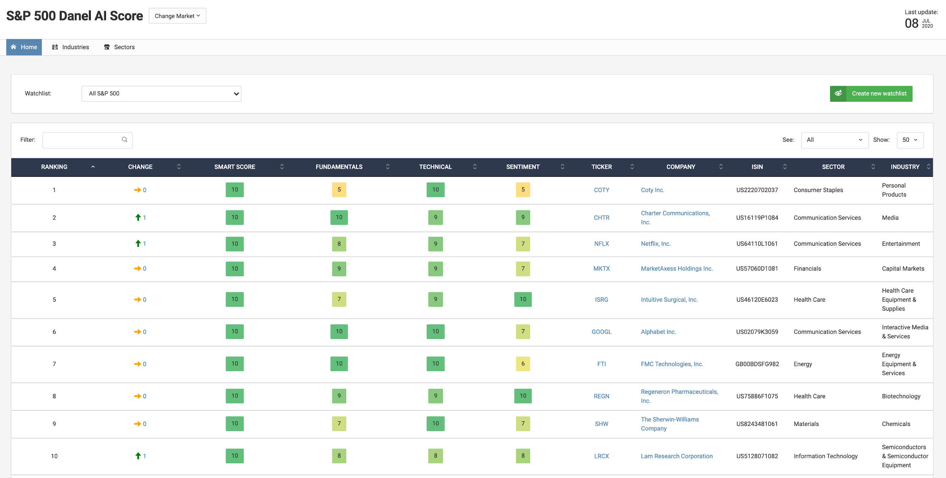
High-resolution image

The behavior of prices of equities in financial markets and the complexity of the interrelation of the different indicators that make up those prices, constitute an analytical challenge that is difficult to tackle for traditional stock analysis models. It is in this context where Danel Capital's Artificial Intelligence models are able to identify patterns of behavior, processing all the information available in the market: fundamental, technical, market sentiment and alternative data.

Danel AI Score App provides a predictive global score for each company on the STOXX 600 and S&P 500 indexes. This score is the Smart Score, which takes daily into account all the available market data for that specific stock. Scores by indicator type (fundamental, technical and sentiment) are also shown separately.

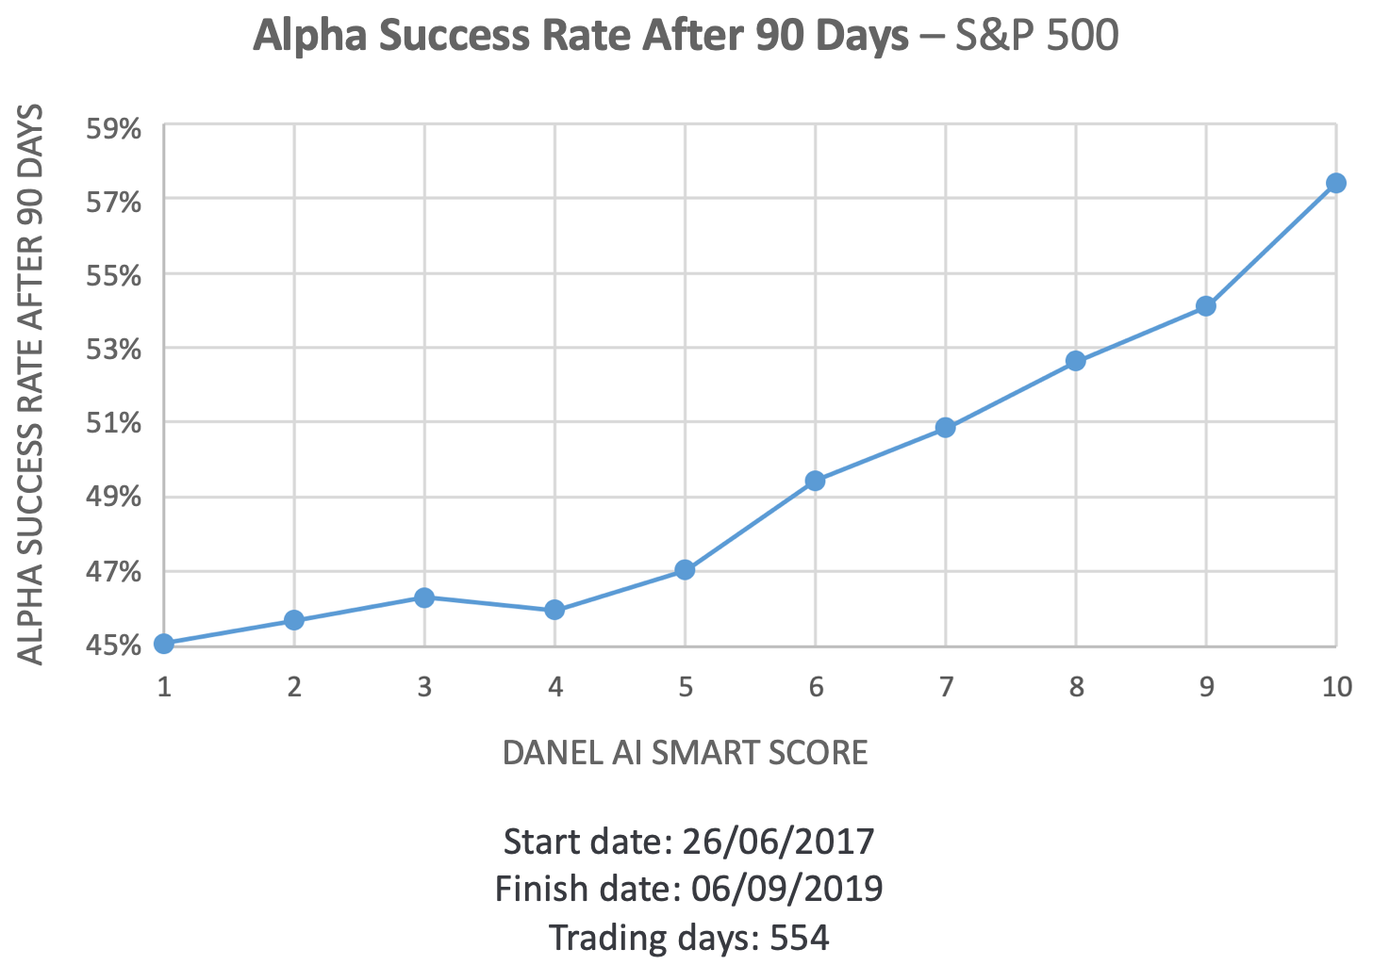

“The value proposition of Danel AI Score App is that Artificial Intelligence’s unique analytical capabilities are perfectly applicable to traditional portfolio management,” said José Luis Álvarez, Board member and CIO at Danel Capital. “The many functionalities, the different levels of information provided, and the traceability of the results of our solution, avoiding the 'black box' effect, make it adaptable to different asset management styles and to different levels of maturity in the adoption of Machine Learning technology.”

“With Danel AI Score App, we fulfilled our company strategy of allowing asset managers to access the power of Artificial Intelligence in a simple and traceable way, from an easy-to-use application,” said Tomás Diago, Founder and CEO of Danel Capital.

More info about Danel AI Score App
Watch the Danel AI Score App video: https://youtu.be/8oBen0EZ2TM
Request a 30-day Free Trial Version: https://try.danelcapital.com/danel-ai-score-app-free-trial-us-pr/

About Danel Capital EAF
Danel Capital EAF is the first entity regulated by the CNMV in Spain that uses Artificial Intelligence and Big Data to improve asset management decision-making. Founded in 2016 by award-winning technological entrepreneur Tomás Diago, it has focused on technological research and development applied to equity investment management. Danel Capital advises investment funds and offers stock analytics solutions and services, which allow managers to improve the selection of stocks and the optimization of their portfolios.

For more information, additional materials or to arrange interviews, please contact:

Giancarlo Cammarota
Marketing Director
Email: giancarlo.cammarota@danelcapital.com
Phone: +34 600 52 55 70.

Danel Capital EAF
Danel Capital EAF is an independent financial advisory company, authorized and supervised by the Spanish National Securities Market Commission (CNMV), with registration Nº 222.
Calle Balmes 129, 2º-1ª, Barcelona, ​​Spain
Phone: +34 932 502 352

