FOR IMMEDIATE RELEASE

HAWAII LANDSCAPE PRINTS FUNDRAISER KICKS OFF
TO SUPPORT ALOHA HARVEST
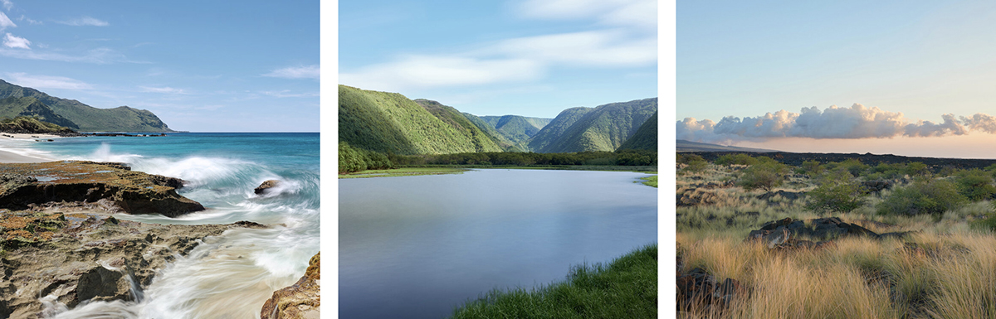
Honolulu photographer selling prints on Indiegogo to raise money for Aloha Harvest

Honolulu, HI, July 22, 2020 — Local photographer David Murphey has found a creative way to shed light on the many who have been affected by the COVID-19 crisis. With a 22% unemployment rate due
to the economic shutdown, many families in Hawaii are going hungry, unable to buy necessities, most especially food. David has decided to lend a hand via his lens by selling fine-art prints of Hawaii landscape scenes on Indiegogo and donating all the proceeds to Aloha Harvest.

“Families are going broke and going hungry. COVID-19 has intensified food insecurity in our state,”
he says. “I’m hoping this project will highlight the adversity many Hawaii families face.”

David is selling a limited edition of 100 large-format, fine-art prints of Hawaii landscape scenes on Indiegogo. Individual prints are priced at $75, with a set of two for $140. 100% of the net proceeds will
be donated to Aloha Harvest.

The fundraiser is now live on Indiegogo. https://igg.me/at/hawaiiprints

About David Murphey
David Murphey is a commercial photographer based in Honolulu, Hawaii. With more than 25 years of experience, he works with advertising agencies, graphic designers, public relation firms and their clients. For more information, visit https://davidmurphey.com or contact David at (808) 222-7011.

About Aloha Harvest
Aloha Harvest is the largest food rescue and redistribution organization in Hawaii. A 501c3 nonprofit, the organization picks up excess food from more than 250 donors and delivers it to at least 175 agencies feeding the hungry per year. All of their services are provided free of charge to both donors and recipients. So far in 2020, they’ve rescued and redistributed more than 1.2 million pounds of food that would have been wasted. For more information, visit https://alohaharvest.org or call (808) 537-6945.

Download high-res images here. https://bit.ly/2ZAbZKH

Contact: David Murphey
Phone: (808) 222-7011 Email: david@davidmurphey.com

