SMB Group’s SMBs: Navigating a Path Forward July Survey Results Now Available
How Will SMBs Get to the New Normal?
COVID-19 has disrupted any notion of business as usual. To understand the immediate impact on SMBs, SMB Group fielded our first survey study on this topic in March: Impact of COVID-19 on Small and Medium Businesses.

Now, SMB Group has released its new, follow-up study, SMBs: Navigating a Path Forward, which explores how SMBs are adapting to the shifting realities of the next normal to get their businesses back on track. In this study, we’ve surveyed decision-makers and influencers in more than 750 SMB (1-1,000 employee) and midmarket (1,000-2,500 employee) businesses. The survey was fielded from mid-June to early July 2020, which is critical to keep in mind as the trajectory and impact of the virus is constantly changing.
Key Findings
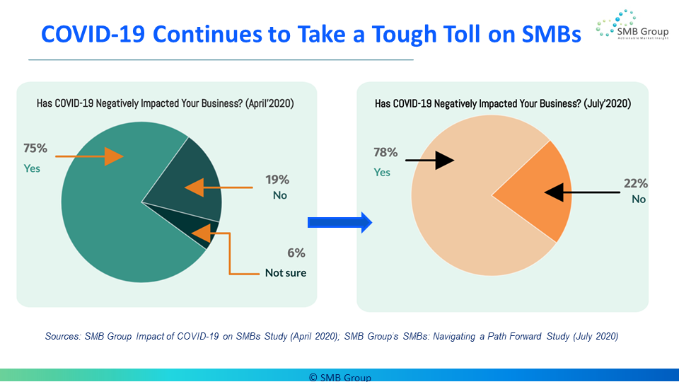
The negative fallout from COVID-19 for most SMBs and midmarket companies continues. According to Laurie McCabe, SMB Group co-founder, “78% of SMBs say COVID-19 has negatively impacted their businesses, which is up slightly from our March survey, in which 75% indicated the virus had negatively impacted their businesses.” In addition, the survey reveals that:
- Overall, smaller businesses have suffered more than larger ones.
- 69% or more of respondents in all industries report negative impact, but severity varies greatly by industry. Businesses in the hospitality, education, and retail industries are most likely to report extremely negative impact, while those in construction, utilities, and financial industries are least likely to do so.
- 38% of businesses temporarily closed and have since reopened, while 18% of businesses have closed and have yet to reopen.
McCabe notes, however, that “Despite these setbacks and challenges, most SMBs and midmarket companies that have survived to date believe that they will be able to keep their businesses afloat.”
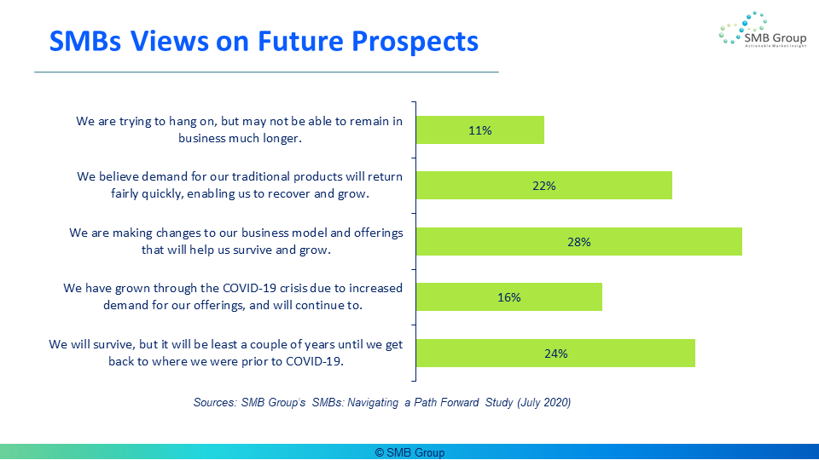
Many are taking steps to change their business practices and business models to sustain their businesses:
- The top three changes businesses have already made are to replace “in-person” meetings and events with video conferencing; changed layout of physical locations, and tied for number three are: increased use of digital marketing channels, created virtual service offerings, and increased use of digital sales channels.
- The top actions businesses are planning to take are to increase use of digital sales channels, develop new products and services, and implement scenario planning.
Cloud solutions continue to prove their value in helping businesses to weather this storm:
- In every category, 83% or more of respondents said cloud applications have been extremely or moderately valuable in helping to weather the COVID-19 crisis.
- 37% said that COVID-19 made them more likely to select a cloud solution for new application investments.
- Among those with work from home programs (WFM), 52% indicated that WFM has had a positive effect on employee productivity, and 61% plan to spend more to better equip work from home employees.
- Customer-facing applications—sales, ecommerce, and customer service as the top three areas that SMBs said they will need to invest in to recover and prepare for growth.
For More Information
This is just a small sample of the study’s findings. Sign up here to receive a copy our free eBook, which will provide further insights into:
- Business impact of COVID-19 on SMBs
- Workforce impact of COVID-19 on SMBs
- Work from home trends
- Technology impact of COVID-19 on SMBs

SMB Group is also offering a comprehensive survey report that provides detailed information about all 42 survey questions, with business size, industry and attitudinal segmentation. This report is designed for vendors that need and in-depth understanding of the business, workforce and technology implications of COVID-19 on SMBs. Please contact Lisa Lincoln, Director, Client Services and Business Development, at lisa.lincoln70@smb-gr.com for the table of contents and pricing information.
The survey was sponsored by Dell Technologies, Mitel, Sage Intacct, Workday and Xero.

About SMB Group
SMB Group is a technology industry research, analysis medium business (SMB) market. and consulting firm focused on technology adoption and trends in the small and Founded in 2008, SMB Group is recognized for thought leadership, research and expertise in the highly fragmented “SMB market” —which is composed of many smaller, more discrete markets.
SMB Group offers research, consulting, and content development services to help clients to:
- Identify market trends and opportunities
- Understand and segment the SMB market
- Evaluate and act upon market opportunities, competitive threats and disruptive trends
- Educate customers and prospects
- Position solutions for growth and competitive advantage
Each year, we develop our Top 10 SMB Technology Trends (add link: https://my.visme.co/projects/31q389kx-top-10-smb-technology-trends-for-2020#s1) for the year ahead.
© SMB Group, 2020

