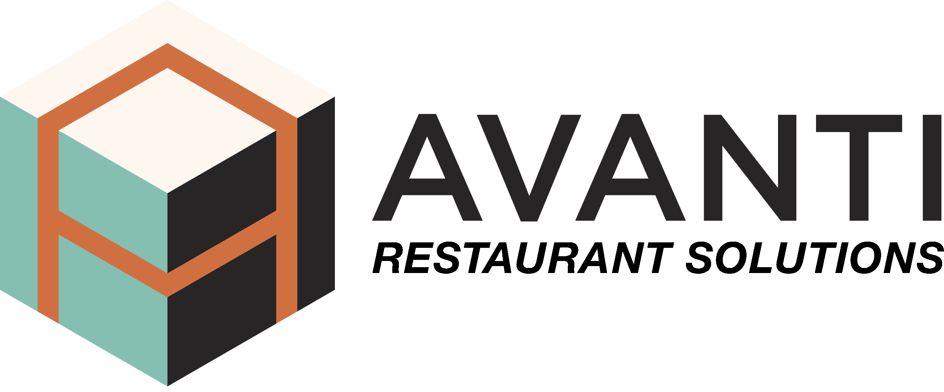
FOR IMMEDIATE RELEASE Contact: Jay Schlarb
jschlarb@avanticorporate.com
714-397-0231

Avanti Restaurant Solutions introduces VirtualCapture™ (VCap) Services to provide the fastest and most accurate as-built design documentation for its commercial kitchen design clients

Costa Mesa, CA (August 10, 2020) – Avanti Restaurant Solutions introduces unparalleled accuracy to data documentation through its new Avanti VirtualCapture™ (VCap) Technology Services. The Avanti Design Studio teams now have unique in-house capabilities to prepare fully interactive as-built designs for clients in days, not weeks, for easier visualization, project planning and change order review. VCap harnesses the speed and power of precise point cloud scans and converts them directly into AutoCAD and/or Revit files as needed.

“Our clients put a high value on the innovations and investments Avanti has made over time for faster collaboration and more efficient coordination between our Design Studio and their teams,” said Avanti CEO and Founder, Mark Rossi.

“Avanti’s introduction of VirtualCapture™ Services is a bold technology step forward for our industry in site survey documentation, project plan accuracy, and flat-out speed to market. It’s particularly well-suited for historical, urban and municipal projects, where VCap’s accuracy to the millimeter can make a critical difference for new-build and renovation projects.”

Avanti VirtualCapture™ is an integral part of Avanti’s expertise as a leading edge partner in architectural, engineering & construction work for commercial kitchen design & equipment planning.

About Avanti Restaurant Solutions

Avanti is a leader in commercial kitchen design, equipment and services, serving national
and regional restaurant, entertainment and hotel/hospitality chains, as well as retail and
other foodservice facility needs. Avanti’s on-staff expertise includes in-house project management and equipment sourcing, the Design Studio and VirtualCapture™ Services – to support clients’ concepts and projects from culinary vision to restaurant opening.
Avanti means “Forward” and since our start in 2003, we have provided solutions and services
to help restaurant and foodservice owner/operators move their businesses forward faster – across more than 3,500 locations in the U.S. and Canada.
#AvantiMeansForward
www.avanticorporate.com

