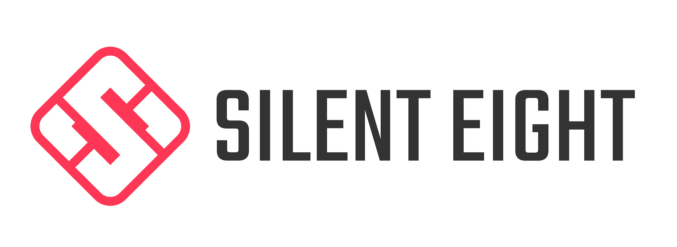
FOR IMMEDIATE RELEASE: AUGUST 13 2020

Silent Eight Extends On-Demand AI Solution for Immediate Backlog Resolution and Ongoing KYC
The cloud-based offering will remain available through 2020 to meet customer demand
New York, New York: Silent Eight announced today that it will offer its powerful artificial intelligence (AI) solution for name, entity, and transaction alert adjudication on-demand, through the remainder of 2020. The decision comes in the wake of the current and ongoing pandemic, which has placed significant constraints and challenges on banks and financial institutions (FIs). These most notably include increasing and burdensome alert backlogs and unprecedented levels of cybercrime.¹ The pandemic has also impacted the ability of both government and private sector institutions to meet their anti-money laundering and counter terrorist financing (AML/CFT) obligations.²

Silent Eight’s AI has historically been installed on-premise for Tier 1 institutions³ to solve name, entity, and transaction alerts. Now the solution will be widely accessible to a broader market, and across more sectors, as a means of providing immediate and ongoing backlog relief, without requiring a long term commitment.

The custom AI is configurable in as few as two (2) weeks via cloud deployment and offers a new way for banks and FIs to solve alerts in a scalable and agile manner in real time, regardless of external conditions such as COVID-19.

“Banks are already under so much pressure in ordinary times, especially as bad actors become more technologically savvy,” said Silent Eight CEO and Founder, Martin Markiewicz.
“But now, with the fast-changing global situation and most of us working remotely and moving to digital transactions, there’s heightened opportunity for financial cyber crime. With so much financial uncertainty fueling recessionary fears, the technology industry as a whole has a responsibility to protect the institutions that ensure the global flow of capital -- and, as a byproduct, the world -- from those looking to wreak havoc.”

The on-demand AI is available immediately. Clients pay only for alerts solved, with no minimum volume commitment.

Features and benefits of the AI include:
- Fully customized; learns from your institutional processes and behavior
- Military-grade encryption
- Deployable in as few as 2 weeks
- No limit on geographies, or hits per alert
- Covers any type of alert: Adverse Media, PEP, Sanctions, Customer Due Diligence
To learn more, visit www.silenteight.com.

About Silent Eight: We are a technology company whose mission is to enable financial institutions to fight global crime with the use of our AI. Our name screening solution works with a client's existing due diligence process to solve every alert and reduce regulatory risk. We are currently used by top tier banks around the world.

______________________
¹ Will Douglas Heaven, “The Pandemic has changed how criminals hide their cash-and AI tools are trying to sniff it out,” MIT Technology Review, [website], https://www.technologyreview.com/2020/08/06/1006104/covid-pandemic-criminals-cash-money-laundering-financial-crime-ai-machine-learning/(accessed 7 August 2020).
Robert Kim, “COVID-19 is raising AML compliance risks even higher,” Bloomberg Law Analysis, [website],
https://news.bloomberglaw.com/bloomberg-law-analysis/analysis-covid-19-is-raising-aml-compliance-risks-even-higher (accessed 28 July 2020).
Thomas Bock, “Pandemic adding to banks’ alert backlog,” Thomson Reuters, [website], https://legal.thomsonreuters.com/en/insights/articles/bank-alert-transaction-fraud, (accessed 28 July 2020).

² Financial Action Task Force (FATF), “COVID-19-related Money Laundering and Terrorist Financing Risks and Policy Responses,” FATF, [website],https://www.fatf-gafi.org/publications/fatfgeneral/documents/covid-19-ml-tf.html (accessed 26 July 2020)
³ “We’ve partnered with Regulatory Technology firm Silent Eight.” Standard Chartered Bank, 9 July 2018, [press release], https://www.sc.com/en/media/press-release/weve-partnered-with-regulatory-technology-firm-silent-eight/

