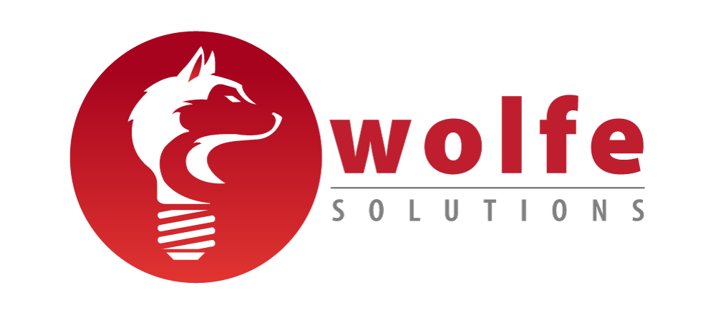

Inc. Magazine Unveils Its Annual List of
America’s Fastest-Growing Private Companies—the Inc. 5000

Wolfe Solutions Ranks No. 2359 on the 2020 Inc. 5000
With Three-Year Revenue Growth of 176.8% Percent

NEW YORK, August 12, 2020 – Inc. magazine today revealed that Wolfe Solutions is No. 2359 on its annual Inc. 5000 list, the most prestigious ranking of the nation’s fastest-growing private companies. The list represents a unique look at the most successful companies within the American economy’s most dynamic segment—its independent small businesses. Intuit, Zappos, Under Armour, Microsoft, Patagonia, and many other well-known names gained their first national exposure as honorees on the Inc. 5000.

“This honor is a testament to our team’s dedication to serving our clients and the trust our clients place in us to drive their business” stated agency founder Jason Wolfe. “Our recognition continues to show the power of sponsorship marketing in sports and entertainment. While 2020 has been a challenging year, we continue to see the value in consumer connections and staying at the forefront of this ever-evolving consumer behavior.”

Not only have the companies on the 2020 Inc. 5000 been very competitive within their markets, but the list as a whole shows staggering growth compared with prior lists as well. The 2020 Inc. 5000 achieved an incredible three-year average growth of over 500 percent, and a median rate of 165 percent. The Inc. 5000’s aggregate revenue was $209 billion in 2019, accounting for over 1 million jobs over the past three years.

Complete results of the Inc. 5000, including company profiles and an interactive database that can be sorted by industry, region, and other criteria, can be found at www.inc.com/inc5000. The top 500 companies are also being featured in the September issue of Inc., available on newsstands August 12.

“The companies on this year’s Inc. 5000 come from nearly every realm of business,” says Inc. editor-in-chief Scott Omelianuk. “From health and software to media and hospitality, the 2020 list proves that no matter the sector, incredible growth is based on the foundations of tenacity and opportunism.”

The annual Inc. 5000 event honoring the companies on the list will be held virtually from October 23 to 27, 2020. As always, speakers will include some of the greatest innovators and business leaders of our generation.

About Wolfe Solutions

We believe in the power of sponsorships and the unmatched emotional connection our clients can build with their consumers and customers. Founded in 2010 and headquartered in Columbia, SC, Wolfe Solutions specializes in customized, brand-centric sponsorship marketing platforms driven by insights and expertise. Our industry leading experience assists brands from multiple industries with managing and maximizing sponsorship investments. Our team of sponsorship marketing ninjas possess a client first ethos that drives our thinking and our success. Learn more at www.wolfesolutions.net.

CONTACT:
Jason Wolfe, Founder
Phone: 704.293.7808
Email: jason@wolfesolutions.net

More about Inc. and the Inc. 5000

Methodology
The 2020 Inc. 5000 is ranked according to percentage revenue growth when comparing 2016 and 2019. To qualify, companies must have been founded and generating revenue by March 31, 2016. They had to be U.S.-based, privately held, for profit, and independent—not subsidiaries or divisions of other companies—as of December 31, 2019. (Since then, a number of companies on the list have gone public or been acquired.) The minimum revenue required for 2016 is $100,000; the minimum for 2019 is $2 million. As always, Inc. reserves the right to decline applicants for subjective reasons. Companies on the Inc. 500 are featured in Inc.’s September issue. They represent the top tier of the Inc. 5000, which can be found at http://www.inc.com/inc5000.

About Inc. Media
The world’s most trusted business-media brand, Inc. offers entrepreneurs the knowledge, tools, connections, and community to build great companies. Its award-winning multiplatform content reaches more than 50 million people each month across a variety of channels including websites, newsletters, social media, podcasts, and print. Its prestigious Inc. 5000 list, produced every year since 1982, analyzes company data to recognize the fastest-growing privately held businesses in the United States. The global recognition that comes with inclusion in the 5000 gives the founders of the best businesses an opportunity to engage with an exclusive community of their peers, and the credibility that helps them drive sales and recruit talent. The associated Inc. 5000 Conference is part of a highly acclaimed portfolio of bespoke events produced by Inc. For more information, visit www.inc.com.
For more information on the Inc. 5000 Conference, visit http://conference.inc.com/.

