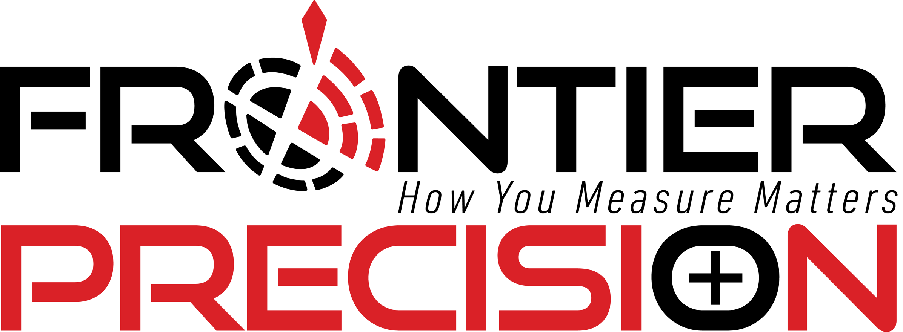

***Inc.* Magazine Unveils Its Annual List of**

**America’s Fastest-Growing Private Companies—the Inc. 5000**

**Frontier Precision Ranks No. 3,789 on the 2020 Inc. 5000**

**With Three-Year Revenue Growth of 95.09% Percent**

**NEW YORK, August 12, 2020** – *Inc.* magazine today revealed that Frontier Precision is No. 3,789 on its annual Inc. 5000 list, the most prestigious ranking of the nation’s fastest-growing private companies. The list represents a unique look at the most successful companies within the American economy’s most dynamic segment—its independent small businesses. Intuit, Zappos, Under Armour, Microsoft, Patagonia, and many other well-known names gained their first national exposure as honorees on the Inc. 5000.

“So proud of our team at Frontier Precision,” says President / CEO Dennis Kemmesat. “This is the second time we have made the Inc*.* list, first appearing in the September 2012 Inc*.* 500 Profiles of Success list - for America's Fastest Growing Private Companies, at No. 358 for Business Products & Services. It's all about people - dedicated professionals that make up our organization, that day in and day out keep our customers as our first priority! For those of you that still wonder what we do - we sell precision measurement and mapping technology to the land survey, engineering, construction, and GIS industries. Again, **congratulations** to all our employee-owners for a job well done!”

Not only have the companies on the 2020 Inc. 5000 been very competitive within their markets, but the list as a whole shows staggering growth compared with prior lists as well. The 2020 Inc. 5000 achieved an incredible three-year average growth of over 500 percent, and a median rate of 165 percent. The Inc. 5000’s aggregate revenue was $209 billion in 2019, accounting for over 1 million jobs over the past three years.

Complete results of the Inc. 5000, including company profiles and an interactive database that can be sorted by industry, region, and other criteria, can be found at [www.inc.com/inc5000](http://www.inc.com/inc5000). The top 500 companies are also being featured in the September issue of *Inc.*, available on newsstands August 12.

“The companies on this year’s Inc. 5000 come from nearly every realm of business,” says *Inc.* editor-in-chief Scott Omelianuk. “From health and software to media and hospitality, the 2020 list proves that no matter the sector, incredible growth is based on the foundations of tenacity and opportunism.”

The annual Inc. 5000 event honoring the companies on the list will be held virtually from October 23 to 27, 2020. As always, speakers will include some of the greatest innovators and business leaders of our generation.

**About Frontier Precision**

Frontier Precision is an employee-owned company with over 30 years of experience, serving: survey, mapping, engineering, construction, GIS, forensics, law enforcement, forestry, water resources, mosquito and vector control, and natural resources professionals throughout the western United States.

As a high-tech company, we’re at the forefront of technology. We see exciting new developments on the horizon, especially in the areas of UAS/drones, laser-based scanning, 3-D visualization, and virtual reality. But we also know that the core of our business is our relationship with you.

We understand your needs, so when we look at new technology, we think about how it can help you work better, faster, more accurately, and more profitable. At Frontier Precision, we don’t follow the technological trends. We lead the way.

Learn More About Frontier Precision at [www.frontierprecision.com](http://www.frontierprecision.com)

**CONTACT:**

Dennis Kemmesat – President / CEO | Frontier Precision  
[dennisk@frontierprecision.com](mailto:dennisk@frontierprecision.com)  
701.222.2030 or Toll-Free: 800.359.3703  
https://www.linkedin.com/company/frontier-precision-inc./

**More about *Inc.* and the Inc. 5000**

**Methodology**

The 2020 Inc. 5000 is ranked according to percentage revenue growth when comparing 2016 and 2019. To qualify, companies must have been founded and generating revenue by March 31, 2016. They had to be U.S.-based, privately held, for profit, and independent—not subsidiaries or divisions of other companies—as of December 31, 2019. (Since then, a number of companies on the list have gone public or been acquired.) The minimum revenue required for 2016 is $100,000; the minimum for 2019 is $2 million. As always, *Inc.* reserves the right to decline applicants for subjective reasons. Companies on the Inc. 500 are featured in *Inc.*’s September issue. They represent the top tier of the Inc. 5000, which can be found at <http://www.inc.com/inc5000>.

**About Inc. Media**

The world’s most trusted business-media brand, Inc. offers entrepreneurs the knowledge, tools, connections, and community to build great companies. Its award-winning multiplatform content reaches more than 50 million people each month across a variety of channels including websites, newsletters, social media, podcasts, and print. Its prestigious Inc. 5000 list, produced every year since 1982, analyzes company data to recognize the fastest growing privately held businesses in the United States. The global recognition that comes with inclusion in the 5000 gives the founders of the best businesses an opportunity to engage with an exclusive community of their peers, and the credibility that helps them drive sales and recruit talent. The associated Inc. 5000 Conference is part of a highly acclaimed portfolio of bespoke events produced by Inc. For more information, visit [www.inc.com](http://www.inc.com).

For more information on the Inc. 5000 Conference, visit <http://conference.inc.com/>.