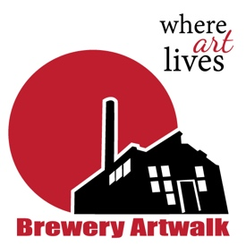  Contact  Brewery Artwalk Association  www.breweryartwalk.com  info@breweryartwalk.com  (323) 638-9382  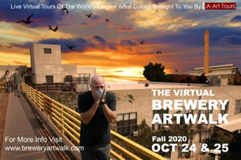 | FOR IMMEDIATE RELEASE  The Virtual Brewery Artwalk  October 24 & 25 11am – 6pm  brewery artwalk association •21oo N. Main St. A10• Los Angeles CA 90031  October 16, 2020  The Brewery Artwalk, A 38-year tradition and staple of the Los Angeles art community, has gone virtual for its upcoming Fall 2020 event.  Since its creation in 1982, the artists of the Brewery Arts Complex have graciously opened their studios to the public to provide art lovers, collectors and the curious alike with a unique view into what it's like to live and work in what has been called the world's largest artist colony. The Artwalk happens twice a year in Spring and Fall, attracting thousands of visitors over the course of a weekend, all eager to view original works of art by many of LA’s top artists. That is, until the recent global pandemic caused by Covid-19 forced its organizers to cancel the Spring event.  Fast forward to this Fall, the Brewery Artwalk Association, has taken on the challenge of recreating the one-of-a-kind experience for an online audience. The BAA's President, Mitzella spoke of the challenges the organization has faced in moving from a live event to a digital platform. "The Brewery Artwalk is unique in that dozens of artists open up their live/work studios and invite the public into their personal space. It's an intimate experience that allows people to connect directly with artists in a way they don't normally get to do in a traditional gallery or museum setting. So, when we started thinking about a virtual event - we felt it was important. We wanted to present it in an authentic way that would preserve that sense of wonder and discovery that makes the Brewery Artwalk so special."  The answer finally came when the BAA teamed up with LA ArtTours. LA ArtTours has been providing live interactive tours (they like call them adventures) of the Los Angeles art scene for over a decade. When the pandemic hit, the team at LA ArtTours got creative, taking their tours online to a virtual audience. Owner Kevin Flint said, "Going virtual has allowed us to expand our reach to a global audience. I think even after the quarantine is lifted; we'll continue to offer this kind of experience as part of our services."  The weekend of October 24 and 25 the BAA in partnership with LA ArtTours will once again “virtually” open their doors and offer free live- streamed tours from 11am - 6pm each day. The live tours will be conducted by Zoom Webinar and will offer visitors from around the world a peek into the Brewery’s 12-acre complex with its historic architecture and hundreds of artist lofts. For those unable to attend the Zoom sessions, the BAA will also be live streaming directly from their website and social media however it's strongly recommended to sign up for the Zoom sessions, which will offer a more interactive experience.  You can find more information about the Brewery Artwalk, The Brewery Artist Complex itself and how to view the live stream event at the Brewery Artwalk Association's website or by contacting the BAA directly at:  Brewery Artwalk Association  www.breweryartwalk.com  info@breweryartwalk.com  (323) 638-9382  For more information about LA ArtTours contact:  LA ArtTours  www.laarttours.com  info@laarttours.com  310-503-2365
