GO Car Wash Prepares to Open New State-of-the-Art Location in Overland Park, KS

OVERLAND PARK, KS – GO Car Wash is excited to announce the upcoming launch of their latest state-of-the-art express car wash location at 11806 W 135th, Overland Park, KS. This will bring the total operating GO Car Wash sites to 21 in the Kansas City market. Grand Opening specials will include free washes for new customers from October 19th – October 25th along with a $9.99 first month membership promotion for any Unlimited wash package. A ribbon-cutting ceremony will be held with the City of Overland Park on location with the City Council President at noon on October 20th, with a Facebook Live event also available.
The new location, opening October 19th, boasts state-of-the-art car wash features.
“The site will feature advanced car wash technology including license plate recognition for GO Unlimited members to access the wash seamlessly. Memberships will be valid at all GO Car Wash locations throughout the market. Numerous GO Car Wash locations have extra member amenities such as free vacuums, free air, member-only lanes, and free mat cleaners,” said Heath Pomerantz, VP of Field Operations.

“We are thrilled to continue to expand our footprint throughout the Kansas City market with the opening of our new location in Overland Park, my first build and site launch with GO Car Wash as CEO,” said Bill Derwin, the new CEO of GO Car Wash. “We look forward to continuing to offer the same exceptional customer experience to new and existing customers in Overland Park and throughout Kansas City as we go deeper into this market. We’re well positioned to keep executing our multi-pronged growth strategy here in Kansas City and to develop a strong dynamic presence in each market we enter.”

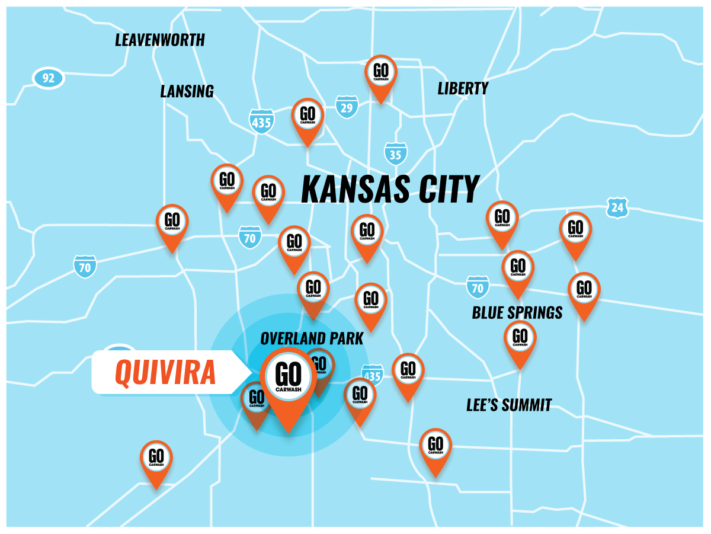

About GO Car Wash
GO Car Wash, headquartered in Phoenix, AZ, currently operates 32 sites in 4 states, including Kanas, Missouri, Nevada, and Texas. GO Car Wash targets high-quality exterior express car washes with a multi-pronged growth strategy focused on acquisitions, partnerships, and new site buildouts.
For more information, visit www.gocarwash.com.
Contact
GO Car Wash
Bill Derwin
Chief Executive Officer (CEO)
bill.derwin@gocarwash.com
303-304-1986

