GO Car Wash Acquires Pirate’s Cove Car Wash Site in San Antonio, TX

SAN ANTONIO, TX — GO Car Wash has acquired a Pirate’s Cove Car Wash site in Schertz, TX, a suburb of San Antonio, continuing its aggressive expansion in the Greater San Antonio Region. GO Car Wash will now operate 33 locations in three diverse markets across the United States.

“We are thrilled to continue expanding our footprint throughout the Greater San Antonio Region. This acquisition marks our eighth location in San Antonio as we swiftly grow our presence there. We look forward to bringing Pirate’s Cove Car Wash into the GO Car Wash family,” said Brett Meinberg, COO of GO Car Wash.

GO Car Wash, a multi-regional car wash company, is rapidly expanding, acquiring and developing growing clusters of customer-centric car washes in some of North America’s most prosperous cities.

“We plan to continue our rapid growth in the Greater San Antonio Region as we have in each market we’ve entered,” said Bill Derwin, CEO of GO Car Wash. “This Pirate’s Cove Car Wash was built consistent with our approach to express car wash layouts. Kevin Chandler has done an excellent job building and opening this wash and we are excited to take ownership.”

GO plans to expand quickly in the Greater San Antonio Region, as it has previously done in its other regions of operation. The GO Car Wash platform is intensely attractive to business owners looking to sell.

“We seek to acquire or build over 20 locations in the Greater San Antonio Region. Our business model lends itself perfectly to success, creating mutual profitability for sellers and GO Car Wash while ensuring an exceptional experience for each of our members and customers. We also have the resources to invest in our team, advancing their careers with ample opportunity for promotion from within, professional development, and a clear path to success,” said Derwin.

GO Car Wash focuses on bold, strategic growth in each market in which it establishes itself.

“When we enter a market, we intend to go deep from the start. We’re always looking for the right opportunities to grow, both in our existing markets and in new regional locations across North America,” said Derwin. “Having multiple locations within easy driving distance of each other in each market allows us to provide the utmost level of service to our members and customers with the best car wash offerings, including unlimited monthly memberships that use license plate recognition technology and can be used at any GO Car Wash location.”

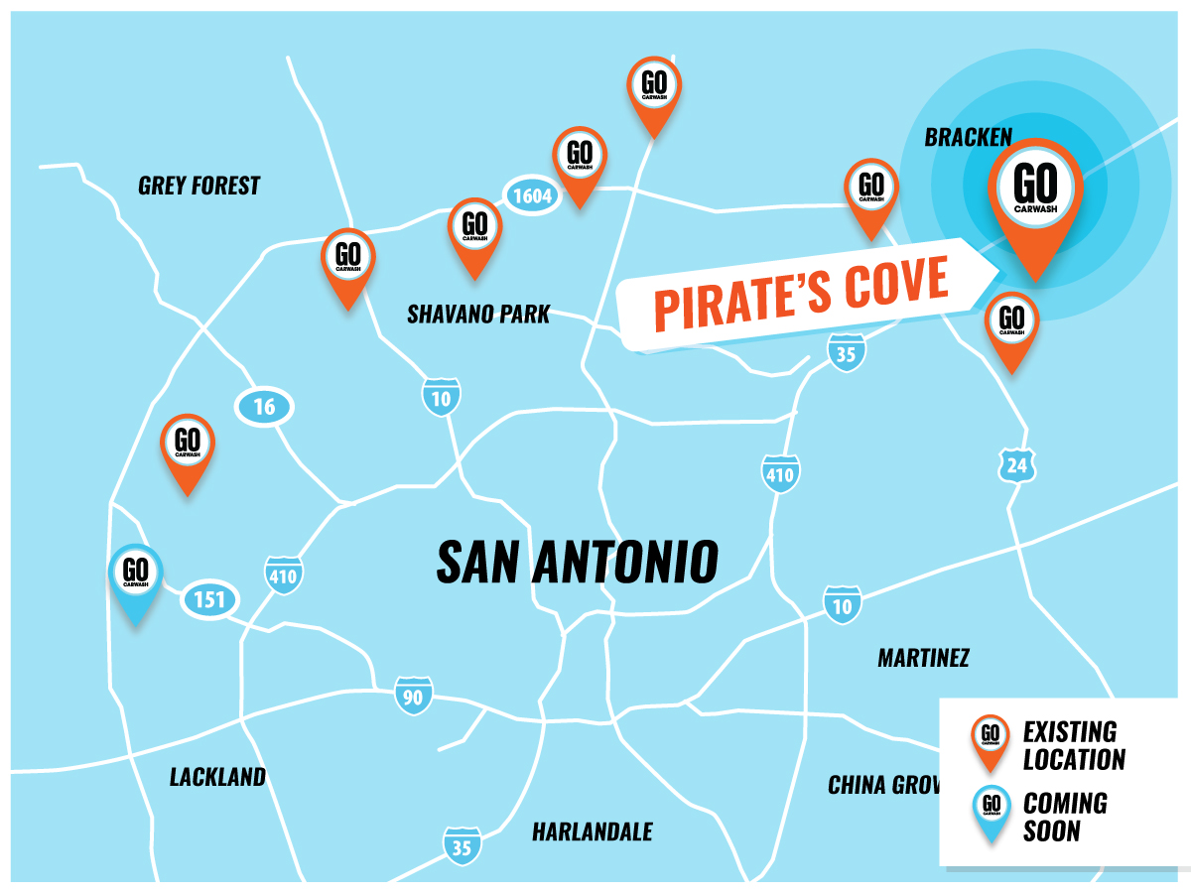

About GO Car Wash
GO Car Wash, headquartered in Phoenix, AZ, currently operates 33 sites in 4 states, including Kanas, Missouri, Nevada, and Texas. GO Car Wash targets high-quality exterior express car washes with a multi-pronged growth strategy focused on acquisitions, partnerships, and new site buildouts.

For more information, please visit www.gocarwash.com.

Contact
GO Car Wash

Bill Derwin
Chief Executive Officer (CEO)
bill.derwin@gocarwash.com
303-304-1986

