FOR IMMEDIATE RELEASE CONTACT: CARRIE LIVINGSTON,
Director of Media Relations, ColinKurtis
Email: carrie@colinkurtis.com
Phone: 815-519-8302

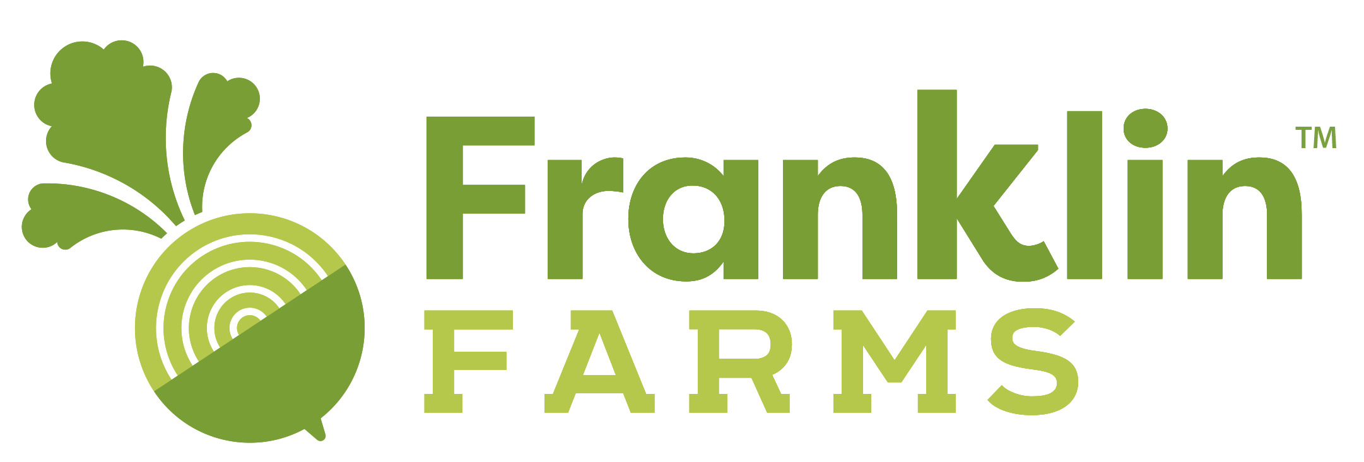

Franklin Farms Announces New Partnership with Purple Carrot

PARSIPPANY, NJ, December 1, 2020—Franklin Farms™, a division of Keystone Natural Holdings, announced they have entered a new partnership with Purple Carrot, the 100% plant-based meal kit company. As a prominent consumer brand and leading supplier of high-quality and delicious meatless offerings, Franklin Farms brings more than twenty years of expertise in plant-based protein foods and innovation to Purple Carrot’s meal kit offerings.

"The Purple Carrot culinary team is so excited to be partnering with Franklin Farms to create delicious plant-based meals we know our customers will love!" said Andrea Norby, Purple Carrot's Head of Culinary. Every Purple Carrot meal kit includes the freshest plant-based ingredients along with a variety of recipes and cooking ideas to inspire consumers.

“We are thrilled to partner with Purple Carrot and excited our customers will have a new and very convenient way to enjoy great-tasting meatless meals in the comfort of their own home,” said Cindy Wong, Vice President of Sales, Franklin Farms. “Purple Carrot offerings are a fresh and super convenient way for consumers to create and enjoy flavorful plant-based foods. Our extra-firm tofu is a very popular item with consumers and is now a key ingredient in these popular home delivery meal kits.”

Amidst this global pandemic, consumers’ shopping behavior is shifting as they seek out plant-based nutrition, such as tofu, as a way to strengthen their immune systems. Foodinsight.org shared results of two recent surveys from the International Food Information Council (IFIC) Foundation, indicating more people are gravitating to plant-based sources of protein during the COVID-19 pandemic.¹ Factors such as meat shortages in some areas, environmental concerns, and a desire to eat healthier diets are among the top reasons consumers cited for their increased interest in plant-based foods.

Franklin Farms uses only the highest quality ingredients to provide a healthy selection of plant-based products for any meal of the day. Product offerings including organic and conventional tofu and seasoned tofu bites, veggie patties, meatless meatballs, seitan, tempeh, edamame and vegan jerky. Franklin Farms is a proud member of healthy brands under Keystone Natural Holdings, a company devoted to developing authentic, healthy-conscious and innovative food.

Purple Carrot is offering a promotion in honor of the partnership. Please visit Franklin Farms on
Instagram or Facebook for discount code, valid until 02/08/21.

To discover more about Franklin Farms and its plant-based product offerings or to find the nearest retail location, please visit www.franklinfarms.com or email info@franklinfarms.com for more information.

¹FOODINSIGHT.ORG (2020). International Food Information Council (IFIC) Foundation, May 2020 survey. Retrieved from: https://foodinsight.org/wp-content/uploads/2020/05/IFIC-COVID-19-May-2020.pdf

###
About Franklin Farms
Franklin Farms began over 20 years ago as a simple mushroom farm in Franklin, Connecticut. Since then, they have been creating exciting yet good-for-you meatless meals from field to table. Great ingredients make great foods which is why Franklin Farms starts with flavor-forward, high-quality plant proteins. They offer a range of health-conscious plant-based protein products that span day parts, meal types, and taste profiles. From end to end, Franklin Farms makes it easy and delicious for consumers to cook with and eat great-tasting plant-based proteins. From our farms to a store near you, find the nearest retail location at: https://www.franklinfarms.com/where-to-buy.

About Purple Carrot
Purple Carrot started with just a seed of an idea in 2014: encourage people to eat more plants for their health and the health of the planet. Today, it is leading the charge for people to adopt a plant-based lifestyle. Purple Carrot's irresistible, globally-inspired recipes, fresh ingredients, and meals are available in the U.S. and Japan. To learn more about Purple Carrot, visit www.purplecarrot.com

