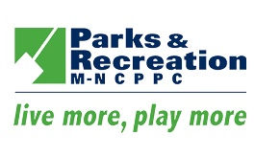
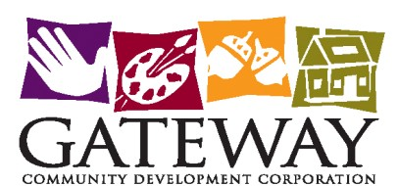

Press Release For Immediate Release

Media Contacts: Pat Thornton Producer: Tia Kane
pthornton@gatewaycdc.org artboxdc.org@gmail.com
Phone: 202-262-6156

Gateway CDC Presents Live Virtual Winter Holiday Arts Program

(North Brentwood, Maryland, December 10, 2020) – Gateway CDC is pleased to announce the first Gateway Virtual Winter Holiday Program, on Saturday, December 12, 2020, 3:00 pm. Tune-in to the livestream of visual and performing artists from the Gateway Arts District for a showcase of new artwork, live demonstrations, and a panel discussion: The Pandemic PIVOT. The program will close with a live Holiday Sing-along, conducted by American singer, songwriter and producer Tamara Wellons. The broadcast will be livestreamed on the Gateway Artbeat YouTube Channel. To join the live audience or sing-along, register here For access to the Press Room, reporters must register as well.

Enjoy entertainment from performance artists, watch streams of visual art, and a live panel discussion: The Pandemic PIVOT, with Pat Thornton, Michelle Darden Lee, Margaret Boozer-Strother, and Dino Wright. For the grand finale be prepared to dance and sing-along with American singer, songwriter and producer Tamara Wellons. The Gateway ArtBeat Stage will also be streamed live. The public can simply join the live stream (here).

Don’t miss the opportunity to support artists from the Gateway Arts District at the first Virtual Winter Holiday Program. Support artists, be entertained and learn how other artists have pivoted during the COVID-19 Pandemic.

# # # #

