Date December 21, 2020
For Release Immediately
Contact Christopher Andrews
candrews@prattmiller.com
(313) 300-1259

Disinfecting Robot SAFI Takes Flight at Detroit Metro Airport
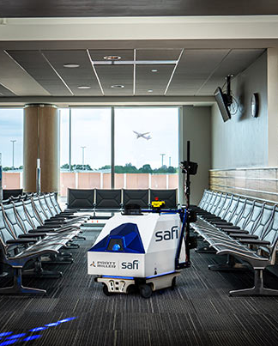
New Hudson, MI (December 21, 2020) – In a continued effort to bring confidence back to the travel industry, Pratt Miller Mobility (PMM) has deployed its disinfecting robot, Safi, at the Detroit Metro Airport McNamara Terminal. Safi was piloted at the Gerald R. Ford International Airport in Grand Rapids, Michigan earlier this year, and is scheduled for deployment in Delta terminals at LaGuardia Airport in New York in the coming weeks.

Safi combines multi-head electrostatic sprayers and autonomous technologies to provide consistent and thorough coverage on surfaces. The robot has a 16-gallon tank capacity that carries FDA-approved disinfectant materials, a long run time and is offered in single or dual battery configuration with an optional charging station. A tight 3-4 foot turning radius allows for zero-turn operation.

This combination of electric, autonomous, large electrostatic spray pattern, and connected digital reporting of coverage provides unmatched value for a wide range of facilities including convention centers, big box retailers, manufacturing facilities, casinos, resorts, and stadiums, just to name a few.

“Our robot is not intended to take the place of human cleaning crews,” said Simon Dean, PMM’s Vice President of Mobility and Core Engineering. “It is however intended to work in parallel with their efforts that could be better spent cleaning smaller, niche spaces.”

Safi is ideal for electrostatically spraying down large spaces and surfaces such as lockers in schools, gaming tables in casinos, high touch points and common areas in big box stores, resorts, cruise ships, etc., allowing maintenance staff the time to focus on spaces that require the personal touch of a human. While the robot is working, it reports back to a web interface dashboard accessible to facility supervisors informing them of what surfaces were covered, when it was covered, and how much disinfectant was used. This sensor and data analytic capability is a first in the disinfecting industry and provides confidence to facility staff and the public alike.

“At Pratt Miller, we have a 30-year history of quickly solving complicated problems with smart engineering and cutting-edge technology, and when we saw how COVID-19 was disrupting the travel industry, we were quick to offer our product to airports” said Dean. “Safi is one solution that allows us to safely get back to business and our daily lives.”

“Safi has been received very well both by the airlines and passengers,” said Jeff Holaly, Key Account Director of ISS, the global facilities services provider for Delta Airlines. “Everybody gets excited when they see Safi, and it brings confidence that they know they’re entering a clean facility.”

Website link
https://www.prattmiller.com/disinfectingrobot

Disinfecting robot product video
https://vimeo.com/486217950

ISS testimonial video
Pratt Miller | Autonomous Disinfecting Robot - ISS Interview on Vimeo

About Pratt Miller Mobility
Pratt Miller is a groundbreaking engineering and product development company. Our winning roots in motorsports enable us to deliver ingenious solutions to our clients' most challenging problems — and wildest ideas.
Pratt Miller Mobility is the preferred Research and Innovation partner and niche-production supplier to the most innovative mobility companies in the world, specializing in Autonomy, Electrification, and Performance.

For more information on Safi, please visit www.prattmiller.com/disinfectingrobot or contact Christopher Andrews, Director of Mobility & Innovation at Pratt & Miller - candrews@prattmiller.com

