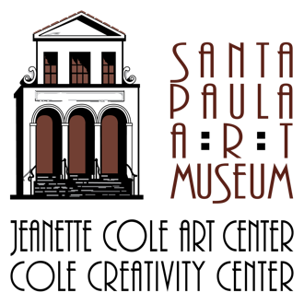
Santa Paula Art Museum
117 North 10th Street / Santa Paula, CA 93060
www.santapaulaartmuseum.org

Media Contact:
Julie Cluster, Director of Media and Marketing
805.525.5554 / info@santapaulaartmuseum.org

FOR IMMEDIATE RELEASE // December 15, 2020

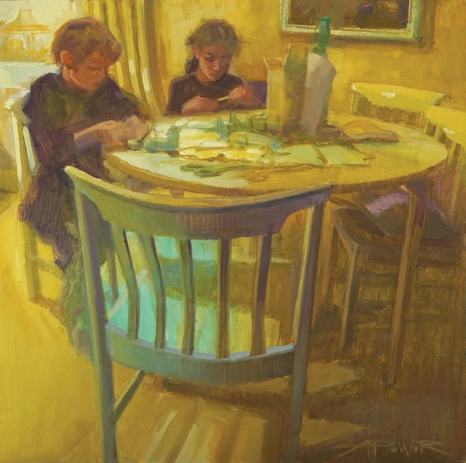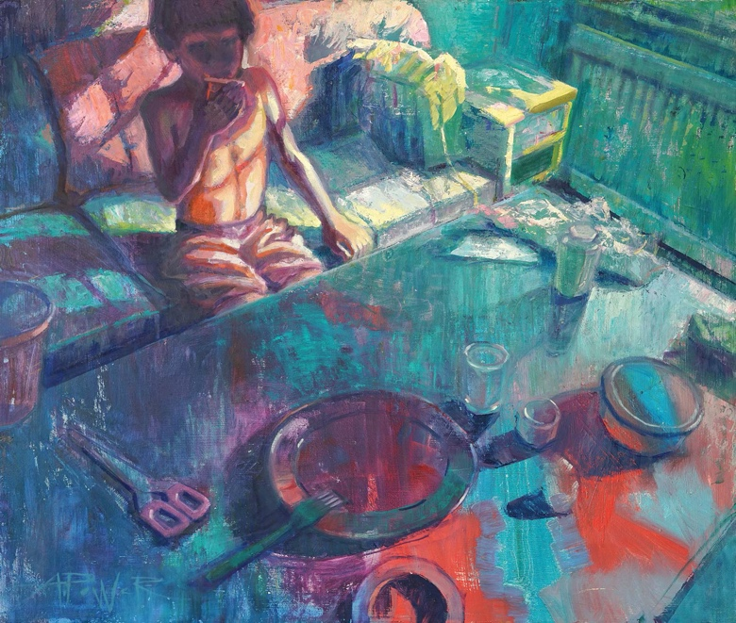

Local Artist Paints With an Eye Towards Hope During the Pandemic

“Silver Linings: Journey of Light,” a solo exhibition by artist Anette Power, will be on view at the Santa Paula Art Museum (117 North 10th Street, Santa Paula, CA 93060)
from February 6, 2021 to May 30, 2021. In the event that the Museum remains closed to the public due to COVID restrictions, the exhibit will be available to enjoy online at www.santapaulaartmuseum.org beginning February 6, 2021.

SANTA PAULA, CA – Light has long been an object of fascination for award-winning local artist Anette Power, informing both how and what she paints. There is, after all, light that can be seen and painted, and then there’s the joy and lightness of feeling that can only be conveyed in an artist’s choice of subject matter. In “Silver Linings: Journey of Light,” her upcoming solo exhibition of 35 oil paintings at the Santa Paula Art Museum, Power hopes that her art will inspire viewers to consider the bright spots in their own lives. “Silver Linings” will be on view from February 6, 2021 to May 30, 2021. There will be a free, virtual sneak peek of the exhibition streamed live from the artist’s studio on Saturday, January 16, 2021, at 2:00 p.m. The public is invited to register for the online event at www.santapaulaartmuseum.org/events. (In the event that the Museum remains closed to the public due to COVID restrictions, the entire exhibit will be available to enjoy online at www.santapaulaartmuseum.org beginning February 6, 2021.)

“In my life and in my art, light is synonymous with joy and an antidote to difficulties and darkness,” says Power. “I’m always looking for the silver lining.” The artist has long been admired for her ability to portray the beauty in everyday objects and moments: old cars and boats, children at play, charming homes and storefronts. For this exhibit it felt particularly meaningful to Power to shine a light on family, everyday life, and ordinary activities – things that now seem extraordinary due to the pandemic. “Art has been such a gift to me in challenging times, helping me to process what I’m going through,” Anette adds.

One experimental approach that the artist has used in her most recent works was to start out with a “mess of color.” Instead of laying down just one paint color on her canvas to start, she would begin with a random assortment of colors. Creating an image out of this chaos of colors seemed like a tangible way to make sense of the unknown. Many of the pieces in the upcoming exhibit also showcase back-lit subjects. For Anette, placing a light source behind the subject was the closest thing to painting a silver lining.

Born on an island off the Swedish coast, Anette Power spent more than a decade working in animation as a background painter for studios like Disney, Warner Bros., Cartoon Network and Universal. She is an artist member of the California Art Club and has been an active board member of the Westlake Village Art Guild for eight years. She maintains a working studio in Newbury Park, California. Power is well-known for her popular painting demonstrations and is a respected juror for art competitions. Her work has been shown in numerous galleries and museum exhibits and has garnered several “Best of Show” awards. Her paintings are collected widely throughout the U.S. and in Sweden. To learn more about Anette, please visit www.anettepower.com.

The Santa Paula Art Museum occupies two historic buildings located at 117 N 10th Street and 123 N 10th Street in downtown Santa Paula. The Museum features rotating exhibitions of vintage and contemporary art, art classes for children and adults, monthly Free Family Days, creative community events, a well-curated gift shop, and more. In support of public health directives, the Museum is currently closed until further notice. Please visit the Museum’s website at www.santapaulaartmuseum.org for the most up to date information including when the Museum will reopen to the public. To contact the Museum, please call (805) 525-5554, or email info@santapaulaartmuseum.org.

Attached publicity images:

“Making Meaning” by Anette Power, oil, 16 x 16 inches.

“Morning Waffles” by Anette Power, oil, 20 x 24 inches.

