FOR IMMEDIATE RELEASE CONTACT: Carrie Livingston
Email: carrie@colinkurtis.com
Phone: 815-519-8302

CONTACT: Nicole Baca
Email: nbaca@nellsonllc.com
Phone: 714-660-0853
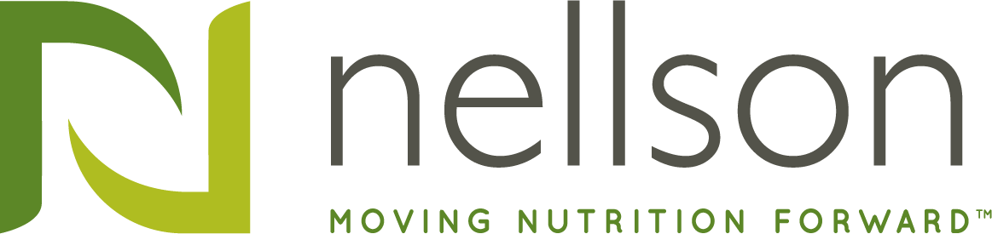

NELLSON PROMOTES JEAN FILION TO CEO
(January 13, 2020) Anaheim, CA – Nellson Nutraceutical LLC (“Nellson”), the leading full-service nutritional bar and powder provider in North America, today announced the appointment of Jean Filion to Chief Executive Officer. He succeeds Jamie Better, effective today. Since 2015, Jean has served as President of Nellson Canada and Chief Operating Officer of Nellson. Jamie Better will assume the role of Executive Chairman of Nellson.
“Since joining our company in 2015 with Nellson’s acquisition of Multibar where he served as CEO, Jean has done an exceptional job overseeing our footprint transformation. This includes the construction and ramp-up of our world-class bar facility in Ontario, California and the consolidation of two legacy facilities, as well as the operational integration of three acquisitions,” said Mr. Better. “I am excited to turn over the reins to such an operationally talented leader who, together with Chief Commercial Officer Bart Child, can take Nellson to the next level of growth.”
“I am honored by the opportunity to succeed Jamie in leading this incredible company,” said Mr. Filion. “Nellson is poised for significant ongoing growth, and I look forward to partnering with our experienced management team and Jamie as we continue to expand our capabilities and deliver value for our customers.”
Seth Hollander, Partner of Kohlberg & Company, Nellson’s majority owner commented, “On behalf of the Board of Directors of Nellson, I wish to thank Jamie for his distinguished service to the company and look forward to his continued role as Executive Chairman. Under his leadership, the business tripled in size, assembled a bi-coastal network of co-manufacturing facilities, and built a first-rate leadership team.”
Mr. Hollander continued, “As President of Nellson Canada and COO of Nellson, Jean has demonstrated outstanding operational leadership as well as deep product knowledge and business savvy. We look forward to continuing to work with Jean and Jamie in driving additional growth.”
Visit www.nellsonllc.com for more information.

###

About Nellson
Nellson Nutraceutical LLC, the leading full-service nutritional bar and powder provider in North America, is based in Anaheim, California with production locations in California, Utah, and Quebec. Founded in 1962, Nellson has over 55 years of diversified expertise in nutrition platforms for bars and powders, serving the sports performance, health and wellness, weight management, and medical nutrition market segments. Nellson offers formulation expertise, quality assurance, regulatory support, flexible production, and sales and marketing support.

About Kohlberg & Company
Kohlberg & Company is a leading private equity firm headquartered in Mount Kisco, New York. Since its inception in 1987, Kohlberg has organized nine private equity funds, through which it has raised over $10 billion of committed equity capital. Over its 33-year history, Kohlberg has completed 84 platform investments and nearly 200 add-on acquisitions, with an aggregate transaction value in excess of $27 billion. For more information, please visit www.kohlberg.com.

