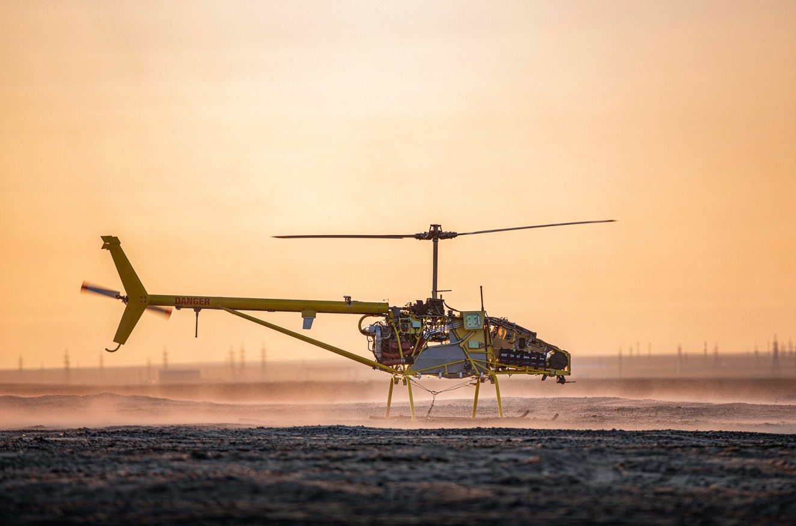
The Manned-to-Unmanned technology has significantly reduced the cost of the UAV, while retaining a payload capacity of 150 kg and a flight time of up to 8 hours.
February, 2021

By the projections of Goldman Sachs, the global UAV market will reach $ 100 billion in 2020, where military drones will account for 70% of the segment. According to analysts of Barclays Bank, the commercial drone market has already reached $ 4 billion and will grow 10 times over the next five years. 1.5 million is accounted for by UAVs in the oil and gas sector.

Based on the "World market of military drones 2017-2027" report by the American analytical company Orbis Research, the greatest growth in demand is expected for attack UAVs: their market share will be 40.8%, the share of high-altitude UAVs with a long flight duration 25.1%, the share of medium-altitude UAVs with a long flight duration 17.4%.

Unlike many other technologies, drones are being introduced faster than previously expected, for both commercial and military applications. They are used in a wide variety of areas and even more extensively than was assumed several years ago. Now manufacturers are forced to adapt to an ever-growing list of possible uses for drones.

Due to the continuous increase in market volumes and the expansion of the scope of UAV applications, the question of obtaining a reliable and at the same time economically profitable UAV that can cope with both government and commercial missions becomes inevitable. This task was successfully achieved using Manned-to-Unmanned technology, which has proved its effectiveness in various conditions.

In January 2021, Freshvale Ltd released another development using the Manned-to-Unmanned technology - the new HEAVY VTOL UAV 150H. This device was developed on the basis of commercial "combat-proven" helicopter CH-7 and proprietary military-grade autopilot AP.X. The new UAV has a high payload capacity of 150 kg, and a longer autonomous flight time compared to analogs - up to 8 hours.
The unmanned helicopter HEAVY VTOL UAV 150H successfully completed its first operational mission in the Far North, carrying out autonomous transportation of 150 kg cargo over a distance of 130 km. The drone demonstrated safe autonomous flight, as well as the economical gas mileage - 22-25 l / h. The operational temperature range of the new UAV is from -20 C to +50 C, only two specialists are required to operate it: one operator and a technician. HEAVY VTOL 150H is also designed to transport goods with a standard trailer or 20-foot container. Freshvale Ltd has announced successful completion of a new test: verification of performance was carried out in the harsh environmental conditions of mountainous areas.
This platform for military, law enforcement, intelligence, and emergency end users will change the concepts of operations of artillery, air defense, intelligence, special operations.
It is capable of bringing the payload with visual line of sight limitations to altitudes that increase VLOS to hundreds of km and to keep it there for up to 8 hours - all at very affordable CapEx and OpEx and without risking the pilot’s life.

UAV can be equipped with a wide range of mission-specific payloads and is suitable for the following missions:
- video surveillance and monitoring,
- thermal surveillance and monitoring,
- SAR surveillance and monitoring,
- LIDAR surveillance and inspections,
- Payload delivery and autonomous transporting,
- radio link range extension and retransmission,
- radio monitoring, direction finding and localization of radio emission sources,
- R&D flying laboratory (meteorology, hydrology etc.),
- transportation of goods,
- air crane.
Additionally, it has multiple use cases related to the delivery of cargo (both industrial and commercial users): offshore oil and gas, hard to reach locations, regular deliveries in rural areas – these are the fields for technological breakouts with new UAV.

Being based on a commercial “combat-proven” CH-7 helicopter, HEAVY VTOL UAV 150H provides its users with the most affordable OpEx and CapEx in such form-factor, reliable performance, simple and easily-accessible maintenance/ repair.
As for autopilot, the main feature of the AP.X automatic control system is a distributed architecture, when each component of the system has its own microcontroller providing data processing and communication with other components within the CAN network (Controller Area Network). The AP.X configuration allows avoiding loading the central processor with routine tasks by distributing management tasks to all system components. At the same time, there are efficiently no restrictions on the number of same-type modules, which makes it possible to implement multiple redundancies on all levels. Almost any payload, or ready-made third-party modules and entire systems can be connected to the system by adding IFC interfaces to the network. The flexible architecture of the AP.X allows us to quickly connect various modules and systems that extend the functions of the unmanned platform, synchronize work with other robotic complexes. For example, it is possible for one operator to simultaneously control several different unmanned vehicles.

One of the priority areas for many countries is the development of cost-effective economical UAVs, as well as the development of unmanned aviation in general. The growing use of unmanned technology for activities such as border surveillance, emergency assistance, military purposes, and law enforcement is a natural consequence of growing technological maturity.

When the use of drones began to spread in the early 2000s, it seemed to everyone that their main use would be the delivery of goods and products. In fact, the potential of such use turned out to be overestimated (so far such delivery is rather in testing mode), while other ways of using UAVs are widespread.

The main advantages of Manned-to-Unmanned converted unmanned aerial vehicles are the lower cost of their purchase and operation, the safety of the pilot and crew, as well as the elimination of the "human factor". Indeed, according to the International Civil Aviation Organization (ICAO), at least 80% of all aviation incidents and accidents occur due to erroneous actions and failures in human performance both in the air and on the ground.

