FOR IMMEDIATE RELEASE CONTACT: CARRIE LIVINGSTON,
Director of Media Relations, ColinKurtis
Email: carrie@colinkurtis.com
Phone: 815-519-8302

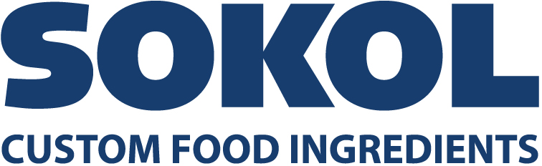

SOKOL ANNOUNCES PARTNERSHIP WITH ROBERT ROTHSCHILD FARMS

COUNTRYSIDE, IL, March 3, 2021—Sokol Custom Food Ingredients, a family-owned company that has been developing custom food formulations for 125 years, has announced a new partnership with Robert Rothschild Farms. As one of the nation’s leading contract manufacturers, Sokol has been handling and distributing national brands for over a century. Now, Sokol is producing a range of Robert Rothschild Farms’ signature premium products in a variety of packaging sizes. The collection ranges from Raspberry Chipotle Sauce to Artichoke Spinach Dip, Chocolate Caramel & Sea Salt Dessert Topping and more.

“We are pleased to partner with Robert Rothschild Farms,” said Paul Noble, Vice President of Sales and Marketing, Sokol. “Our partnership started just over a year ago as Sokol began production of one of Robert Rothschild Farms’ flagship items––Roasted Pineapple and Habanero Sauce. Since this time, our partnership has blossomed with Sokol commercializing an additional ten SKUs with another ten on the way.”

“Our partnership with Sokol has been the catalyst for our growth,” Jonathan Jeffer, CEO of Robert Rothschild Farms. “Their flexibility has enabled us to scale our business very rapidly without ever a fear of quality being compromised. They are a very professional team. We work through challenges together and have been able to positively contribute to each other’s respective businesses. We would not have been able to achieve the growth that we have this year without them.”

“A large part of our success has come from an all-hands-on-deck approach to commercialization, with teammates from both companies working together to bring these products to life,” said Noble. “In particular, our R&D teams have worked together through benchtop development and production scale-up to ensure that products are produced to the high quality standards of both companies. We look forward to our continued work together and encourage everyone to try these flavorful products from Robert Rothschild Farms.”

Learn more about how Sokol can help meet your product needs and brand goals here. Sokol’s contract manufacturing can include ingredient sourcing, manufacturing, warehousing, inventory control, distribution management and more. They offer a variety of packaging sizes and may accommodate needs for kosher, halal, gluten-free, organic and non-GMO manufacturing.
###
About Sokol Custom Food Ingredients
Sokol Custom Food Ingredients is a family-owned company that has been developing custom food formulations for retail, industrial and foodservice industries worldwide for 125 years. Through a century of evolution and adaptation, Sokol, along with an impressive portfolio of retail and private label products such as Solo Foods retail brand, has evolved into a multifaceted food company focused on long-lasting strategic partnerships. Sokol’s team of formulation experts, quality ingredients, optimized production process, packaging solutions and dedicated customer service team give customers a unique experience and the ability to tap into current market trends and get to market quickly.

