National SNUC Awareness Day - social media toolkit
When: Annually, on April 11th  HashTags: #SNUCday  #NationalSNUCday | Image for social media posting:  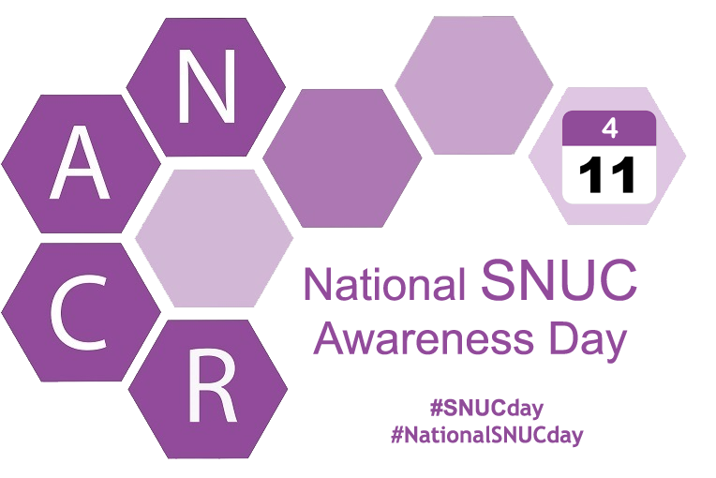
How to Participate
- Light a candle on 4/11 on behalf of National SNUC Awareness Day. Let this light represent your dedication to finding a cure for SNUC cancer, and for honoring those we love, remember, or grieve.
- Snap a picture of your candle, or, of you lighting / holding the candle.
- Share your photo(s) using the hashtags #SNUCday and #NationalSNUCday in your post.
- Encourage your followers to donate $4.11 on April 11, to www.TheNACR.org
- Publically recognize someone impacted by a SNUC diagnosis or who has lost a battle with the disease on our Faces of SNUC Forum. TheNACR will celebrate this individual throughout the day on April 11, annually!
Paragraph examples you could use on your social media - in advance of April 11:
On April 11, light a candle to support National SNUC Awareness Day. #SNUCday
I am using my social media platform to spread awareness about a rare head and neck cancer known as SNUC and the importance of lifesaving cancer research. Join me by lighting a candle on April 11, and donating $4.11 to the cause. #SNUCday #NationalSNUCday
This April 11, I am using my platform to raise awareness for a rare head and neck cancer known as SNUC and its cure. Join my friends at @TheNACR by lighting a candle on April 11 to honor those we love, remember, or grieve, and donate $4.11 to the cause. #NationalSNUCday #SNUCday
Join me on April 11 and post a photo of a lit candle representing your support for advancing SNUC cancer research. #NationalSNUCday #SNUCday
Paragraph examples you could use on your social media - the day of April 11:
Today is #NationalSNUCday I am using my platform to raise awareness for this rare head and neck cancer known as SNUC and to help find a cure. Light a candle in honor of someone you know, remember or grieve and donate to @TheNACR to help us advance on a cure. #SNUCday
Today is 411 (April 11) code for information & awareness! I am donating $4.11 to @TheNACR, & if 20 of my friends did the same, we would raise more than $80 to support cancer research and a cure! #SNUCday #NationalSNUCday
www.TheNACR.org Foundation Social Media:
Facebook: @TheNACRorg
YouTube: @TheNACR
Questions: Contact TheNACRorg@gmail.com or (800)374-5141

