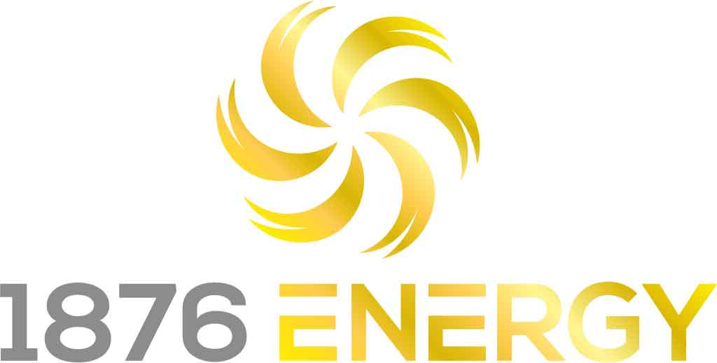

The new office in Phoenix marks the company’s second location in Arizona and the fourth state where they offer home solar installation services.
PHOENIX, Arizona (PRWEB) April 8th, 2021 — 1876 Energy, one of the fastest-growing home solar service providers in the nation, now offers affordable electricity options to homeowners in the Phoenix area. The new office marks the company’s second location in Arizona and the fourth state where they offer home and commercial solar installation services.
“We are very excited to offer competitive energy pricing to more homeowners throughout Arizona. The state has proven to be an excellent fit for solar power,” said Chief Executive Officer, Tim Padden. “It offers year-round sunshine, immediate savings for customers and homes ideally suited for rooftop solar. All of these factors lead to cost savings that we can pass on to our customers, we see tremendous growth potential over the next few years.”
1876 Energy launched its first Arizona office in the city of Tucson in February 2019 and expects to hire over 50 additional employees to help scale its operations across the Grand Canyon state by the end of the year.
About 1876 Energy
1876 Energy ( Named for the year that solar was invented) is a top residential solar contractor with operations in Texas, Colorado, Arizona, and California. The owner-operated business is committed to providing savings for their customers and helping the environment by providing clean, affordable electricity to qualified homeowners. 1876 Energy focuses on customer experience and education managing the entire customer experience from enrollment through installation and activation of each solar energy system to make the process simpler.

Originally published on PR WEB.

For any media-related inquiries, please contact:
Marketing Department
marketing@1876energy.com
1-855-968-7187

