FOR IMMEDIATE RELEASE CONTACT: CARRIE LIVINGSTON,
Director of Media Relations, ColinKurtis
Email: carrie@colinkurtis.com
Phone: 815-519-8302

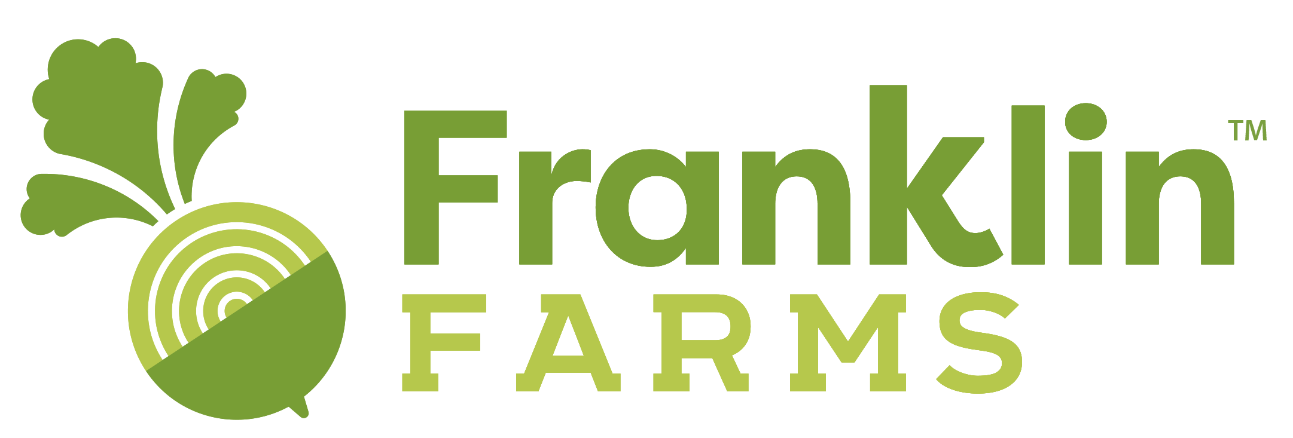

Franklin Farms Unveils Fusion Tofu–
A New Easy-To-Prepare, Flavor-Infused Tofu

PARSIPPANY, NJ, April 13, 2021—Franklin Farms™, a division of Keystone Natural Holdings, is introducing Fusion Tofu to its growing line of plant-based products. Infused with different flavors, this new line of extra-firm tofu offers consumers craveable flavor and functionality, saving time with a new easy-to-prepare healthy meal solution. Fusion Tofu is vegan, non-GMO, gluten free, cholesterol free and provides an excellent source of protein ranging from 10-11 grams per serving.

Fusion Tofu will be available at leading retailers in the coming weeks. New York Metro grocery retailers Key Food and King Kullen are expected to lead efforts with Fusion Tofu hitting shelves this May.

“Fusion Tofu is a new way for consumers to eat healthier, with vibrant flavor in every bite,” said Kenny Sung, CEO, Keystone Natural Holdings. “It was our goal to take the intimidation out of preparing tofu by offering our consumers a tofu that is infused with flavor, pre-seasoned, and pre-pressed for easy slicing or cubing. Today’s consumers are cooking at home and looking for plant-based products that are simple to prepare, without adding stress or confusion to dinner time. 66% of consumers of plant-based proteins said they would eat more plant-proteins if they knew how to best prepare them according to a recent Survey Data from National Panel Database. While many consumers reported enjoying tofu when going out to eat, preparing tofu at home could be considered intimidating, as it can require pressing or seasoning/marinating depending on the recipe.”

Now more than ever, consumers are shifting towards healthier diets. They are increasingly attracted towards tofu, a complete protein containing all nine essential amino acids. As a plant-based protein tofu provides various health benefits, such as maintaining healthy bones, and has been found to help prevent various cancers. Grand View Research has forecasted the tofu market will reach $308 million in sales by 2022.

Franklin Farms’ Fusion Tofu contains no preservatives, artificial colors or flavors and is currently available in four savory flavor-forward options, including:
- Curry
- Tuscan Tomato
- Italian
- Mediterranean

“One of the most appealing aspects of our Fusion Tofu is that it can be enjoyed in a variety of ways,” said Cindy Wong, Vice President of Sales, Franklin Farms. “It can be prepared hot or cold and is incredibly versatile. Fusion Tofu is ready to eat and can be quickly added to salads, stir-fries, wraps, pasta dishes, buddha bowls, and more. There is no draining or pressing required, making it a very convenient plant-based option for our consumers.”
Franklin Farms has more than twenty years expertise in plant-based protein foods and uses only the highest quality ingredients and packaging to provide a healthy selection of plant-based products for any meal of the day. Product offerings including veggie patties, meatless meatballs, tofu, seitan, tempeh, edamame vegan jerky, Planty Good Patties and Ground and Vegan Wraps. Franklin Farms is a proud member of healthy brands under Keystone Natural Holdings, a company devoted to developing authentic, health-conscious and innovative food.

To learn more about Franklin Farms and its plant-based product offerings or to find the nearest retail location, please visit www.franklinfarms.com or email for more information.

###
About Franklin Farms
Franklin Farms began over 20 years ago as a simple mushroom farm in Franklin, Connecticut. Since then, they have been creating exciting yet good-for-you meatless meals from field to table. Great ingredients make great foods which is why Franklin Farms starts with flavor-forward, high-quality plant proteins. They offer a range of health-conscious plant-based protein products that span day parts, meal types, and taste profiles. From end to end, Franklin Farms makes it easy and delicious for consumers to cook with and eat great-tasting plant-based proteins. From our farms to a store near you, find the nearest retail location at: https://www.franklinfarms.com/where-to-buy.

