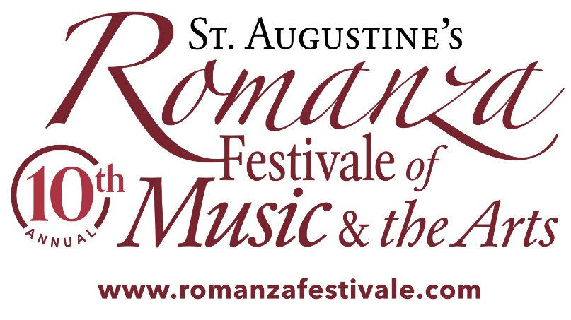
For Immediate Release Contact: Kathy Vande Berg (914) 980-3051 kathvan@comcast.net

10-year anniversary with Romanza Festivale of Music and the Arts, May 1-15
Myriad of free events and live performances in St. Johns County, Fla.

St. Augustine, Fla. – April 12, 2021 – Romanza Festivale of Music and the Arts, the renowned professional performance series with art, music and culture in historic St. Augustine, Fla. is celebrating its 10th year and includes 35 events and exhibits by dozens of independent nonprofit organizations and talent. From Saturday, May 1 until Saturday, May 15, daily concerts, plays, dance showcases, art exhibits, opera, wine events, and more will be featured. Romanza Festivale is the only local event which showcases the arts, culture and heritage. It is an annual collaboration by dozens of organizations and businesses in St. Augustine, Fla. Many events are free of charge and open to the public. Kathleen Vande Berg is the Chair of Romanza Festivale. Romanza Board members include Albert Syeles, Pat Syeles, Glo MacDonald, and Lisa Mack. For general information, schedules and locations, visit the website at https://www.romanzafestivale.com.

According to key founders and board members of Romanza-St. Augustine Kathy Vande Berg, and Albert and Pat Syeles of St. Augustine, Fla., the milestone tenth anniversary year for Romanza Festivale has been scheduled for attendees to participate in live, in-person activities after the past year of event cancellations. All functions will follow current CDC protocol and proper distancing. Entertainment genres include music, heritage and culture, culinary and wine, dance, spoken word, theatre, visual art, and many additional productions at a diversity of local venues. Visit the website for events at https://www.romanzafestivale.com/events.
Starting on Saturday May 1 until Saturday May 15 headliners include Duo Beaux Arts - Concert Pianists, Mama Blue’s Concert Special for Mother’s Day, Romanza Dance Kaleidoscope, and a finale with Akia Uwanda, Soul Vocalist.

Well known performance artists featured in and around the Festivale and attraction dates will include St. Augustine Community Chorus, Florida School of the Arts, River City Jazz Ensemble, Catch the Groove, The Three Tellers, St. Augustine Art Association Plein Air Art and Exhibit, Spanish Wine Tasting, Ancient City Poets, Sam Pacetti, and many more.

Additionally, organizers will showcase a collaboration between First Coast Opera and A Classic Theatre to include a world premiere operetta written by First Coast Opera’s Artistic Director Curtis Tucker and Nelson Sheeley. A special pre-Festivale kickoff event by the Emma Concert Association will feature The Gainesville Orchestra performing on April 27 at The Amp in St. Augustine.

According to Vande Berg, participating groups or solo performers will receive a stipend from Romanza for their performances. “In response to hardships created by event cancellations and venue closures related to the Coronavirus, Romanza intends this arrangement to help sustain the viability and vibrancy of St. Augustine’s arts community into a healthy recovery when the crisis is past,” said Vande Berg. “Romanza believes in supporting the arts and our local artists. The Festivale has been able to operate at a level of increasing support for our community artists and musicians through paid performances, sponsorships, awards, scholarships, and significant promotions.”

Romanza Festivale and the Celtic Festival, along with the St. Augustine St. Patrick Parade, among other events have been produced by Romanza-St. Augustine, Inc. a 501(c)(3) nonprofit. Visitors from the U.S. and around the world, local and regional residents, and guests spend multiple days enjoying the family entertainment offerings, most of which are free. Leading regional and local talent will showcase their talents in historic St. Augustine, the Nation’s Oldest City.

According to Albert Syeles, cultural organizations and businesses in St. Johns County look forward to Romanza as a showcase for their work. “We are proud to once again bring the Romanza Festivale of Music and The Arts to our beautiful city with daily events featuring dozens of concerts, shows, exhibits and much more, while also including local arts and cultural nonprofit organizations,” he said. Syeles added: Romanza in Spanish is a love song, Romanza in Italian is a love affair, and Romanza in St. Augustine means celebrating our heritage in arts and culture.

Romanza Festivale is funded in part by the St. Johns County Tourist Development Council, and by the State of Florida, Department of State, Division of Cultural, and Florida Council on Arts and Culture. For more information, contact Kathy Vande Berg at (914) 980-3051 or email kathvan@comcast.net.

