PRESS RELEASE CONTACT: Carrie Livingston
Email: carrie@colinkurtis.com
Phone: 815-519-8302

CONTACT: Nicole Baca
Email: nbaca@nellsonllc.com
Phone: 714-660-0853
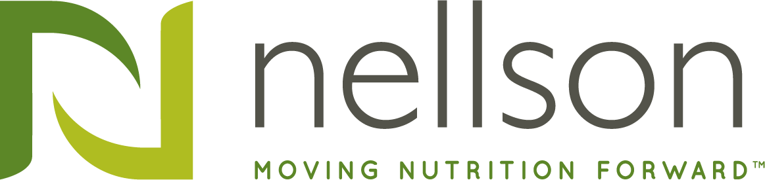

NELLSON ADDS ERP PLATFORM TO GIVE BUSINESS AND BRAND PARTNERS
A COMPETITIVE EDGE IN THE MARKETPLACE

(April 21, 2021) Anaheim, CA – Nellson, LLC (Nellson), a leading North American manufacturer of branded and private label nutritional bar and functional powder solutions, recently completed Enterprise Resource Planning (ERP) integration. Nellson partnered with 9EDGE Inc. (www.9EDGE.co) and Oracle (www.oracle.com) to deploy Oracle’s JD Edwards 9.2 ERP system throughout the organization. The global ERP model brings all Nellson manufacturing and corporate systems under a single umbrella, supporting rapid growth with streamlined processes. It should provide Nellson’s brand partners with controlled costs and a competitive edge in the marketplace.

“We are very pleased to have ERP fully integrated across our business,” said Bart Child, Chief Commercial Officer of Nellson. “We began this undertaking back in 2016, so this achievement is a major milestone for our organization. At Nellson, we are committed to helping our brand partners stay one step ahead of the competition. ERP gives our business and our brand partners a considerable edge in the marketplace with controlled costs and harmonized processes. It also provides a scalable platform to support the next phase of our growth.”

“Nellson saw the need for a standardized platform that would support our evolving business and let us streamline processes through all of our factories,” said Sean Selman, VP of US Supply Chain and Information Technology, Nellson. “One of the many areas we focused on was supply chain processes. By using a common platform for all locations, our business units are able to quickly see production plans, inventory positions and consumption demands for shared materials across all sites. With the increased pressures on supply chain due to Covid, we are able to more precisely utilize excess materials between sites and keep customer products on the shelves.”

“Our customers’ number one request is ease of doing business,” said Child. “They need more from their business partners to lower costs and streamline processes, so a network systems solution is critical for success. With our ERP JDE 9.2, we are able to expand our IT footprint to meet initiatives to mutually lower costs and simplify working relationships. Once fully integrated, we expect to offer a customer portal where our brand partners can access critical business information such as new product launches, open order status, and unique material inventory in real time. We are confident that these and other services will create a customer experience second to none.”

“That is part of the beauty our ERP platform,” said Selman. “JDE 9.2 allows us to integrate non-ERP systems more easily to provide a deeper level of integration throughout all of Nellson including new product introduction, formula management and finite scheduling. Our ERP platform is very adaptable and flexible to keep up with our rapid growth. It also allows us to seamlessly begin our journey towards digital transformation and Azure cloud adoption.”

Nellson supports brand partners through all stages of the production process with the strategic sourcing, continuous improvement and risk management to ensure your next nutrition product is a success. Find out how Nellson can help with your next winning bar and powder project by visiting www.NellsonLLC.com.

###

About Nellson
Nellson, the leading full-service nutritional bar and powder provider in North America, is based in Anaheim, California with production locations in California, Utah, and Quebec. Founded in 1962, Nellson has over 55 years of diversified expertise in nutrition platforms for bars and powders, serving the sports performance, health and wellness, weight management, and medical nutrition market segments. Nellson offers formulation expertise, quality assurance, regulatory support, flexible production, and sales and marketing support.

About Kohlberg & Company
Kohlberg & Company is a leading private equity firm headquartered in Mount Kisco, New York. Since its inception in 1987, Kohlberg has organized nine private equity funds, through which it has raised over $11 billion of committed equity capital. Over its 33-year history, Kohlberg has completed 84 platform investments and nearly 200 add-on acquisitions, with an aggregate transaction value in excess of $27 billion. For more information, please visit www.kohlberg.com.

