ESerebrinsky Press Release - For Immediate Release / April 2021

LOS RABANES “ A TODO VOLUMEN PANDEMIA RECORDS”
PRESS MATERIAL DOWNLOAD
The long awaited album by Los Rabanes featuring icons of Latin American rock will be available on all digital platforms this Friday, April 30.
A TODO VOLUMEN “PANDEMIA RECORDS”
Los Rabanes considered the most important rock band in Panama and an icon in Latin America that has more than half a million monthly listeners on Spotify (500K) and winners of the Latin Grammy for best rock band are releasing their new musical production “A todo volumen: Pandemia Records ” an album that could become the next cult work for rock in Spanish, a masterpiece in which they had the chance to play with the main exponents of Latin rock culture such as Beto Cuevas (La Ley), Randy Ebrigt (Molotov), ​​Los Pericos, La Mosca Tse Tsé, Los Autenticos Decadentes, Che Sudaka, Wendy Sulca, Vampiro, Koky Bonilla, Los Caligaris, El Pollo Brito, and Roberto Delgado, among many others. Recorded from home during the pandemic it will undoubtedly be a jewel that will remain in the collective memory.
'The pandemic will not silence us or win us over. It has been a time to be more united than ever, despite the geographical distances. Music can do everything and this album is an emblem that transcends borders so we want this musical production to be like a virus but positive with all the power that ska has'- added Emilio Regueira vocalist of Rabanes.

" Un millón de amigos" https://youtu.be/H4LnpTMhzG4
This album, which began as an idea in the midst of a pandemic, took form by contacting music artists and paying a tribute to the history of rock in Spanish.
The first single released was "Un millón de amigos" (A million friends) a ska version under the slogan 'The world needs a million friends not a million infected' which went around the world as a hymn of joy and togetherness in moments when it is so much needed the song is perform by Los Pericos and Los Rabanes.

"De música ligera" https://youtu.be/79hWHYj2CmQ
To commemorate one of the greatest Spanish Rock bands "Soda Stereo" the song "De Musica Ligera" it's a tribute to the legacy of Gustavo Cerati performed by Los Rabanes featuring Beto Cuevas - voice of the Chilean band La Ley- and Randy Ebright, drummer for the Mexican Molotov.

"Quizás, Quizás, Quizás" https://youtu.be/7LR6cm2lzz0
One of the outstanding songs of the album is "Quizás, quizás, quizás" recognized as a world classic composed in 1947 by the Cuban Osvaldo Farres and it is covered by Los Rabanes together with the Caligaris from Argentina and Afrodisíaco from Peru in "Ska 2020" The three bands came together to give it a fresh, cheerful and energetic sound.

"Cómo te deseo" https://youtu.be/kThhrkm20pc
A classic song immortalized by the Mexican band Maná which features the great guitarist César López “Vampiro” and the Peruvian superstar Wendy Sulca was released on Friday, February 12 which also features Guillermo Novellis from the legendary Argentine band La Mosca Tse Tsé and Khaled el Letraficador, a Panamanian urban artist.

"Caminando" https://youtu.be/lhsyjxlwMh8
'It is a very positive song that reminds us that walking little by little new paths are opened, a new path with a motivating spirit in this year where things begin to change in favor of humanity ” affirms Emilio Regueira, singer of Los Rabanes.
Los Rabanes shared with Los Auténticos Decadentes their admiration for Rubén Blades and when they proposed them to be part of this album they were delighted to accept. The complement of this song is in the hands of Rafael “Pollo” Brito, a true folk star who with his 'Cuatro Venezolano' mixes Afro-Venezuelan folk rhythms with pop rhythms. He has made history in the autochthonous roots of Latin America and through Roberto Delgado's mastery, director of the Rubén Blades orchestra. The dj Maripaez contributed to this song with electronic sounds as well as the trombonist Avenicio Núñez and Herbert Ureña.

ABOUT ROCKASS ONLINE MUSIC

Rockass Online Music a New York-based record company, releases one of the best collaborative albums in a long time thanks to their efforts connecting friends who are determined to instill hope in times of pandemic. Rockass Online Music and its founder Javier Solis, continues to innovate and demonstrate that despite the circumstances it is possible to continue growing with talent and drive exactly as they are doing with Los Rabanes 'A todo volumen: Pandemia Records'.

Smart Link - PRE SAVE
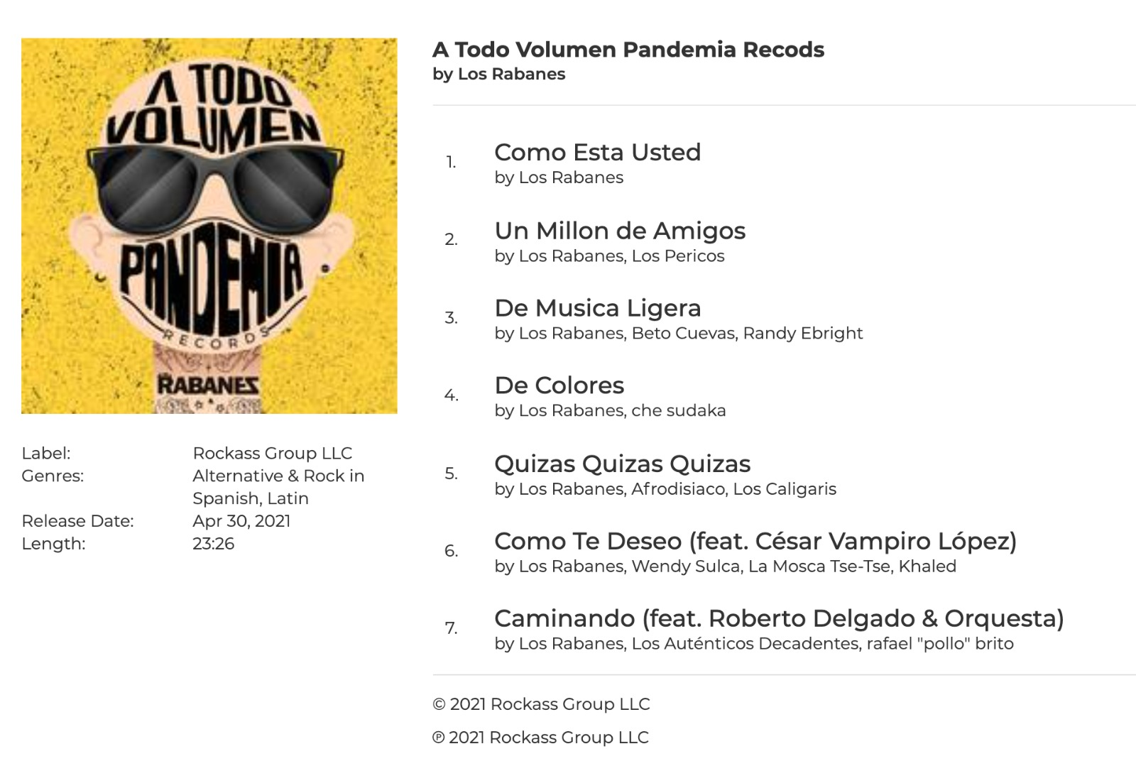

ENTREVISTAS DISPONIBLES Prensa Latinoamérica y Estados Unidos
Eva Serebrinsky +1 862 270 7088

